

SOFTWARE REQUIREMENT SPECIFICATION
Smart Quiz Platform (SQP)

– Hanoi, May 2026 –
Table of Contents
I. Record of Changes 5
II. Software Requirement Specification 6
1. Overall Requirements 6
1.1 Context Diagram 6
1.2 Main Business Processes 7
1.2.1 Learn Study Set Process 7
1.2.2 Exam Session Process 8
1.2.3 Class Setup & Management 9
1.2.4 Add new questions to Question Bank 10
1.2.5 Payment & Subscription 11
1.3 User Requirements 11
1.3.1 Actors 11
1.3.2 Use Cases (UC) 12
1.3.2.1 UCs for Guest 16
1.3.2.2 UCs for Learner 17
1.3.2.3 UCs for Teacher 18
1.3.2.4 UCs for Admin 19
1.4 System Functionalities 20
1.4.1 Screens Flow 20
1.4.2 Screen Authorization 20
1.4.3 Non-UI Functions 22
1.5 Entity Relationship Diagram 23
2. Use Case Specifications 24
2.1 Public Access & Discovery 24
2.1.1 View homepage 24
2.1.2 Search public study sets 25
2.1.3 Search public user accounts 27
2.1.4 View public study set detail 28
2.2 Authentication & Profile 29
2.2.1 Register account 29
2.2.2 Log in with account 30
2.2.3 Log in with Google 31
2.2.4 Forgot password 33
2.2.5 Log out account 34
2.2.6 View personal profile 35
2.2.7 Edit personal profile 36
2.2.8 Change password 37
2.3 Class management 39
2.3.1 View joined classes 39
2.3.2 Join class 40
2.3.3 View created classes 42
2.3.4 Create class 43
2.3.5 Generate class invitation 44
2.3.6 View class member list 46
2.3.7 Approve class join request 47
2.3.8 Remove learner from class 48
2.4 Question Bank Management 49
2.4.1 View question banks 49
2.4.2 Create question bank 51
2.4.3 Update question bank information 53
2.4.4 Delete question bank 55
2.4.5 Import questions from Excel 56
2.4.6 View question import errors 58
2.4.7 Preview imported questions 60
2.4.8 Create question 61
2.4.9 Update question 63
2.4.10 Delete question 65
2.4.11 Generate questions from material 66
2.5 Study Set Learning 69
2.5.1 View joined study sets 69
2.5.2 Create study set 70
2.5.3 Assign study set to class 72
2.5.4 Study with flashcard mode 74
2.5.5 Take study set quiz 76
2.5.6 Review wrong answers 77
2.5.7 Request AI answer explanation 79
2.5.8 View personal learning progress 81
2.6 Exam Session 82
2.6.1 View available exams 82
2.6.2 View exam information 84
2.6.3 Take exam 85
2.6.4 View exam result 86
2.6.5 Create exam session 88
2.6.6 Configure exam settings 89
2.6.7 View exam information 90
2.7 Analytics & Reporting, Notification 91
2.7.1 View learning analytics 91
2.7.2 Export report 93
2.8 Payment & Subscription 94
2.8.1 View premium plans 94
2.8.2 Upgrade to Premium 96
2.9 Admin Management & System Monitoring 98
2.9.1 View user list 98
2.9.2 Update user role 99
2.9.3 Hide public learning resource 101
2.9.4 View system status 103
3. Functional Requirements 104
3.1 Feature Name1 104
3.1.1 SubFeature Name1.1 104
3.1.1.1 Screen/Function Name1 104
3.1.1.2 Screen/Function Name2 105
3.1.2 SubFeature Name1.2 105
3.2 User Authentication 105
3.2.1 User Register 105
3.2.2 User Login 105
3.2.3 Password Reset 105
3.3 System Administration 105
3.3.1 Master Data 105
3.3.1.1 Setting List 105
3.3.1.2 Setting Details 106
3.3.2 User Management 106
3.3.2.1 User List 106
3.3.2.2 User Details 106
4. Non-Functional Requirements 107
4.1 External Interfaces 107
4.2 Quality Attributes 107
4.2.1 Usability 107
4.2.2 Performance 108
4.2.3 Security 108
4.2.4 Availability 108
4.2.5 Compatibility 109
4.2.6 Scalability 109
5. Requirement Appendix 110
5.1 Business Rules 110
5.2 System Messages 113
5.3 Security Requirements 116
5.4 Usability Requirements 116
5.5 Data Integrity Requirements 116
5.6 Maintainability Requirements 117

I. Record of Changes
Date | A*  M, D | In charge | Change Description
18/05 | A | 1.1, 1.2, 1.3 | Init context, business flow and use case
19/05 | A | 2 | Use case specification
21/05 | A, M | 1.2, 5.1 | Business Rules, more business processes
31/05 | M, A | 1.1, 1.2, 1.3, 1.4, 1.5, 2.5, 5.1 | Reworked Study Set ownership and Question Bank repository use cases
*A - Added M - Modified D - Deleted

II. Software Requirement Specification

1. Overall Requirements

1.1 Context Diagram
The Smart Quiz Platform (SQP) is an integrated online learning and assessment system designed to support the full cycle of study, practice, and examination. Guests can discover and study public study sets, then register to become a Learner or Teacher. Learners can join classes via code or invitation link, create their own public study sets, add questions manually, import questions from Excel, generate questions from learning materials with Premium AI access, study through flashcard and quiz modes, review wrong answers, and track personal learning progress. Teachers have the same study set creation capabilities as Learners, and can also assign study sets to classes, create study sets from their reusable question banks, configure official exam sessions, and export scoreboards and analytics reports. Question Banks now act as Teacher-only reusable repositories for questions that can be used repeatedly when creating study sets or exam sessions; they are not the main learner-facing learning object. Both Learners and Teachers can upgrade to Premium through an integrated Payment Gateway. Admins oversee user accounts, role permissions, public learning resources, and system stability. Email Service handles automated notifications, and Supabase Authentication handles login, session management, and password resets.
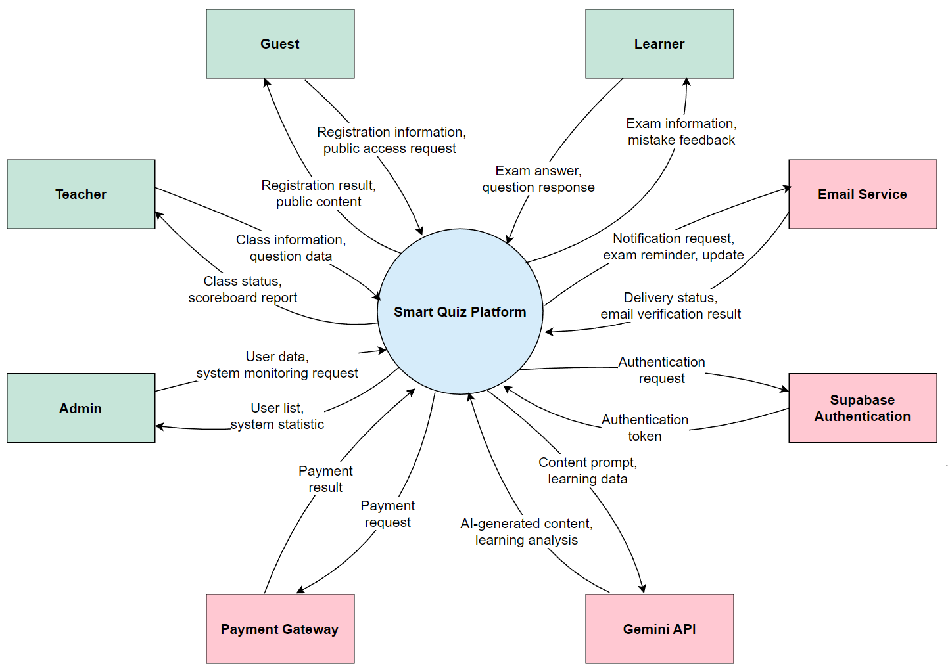

1.2 Main Business Processes

1.2.1 Learn Study Set Process
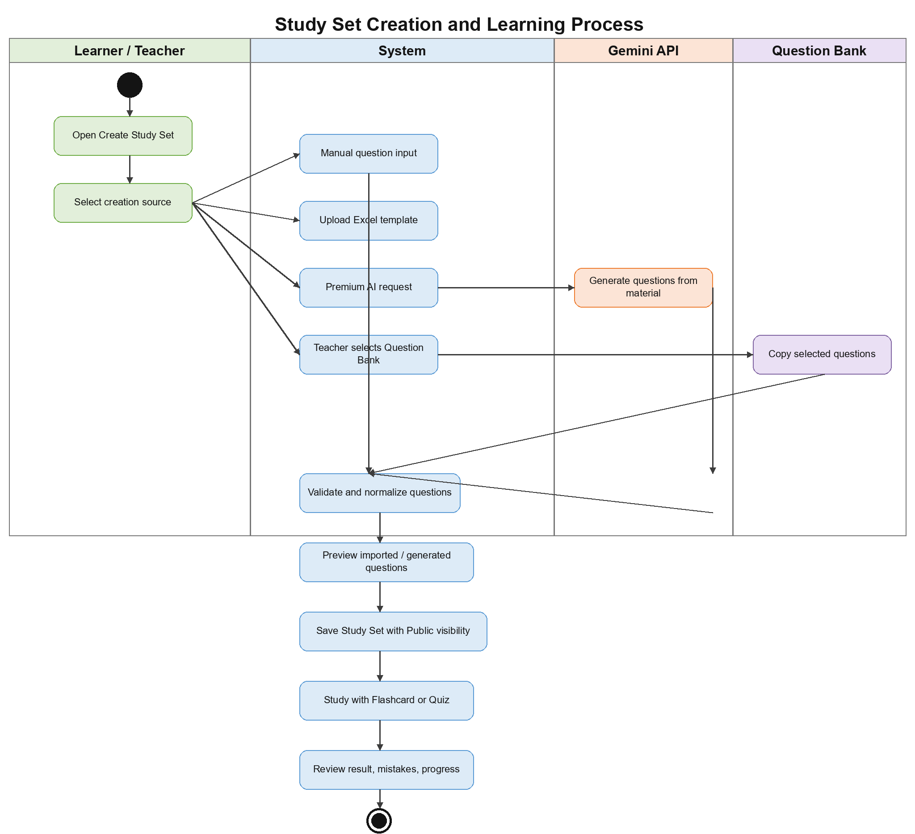

1.2.2 Exam Session Process
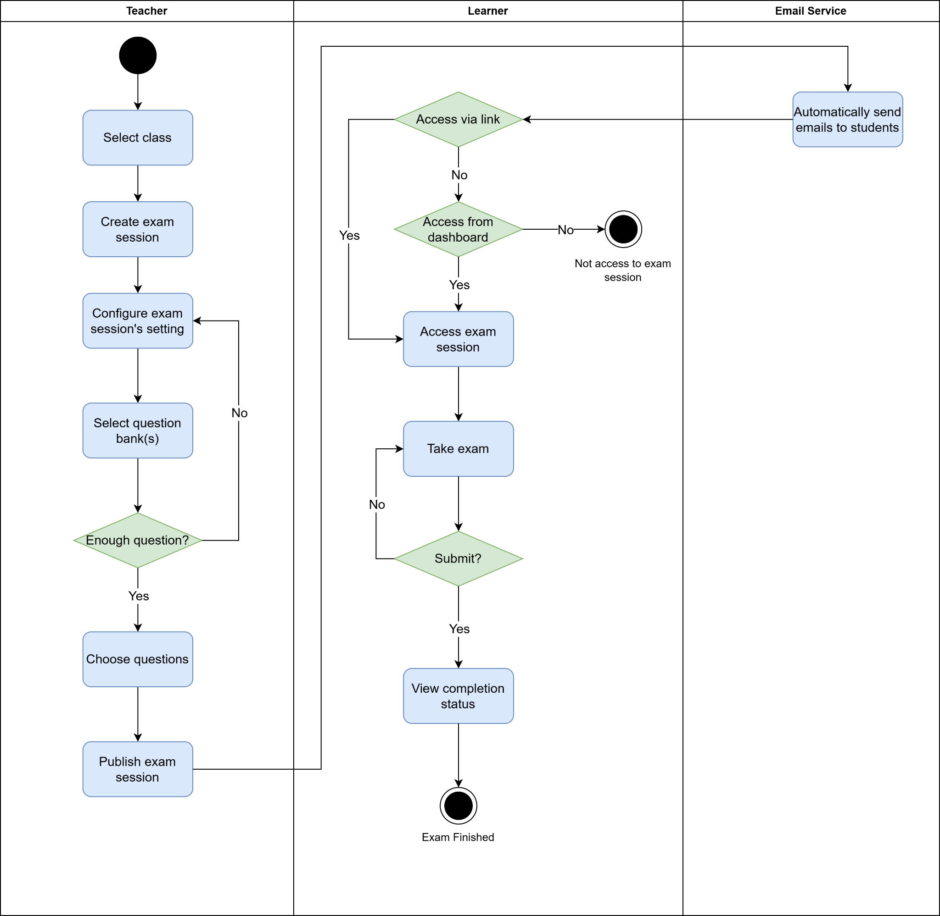

1.2.3 Class Setup & Management
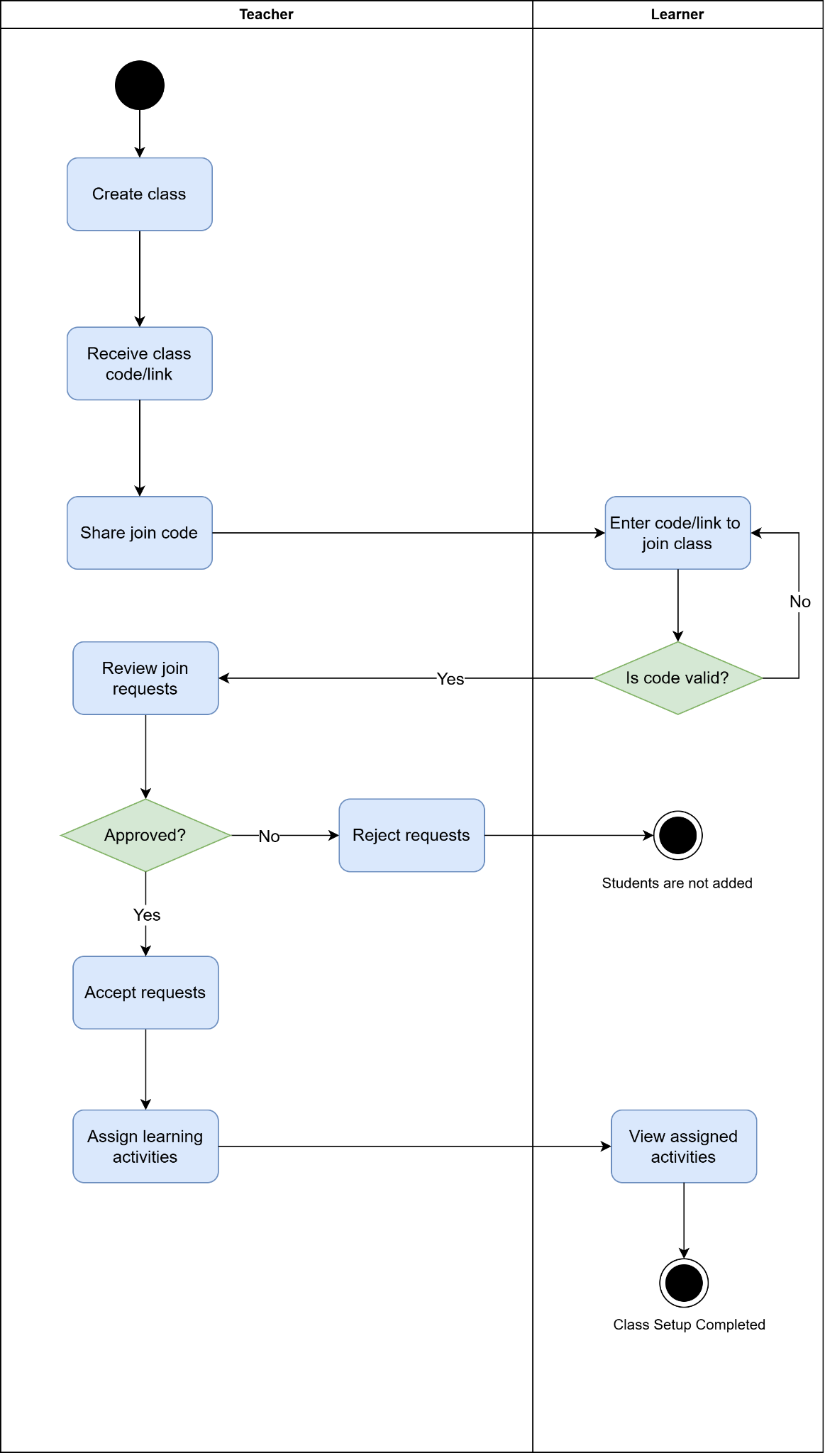

1.2.4 Study Set Creation & Manage Question Repository
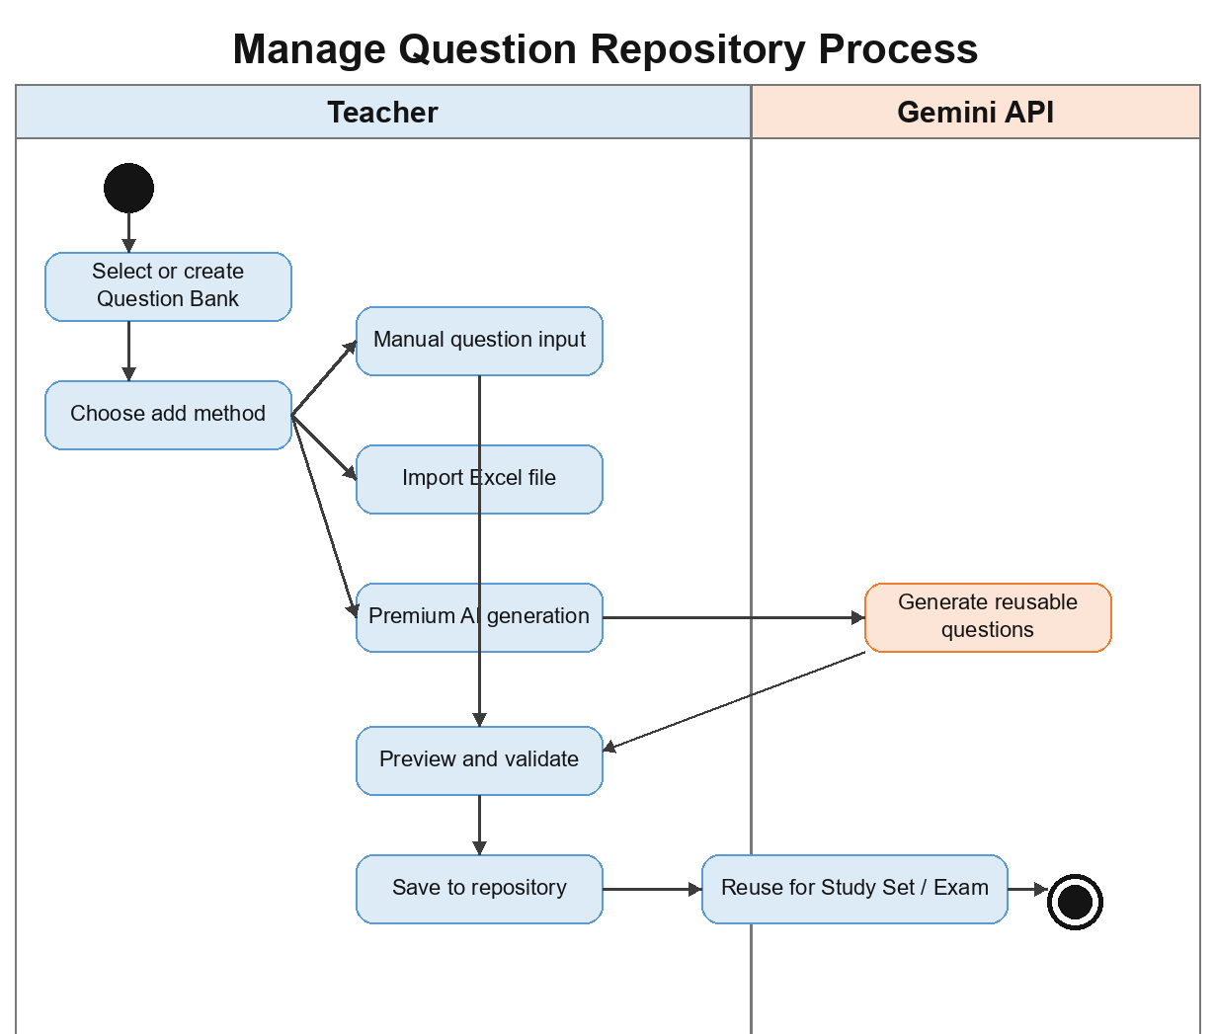

1.2.5 Payment & Subscription

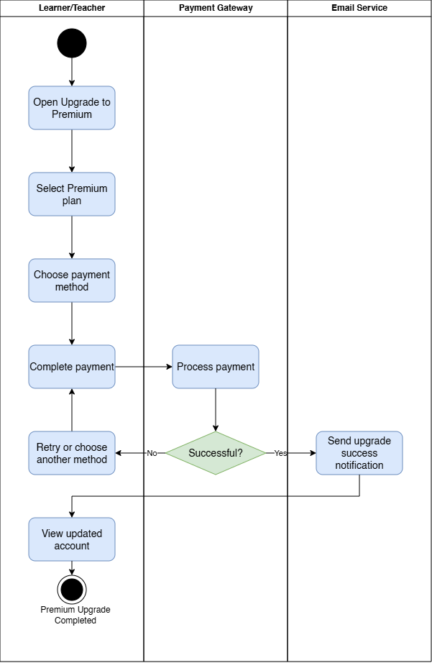

1.3 User Requirements

1.3.1 Actors
# | Actor | Description
1 | Guest | An unregistered user who accesses the platform to view general information, search public study sets, and study public flashcards.
2 | Learner | A registered learner who joins classes, creates and manages owned study sets, imports or generates study set questions, practices flashcards and quizzes, participates in exams, reviews mistakes, and tracks learning progress.
3 | Teacher | An educator who creates and manages classes, creates study sets, assigns study sets to classes, manages Teacher-only question banks as reusable repositories, configures exam sessions, and exports scoreboards or analytics reports.
4 | Admin | A high-level administrator responsible for managing user accounts, configuring role permissions, and monitoring the overall stability of the platform.
5 | Supabase Authentication | An external system that manages user login, session management, and account security.
6 | Email Service | An external system used to send automated exam reminders, test results, and updates from teachers to learners.
7 | Payment Gateway | An external payment gateway that processes transactions for Premium upgrades or paying service fees.
8 | Gemini API | An external artificial intelligence service used to generate study set or question bank questions, explain answers, and analyze learning content.

1.3.2 Use Cases (UC)
ID | Use Case | Actor | Feature | Use Case Description
UC-01 | View homepage | Guest | Public Access | Guest views the landing page of the platform.
UC-02 | Search public study sets | Guest, Learner, Teacher | Public Search | Guest, Learner, or Teacher searches public study sets by keyword.
UC-03 | Search public user accounts | Guest, Learner, Teacher | Public Search | User searches public user accounts by keyword.
UC-04 | View public study set detail | Guest, Learner, Teacher | Public Learning | Guest, Learner, or Teacher views details of a public study set, including title, description, subject, topic, visibility, owner information, and learning content.
UC-05 | Study flashcards | Guest, Learner, Teacher | Flashcard | Guest, Learner, or Teacher studies questions and answers using flashcard mode. Guest can only study public flashcards, while authenticated users can study public or accessible study sets.
UC-06 | View premium plans | Guest, Learner, Teacher | Payment & Subscription | User views available Premium plans and their benefits.
UC-07 | Register account | Guest | Authentication | Guest creates a new account on the platform.
UC-08 | Log in with account | Guest, Learner, Teacher, Admin | Authentication | User logs in to the platform using a registered account and valid credentials.
UC-09 | Log in with Google | Guest, Learner, Teacher, Admin | Authentication | User logs in to the platform using a Google account. The system authenticates the user through Google OAuth and creates or retrieves the corresponding platform account.
UC-10 | Forgot password | Learner, Teacher, Admin | Authentication | User requests and completes a password reset when they forget their password.
UC-11 | Log out account | Learner, Teacher, Admin | Authentication | User logs out from the current session.
UC-12 | View personal profile | Learner, Teacher, Admin | User Profile | User views their personal profile information before making any updates.
UC-13 | Edit personal profile | Learner, Teacher, Admin | User Profile | User updates allowed personal profile information such as full name, phone number, avatar, or profile details.
UC-14 | Change password | Learner, Teacher, Admin | User Profile | User changes their account password after accessing their personal profile.
UC-15 | Upgrade to Premium | Learner, Teacher | Payment & Subscription | Learner or Teacher selects a Premium plan, completes payment, and receives Premium access after the payment is successful.
UC-16 | View joined classes | Learner | Class Management | Learner views the list of classes they have joined.
UC-17 | Join class | Learner | Class Management | Learner joins a class using a valid class code or invitation link.
UC-18 | View accessible study sets | Learner, Teacher | Study Set | User views study sets they own, public study sets they started learning, or study sets assigned through a joined class or managed class.
UC-19 | Take study set quiz | Learner | Quiz | Learner takes a quiz generated from an assigned or accessible study set. Guest is not allowed to use this mode.
UC-20 | Review wrong answers | Learner | Mistake Review | Learner views the list of questions they answered incorrectly.
UC-21 | Request AI answer explanation | Learner | AI Explanation | Premium Learner requests an AI-generated explanation for a question and answer.
UC-22 | View personal learning progress | Learner | Learning Analytics | Learner views personal learning progress, including practiced questions, accuracy rate, repeated mistakes, and weak topics.
UC-23 | View available exams | Learner | Real-time Exam | Learner views exam sessions available to them.
UC-24 | View exam information | Learner | Real-time Exam | Learner views exam information such as exam time, duration, number of attempts, and result visibility rule.
UC-25 | Take exam | Learner | Real-time Exam | Learner takes an exam by starting the attempt, answering exam questions, restoring the attempt when needed, and submitting the exam.
UC-26 | View exam result | Learner | Result Review | Learner views exam result if the teacher allows result visibility.
UC-27 | View created classes | Teacher | Class Management | Teacher views the list of classes they created or are assigned to.
UC-28 | Create class | Teacher | Class Management | Teacher creates a new online class and auto-generated class code.
UC-29 | Generate class invitation | Teacher | Class Management | Teacher generates invitation link via email.
UC-30 | View class member list | Teacher | Class Management | Teacher views the list of learners in a class.
UC-31 | Approve class join request | Teacher | Class Management | Teacher approves a learner request to join the class.
UC-32 | Remove learner from class | Teacher | Class Management | Teacher removes a learner from a class.
UC-33 | View question banks | Teacher | Question Bank Repository | Teacher views the reusable question banks they created or are authorized to access for repeated study set or exam creation.
UC-34 | Create question bank | Teacher | Question Bank Repository | Teacher creates a new question bank as a reusable repository for questions that can later be selected for study sets or exam sessions.
UC-35 | Update question bank information | Teacher | Question Bank Repository | Teacher updates question bank title, description, subject, topic, visibility, or repository configuration.
UC-36 | Delete question bank | Teacher | Question Bank Repository | Teacher deletes, archives, or hides a question bank that is no longer needed, subject to integrity rules for exams and historical records.
UC-37 | Import questions from Excel | Teacher | Question Bank Repository | Teacher uploads an Excel file containing reusable questions into a question bank.
UC-38 | View question import errors | Teacher | Question Bank Repository | Teacher views row-level errors when the uploaded Excel file for a question bank is invalid.
UC-39 | Preview imported questions | Teacher | Question Bank Repository | Teacher previews valid reusable questions before saving them into the question bank.
UC-40 | Create question | Teacher | Question Bank Repository | Teacher manually creates a reusable question in the question bank.
UC-41 | Update question | Teacher | Question Bank Repository | Teacher updates reusable question content, answer options, correct answer, score, explanation, tags, chapter, lesson, topic, subject, or difficulty level.
UC-42 | Delete question | Teacher | Question Bank Repository | Teacher deletes, archives, or hides a reusable question from the question bank, subject to integrity rules.
UC-43 | Generate questions from material | Teacher | Question Bank Repository | Premium Teacher generates reusable question bank questions from uploaded learning material using AI.
UC-44 | Create study set | Learner, Teacher | Study Set | Learner or Teacher creates a public study set as the primary learning object. The study set may be created from manual questions, Excel import, AI-generated questions, or, for Teachers only, selected questions copied from a Teacher-owned question bank.
UC-45 | Assign study set to class | Teacher | Study Set | Teacher assigns an owned or authorized study set to a class or selected learners.
UC-46 | Create exam session | Teacher | Exam Session | Teacher creates an official exam session for a class using selected questions or an authorized question bank as the reusable source.
UC-47 | Configure exam settings | Teacher | Exam Session | Teacher configures exam time, allowed attempts, question randomization, answer randomization, and result visibility.
UC-48 | View exam information | Teacher | Exam Session | Teacher views configured exam information, including selected class, question source, exam time, attempt limit, randomization settings, and result visibility.
UC-49 | View learning analytics | Teacher | Analytics & Report | Teacher views learning, exam, learner, question, and class performance analytics.
UC-50 | Export report | Teacher | Analytics & Report | Teacher exports scoreboards or reports to Excel, PDF, or CSV.
UC-51 | View user list | Admin | User Management & Authorization | Admin views the list of users in the system.
UC-52 | Update user role | Admin | User Management & Authorization | Admin updates the role of a user account.
UC-53 | Hide public learning resource | Admin | Resource Management | Admin hides inappropriate or invalid public learning resources such as public study sets or other public learning content.
UC-54 | View system status | Admin | System Monitoring | Admin views the operational status of the platform.
UC-55 | Manually add questions to study set | Learner, Teacher | Study Set | Learner or Teacher manually adds questions, answer options, correct answers, explanations, tags, subject, topic, and difficulty into an owned study set.
UC-56 | Import study set questions from Excel | Learner, Teacher | Study Set | Learner or Teacher uploads an Excel file to create or append questions directly into an owned study set.
UC-57 | View study set import errors | Learner, Teacher | Study Set | Learner or Teacher reviews row-level validation errors for an imported Study Set Excel file before saving valid questions.
UC-58 | Preview imported or generated study set questions | Learner, Teacher | Study Set | Learner or Teacher previews valid imported or AI-generated questions before saving them into a study set.
UC-59 | Generate study set questions from material | Learner, Teacher | Study Set | Premium Learner or Premium Teacher generates study set questions from uploaded learning material using Gemini API.
UC-60 | Create study set from question bank | Teacher | Study Set | Teacher creates a study set by selecting and copying questions from an owned or authorized question bank. This does not grant Learners access to the source question bank.
UC-61 | Update question in study set | Learner, Teacher | Study Set | Study set owner updates question content, answer options, correct answer, explanation, tags, subject, topic, or difficulty in an owned study set.
UC-62 | Delete question from study set | Learner, Teacher | Study Set | Study set owner deletes or removes a question from an owned study set, subject to historical learning data rules.

1.3.2.1 UCs for Guest
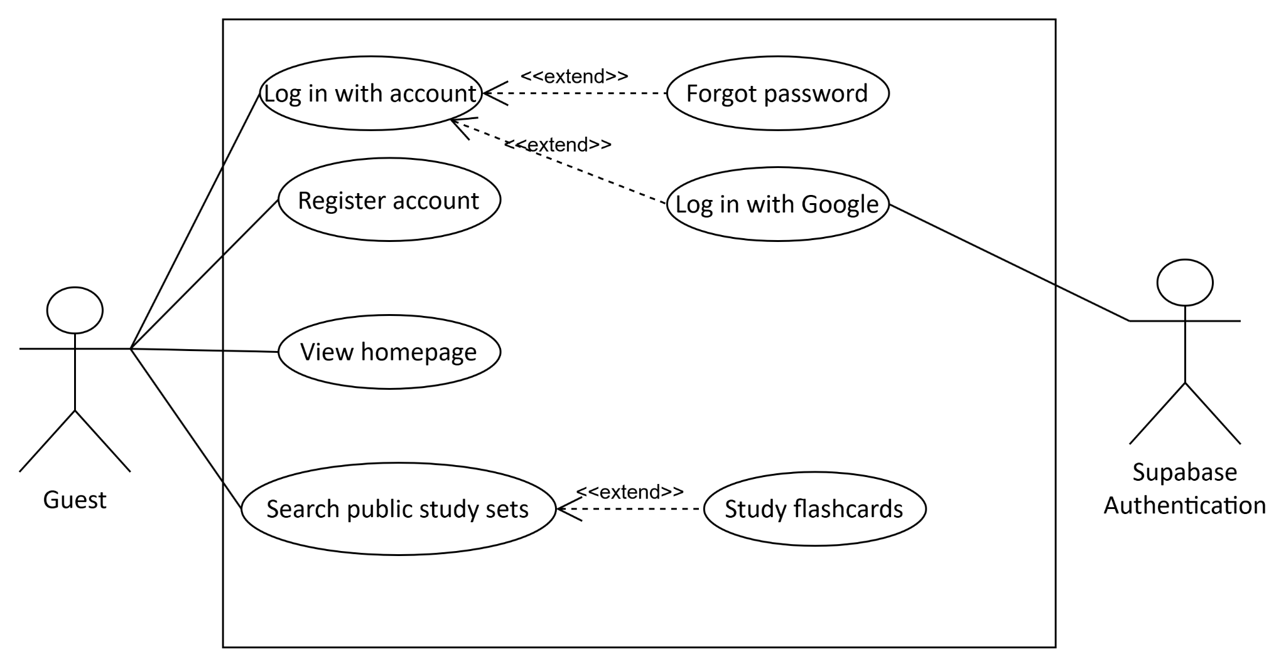

1.3.2.2 UCs for Learner
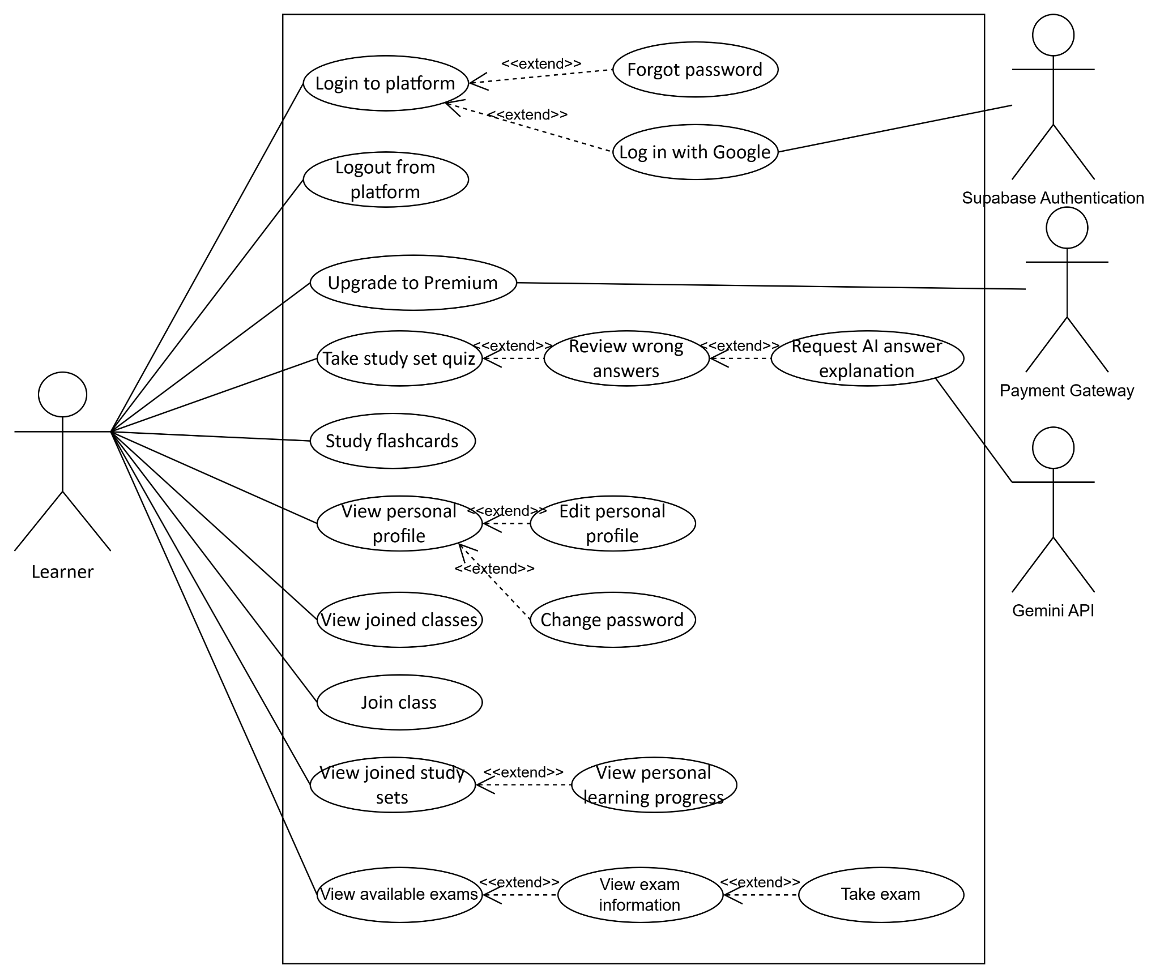

1.3.2.3 UCs for Teacher
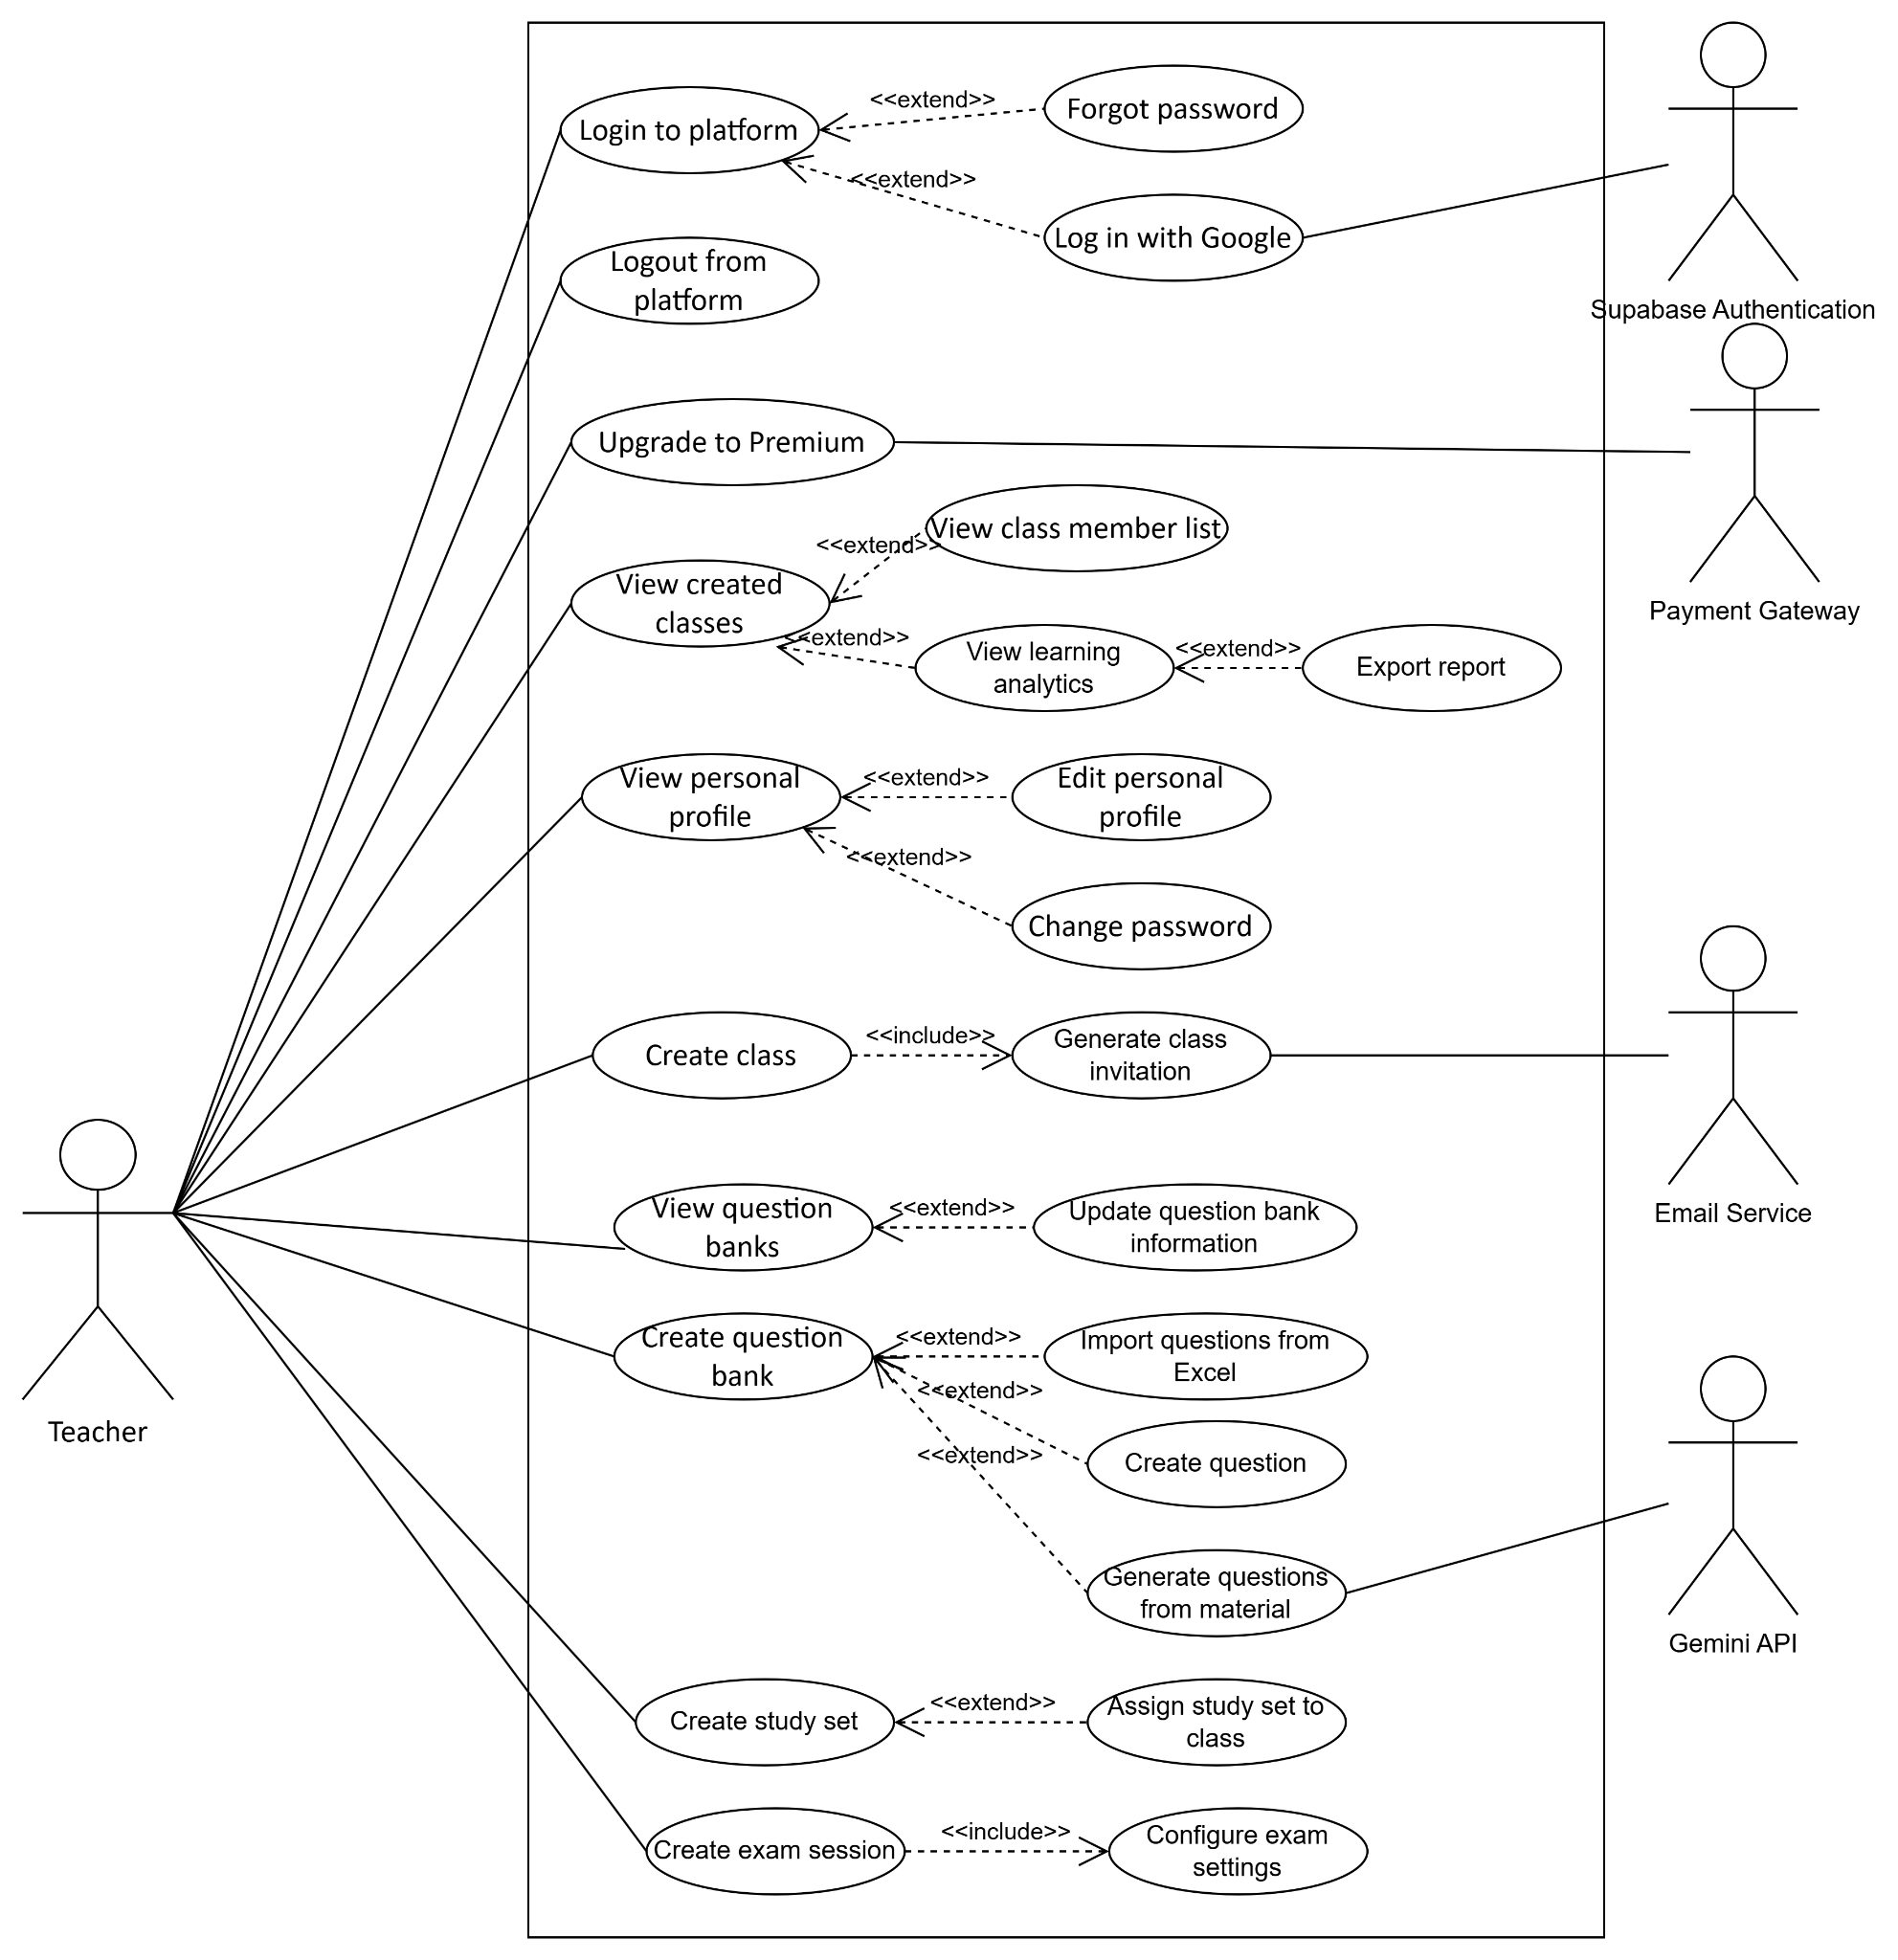

1.3.2.4 UCs for Admin
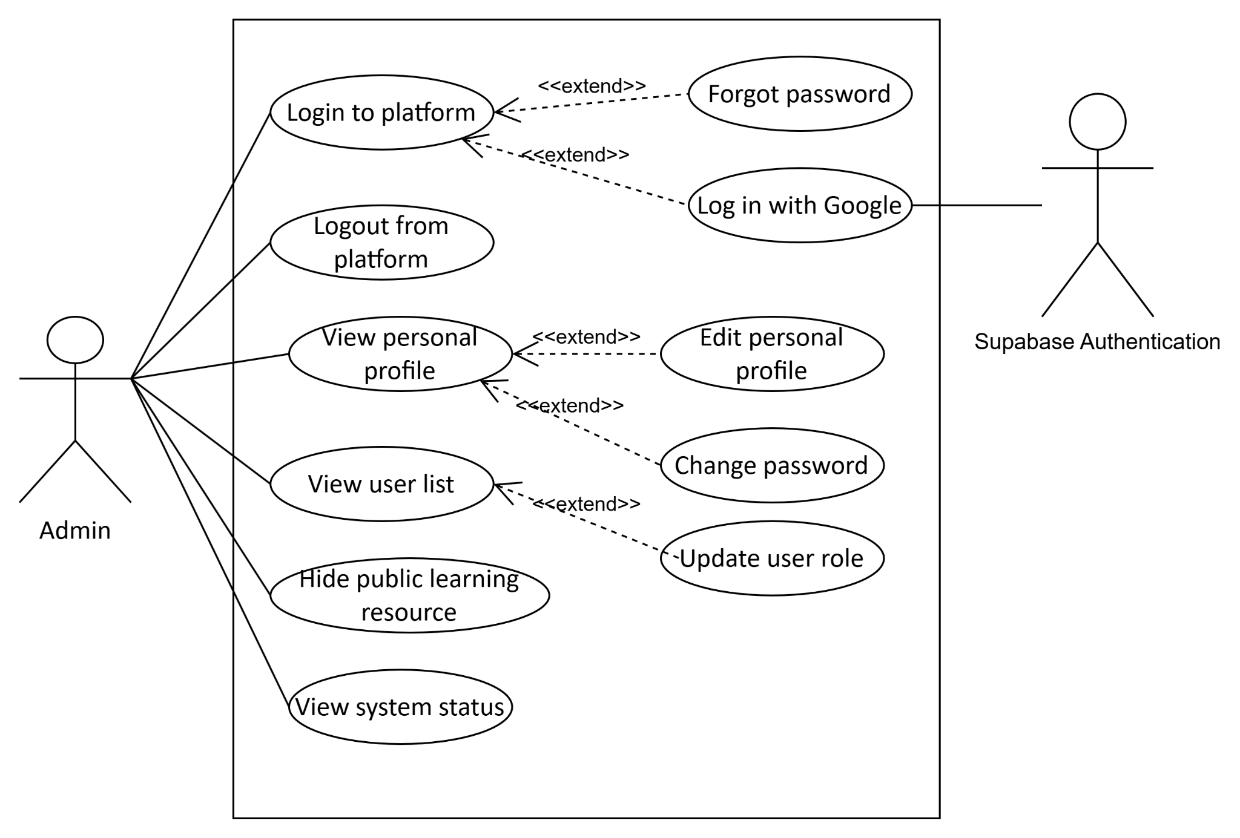

1.4 System Functionalities

1.4.1 Screens Flow
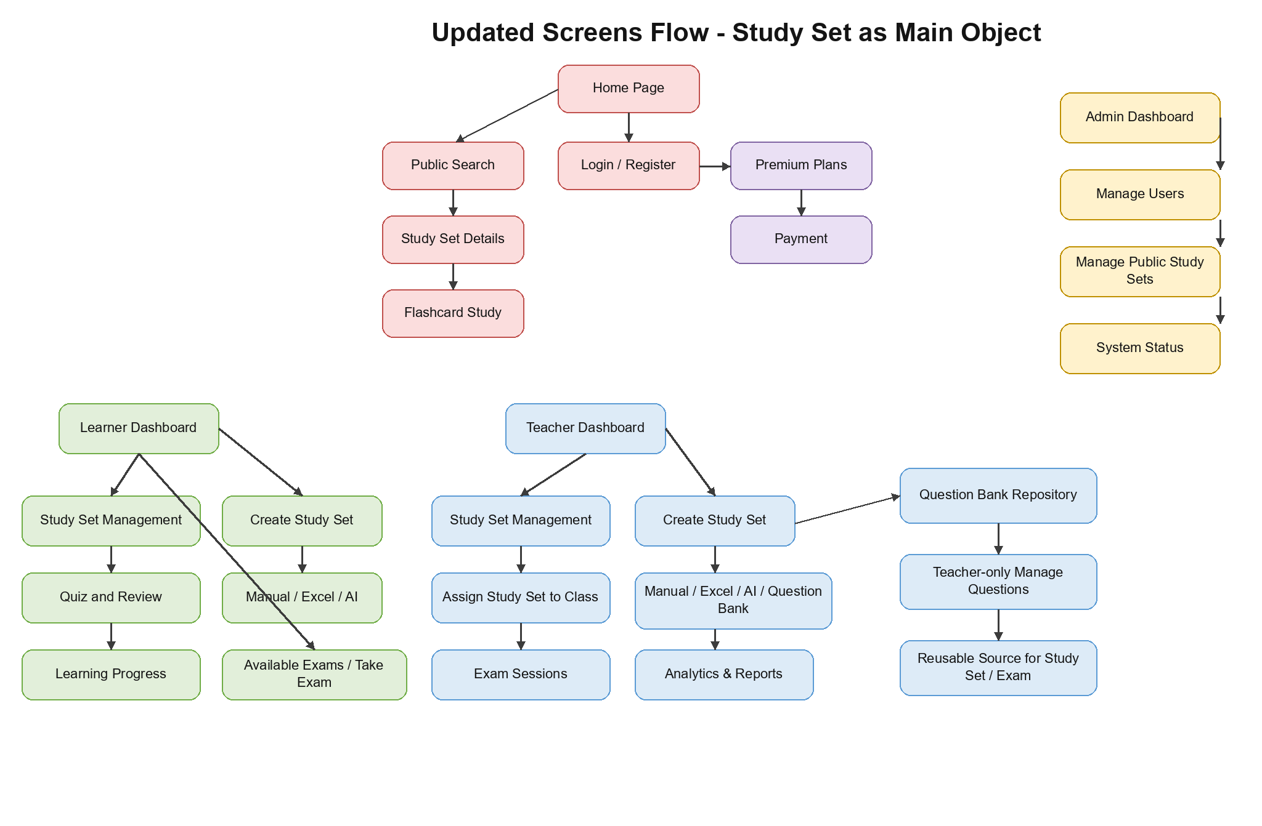

1.4.2 Screen Authorization
Screen | Guest | Learner | Teacher | Admin
Home Page | X | X | X | X
Public Search | X | X | X | -
Study Set Details | X | X | X | -
Flashcard Study | X | X | X | -
Register | X | - | - | -
Login | X | X | X | X
Forgot Password | X | X | X | X
Reset Password | X | X | X | X
Learner Dashboard | - | X | - | -
Teacher Dashboard | - | - | X | -
Admin Dashboard | - | - | - | X
User Profile | - | X | X | X
Notification Center | - | X | X | X
Premium Plans | X | X | X | -
Payment | - | X | X | -
Available Exams | - | X | - | -
Exam Information | - | X | - | -
Take Exam | - | X | - | -
Exam Result | - | X | - | -
Learner Classes | - | X | - | -
Learner Class Detail | - | X | - | -
Accessible Study Sets | - | X | X | -
Study Set Detail | - | X | X | -
Study Set Quiz | - | X | - | -
Quiz Result and Review | - | X | - | -
Learning Progress | - | X | - | -
Study Set Management | - | X | X | -
Teacher Classes | - | - | X | -
Teacher Class Detail | - | - | X | -
Assign Study Set | - | - | X | -
Exam Sessions | - | - | X | -
Exam Configuration | - | - | X | -
Monitor Exam Session | - | - | X | -
Analytics & Reports | - | - | X | -
Question Banks | - | - | X | -
Question Bank Detail | - | - | X | -
Question Bank Edit | - | - | X | -
Question Editor | - | - | X | -
Question Bank Import Questions | - | - | X | -
Question Bank AI Generation | - | - | X | -
Manage Users | - | - | - | X
Manage Classes | - | - | - | X
Manage Study Sets | - | - | - | X
Manage Payroll | - | - | - | X
Manage Resources | - | - | - | X
Study Set Editor | - | X | X | -
Study Set Excel Import | - | X | X | -
Study Set AI Generation | - | X | X | -
Create Study Set from Question Bank | - | - | X | -

1.4.3 Non-UI Functions
[Provide the descriptions for the non-screen system functions, i.e batch/cron job, service, API, etc.]
# | Feature | System Function | Description
1 | <<Feature Name>> | <<Function Name1>> | <<Function Name1 Description>>
2 | …

1.5 Entity Relationship Diagram
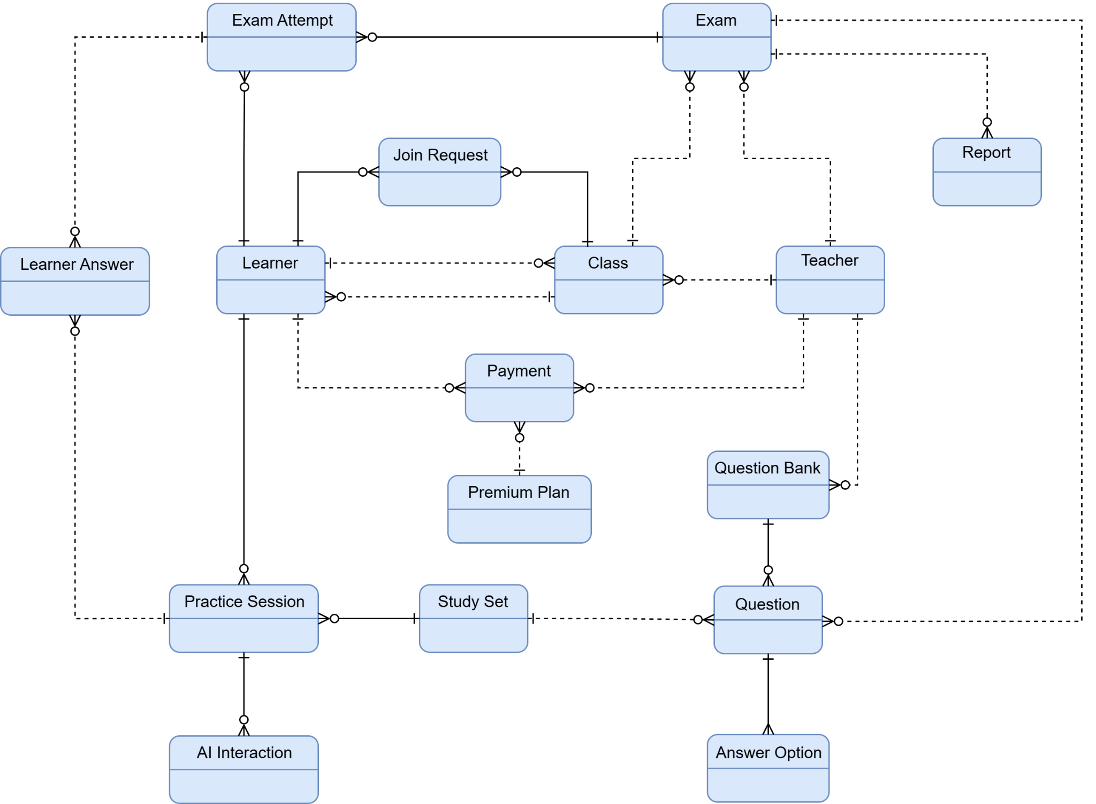

Entities Description
# | Entity | Description
1 | Learner | A student or learner who joins classes, creates and manages owned study sets, practices study sets, takes exams, submits answers, and uses learning features in the platform.
2 | Teacher | An educator who creates and manages classes, study sets, Teacher-only question banks, exams, and reports.
3 | Class | An online learning class created by a teacher where learners can join, receive study sets, and participate in exams.
4 | Join Request | A request submitted by a learner to join a class, which can be reviewed or approved by a teacher.
5 | Question Bank | A Teacher-owned reusable repository of questions used as a source for repeated study set creation or official exam creation. Learners and Guests do not access question banks directly.
6 | Question | A learning or assessment item that may belong to a study set or a Teacher-owned question bank and can be used in practice sessions or exams.
7 | Answer Option | A possible answer choice for a question.
8 | Study Set | A primary learner-facing learning object created by a Learner or Teacher. It contains selected, imported, manually entered, AI-generated, or Teacher-copied questions and is Public by default.
9 | Practice Session | A learning session where a learner practices a study set and answers questions outside of an official exam.
10 | Learner Answer | The answer submitted by a learner during a practice session or exam attempt.
11 | Exam | An official assessment created by a teacher and assigned to a class.
12 | Exam Attempt | A learner’s attempt to take an exam, including submitted answers, completion status, score, and result information.
13 | Report | A report or scoreboard generated from class, exam, learner performance, or learning analytics data.
14 | Payment | A payment transaction made by a learner or teacher for a premium plan.
15 | Premium Plan | A paid service plan that provides learners or teachers with access to premium features.
16 | AI Interaction | An interaction between a learner or teacher and the AI service, such as requesting answer explanations or generating study set or question bank questions.

2. Use Case Specifications

2.1 Public Access & Discovery

2.1.1 View homepage
ID and Name: | UC-01 View homepage
Created By: | Vương Trung Quốc | Date Created: | 22/5/2026
Primary Actor: | Guest, Learner, Teacher | Secondary Actors:
Description: | As a Guest, I want to view the platform homepage so that I can understand SQP’s main features, explore public learning resources, and decide whether to register or log in.
Trigger: | The user enters the platform's URL in a web browser or clicks a link directing to the homepage.
Preconditions: | PRE-1. The system is online and accessible over the network.  PRE-2. The user has an active internet connection and a compatible web browser.
Postconditions: | POST-1. The system successfully renders the landing page for the user.  POST-2. The system allows the user to browse public content or navigate to authentication pages.
Normal Flow: | UC-1.0 View homepage  1. The Guest navigates to the platform's base URL.  2. The system receives the request and identifies that the user is unauthenticated (Guest).  3. The system renders the homepage, displaying the welcome banner, public resources, and a navigation bar containing "Login" and "Register" options.  4. The Guest browses the page content and may interact with public elements.
Alternative Flows: | UC-1.1 Authenticated User Views Homepage  1. An authenticated user navigates to the base URL.  2. The system identifies the user's active session and role.  3. The system renders the homepage but updates the navigation bar to show personalized options instead of Login/Register.  4. The user browses the homepage.
Exceptions: | UC-1.0. E1 No Public Resources Available  1. The system attempts to load public study sets or flashcards but finds no records matching the public visibility criteria.  2. The system renders the homepage but hides the public resources section or displays a message.  3. The use case continues at step 4.  UC-1.0. E2 Server Error or Maintenance  1. The system encounters an internal error or is down for maintenance.  2. The system displays a standard error page or a maintenance notification (MSG41).  3. The use case ends.
Priority: | High
Frequency of Use: | Very High. This is the entry point for almost all new visitors and returning users.
Business Rules: | BR-01, BR-02
Other Information: | The homepage serves as the primary marketing and discovery tool. Performance and loading speed are critical for this use case to ensure a high user retention rate.
Assumptions: | The system caching mechanisms are optimized to handle high volumes of Guest traffic on the homepage without requiring heavy database queries for every visit.

2.1.2 Search public study sets
ID and Name: | UC-02 Search public study sets
Created By: | Vương Trung Quốc | Date Created: | 22/5/2026
Primary Actor: | Guest, Learner | Secondary Actors:
Description: | As a Guest or Learner, I want to search public study sets by keyword so that I can find relevant learning materials quickly.
Trigger: | The user enters a keyword into the search bar and submits the search request.
Preconditions: | PRE-1. The User (Guest or authenticated Learner) has accessed the platform.  PRE-2. The search functionality is active and accessible.
Postconditions: | POST-1. The system successfully retrieves and displays a list of public study sets matching the search criteria.
Normal Flow: | UC-2.0 Search Public Study Sets  1. The user navigates to the search bar.  2. The user enters a search keyword related to a study set's title, topic, or description.  3. The system queries the database for study sets that match the keyword, ensuring their visibility status is "Public" and they have not been hidden by an Admin.  4. The system renders and displays the search results, showing basic details.  5. The user views the search results.
Alternative Flows: | UC-2.1 Apply Search Filters  1. The user enters a search keyword and selects additional filters.  2. The system queries the database using both the keyword and the applied filters.  3. The system displays the refined list of matching public study sets.  4. The user views the filtered results.  UC-2.2. No results found  1. The system queries the database but finds no public study sets matching the keyword (or all matching sets are private).  2. The system displays a message and suggests the user try different or broader keywords.
Exceptions: | UC-2.0. E1 Invalid search input  1. The user submits an empty search query or a query containing only unsupported special characters.  2. The system displays the message (MSG03) and asks the user to enter a valid search keyword.  3. The use case ends.
Priority: | High
Frequency of Use: | High. This is a primary discovery tool used frequently by both Guests exploring the platform and Learners looking for specific materials.
Business Rules: | BR-01, BR-02
Other Information: | - Search results should ideally be paginated.  - The search algorithm may prioritize exact matches or popular study sets to improve the user experience.
Assumptions: | - The system utilizes an efficient indexing or search mechanism capable of handling text-based queries rapidly.  - The database correctly maintains the visibility state of all study sets.

2.1.3 Search public user accounts
ID and Name: | UC-03 Search public user accounts
Created By: | Vương Trung Quốc | Date Created: | 23/5/2026
Primary Actor: | Guest, Learner, Teacher | Secondary Actors:
Description: | As a Guest, Learner, or Teacher, I want to search public user accounts so that I can discover public profiles and learning resources shared by other users.
Trigger: | The user enters a keyword into the search bar and submits the search request.
Preconditions: | PRE-1. The user has accessed the platform.  PRE-2. The search functionality is active and functioning correctly.
Postconditions: | POST-1. The system successfully retrieves and displays a list of active public user accounts matching the search criteria.  POST-2. The system does not expose any private user information in the search results.
Normal Flow: | UC-3.0 Search Public User Accounts  1. The user navigates to the user search function.  2. The user enters a search keyword and initiates the search.  3. The system finds active user accounts matching the keyword, ensuring only public profile data is retrieved.  4. The system renders the search results, displaying basic public information for each matching account.  5. The user reviews the search results.
Alternative Flows: | UC-3.1 Access User Profile  1. While reviewing the search results, the user clicks on a specific user account.  2. The system redirects the user to the public profile page of the selected user.  UC-3.2. No users found  1. The system queries the database but finds no users matching the keyword.  2. The system displays a message and suggests the user try different.
Exceptions: | UC-3.0. E1 Invalid search input  1. The user submits an empty query or a query with invalid special characters.  2. The system ignores the request or displays a validation error (MSG03) prompting for a valid keyword.  3. The use case ends.
Priority: | Medium
Frequency of Use: | Medium. Used when users want to find specific classmates, instructors, or content creators on the platform.
Business Rules: | BR-01, BR-10
Other Information: | - To optimize database performance, the search query should be indexed on frequently searched fields like name and username.  - Pagination or infinite scrolling should be implemented to handle search queries that return a large number of users.
Assumptions: | The system clearly differentiates between public profile data and private account data, ensuring strict data privacy compliance during the search process.

2.1.4 View public study set detail
ID and Name: | UC-04 View public study set detail
Created By: | Vương Trung Quốc | Date Created: | 23/5/2026
Primary Actor: | Guest, Learner | Secondary Actors:
Description: | As a Guest or Learner, I want to view the details of a public study set so that I can review its title, description, subject, topic, and learning content before studying it.
Trigger: | The user clicks on a public study set link from the homepage, search results, or accesses it via a direct URL.
Preconditions: | PRE-1. The selected study set exists in the system.  PRE-2. The selected study set's visibility is set to Public and it has not been hidden by an Admin.
Postconditions: | POST-1. The system successfully displays the study set details and its associated learning content.  POST-2. The system provides access buttons to available public study modes.
Normal Flow: | UC-4.0 View Public Study Set Detail  1. The user selects a specific public study set to view.  2. The system verifies the visibility status and accessibility of the requested study set.  3. The system retrieves the study set details and the complete list of content.  4. The system renders the study set detail page, displaying all retrieved information.  5. The user views the study set and scrolls through the learning content.
Alternative Flows: | UC-4.1 Change Content Display Format  1. While viewing the study set details, the user clicks the option to change the layout (e.g., from List view to Grid view).  2. The system rearranges and displays the learning content according to the selected layout.
Exceptions: | UC-4.0. E1 Study set is private or hidden  1. The system detects that the requested study set is private or has been hidden by an Admin.  2. The system blocks access and displays an error message (MSG11).  3. The use case ends.
Priority: | High
Frequency of Use: | High. Viewing study material details is a core activity performed frequently by users exploring the platform.
Business Rules: | BR-01, BR-02, BR-03
Other Information: | - Public study set detail pages should be optimized to allow external search engines to index the learning content and attract new Guests to the platform.  - The UI should clearly indicate if the user needs to log in to access specific restricted modes related to the study set.
Assumptions: | The system's access control mechanism is robust enough to strictly verify resource visibility (Public vs. Private) before rendering the page, ensuring private data is never leaked via direct URL access.

2.2 Authentication & Profile

2.2.1 Register account
ID and Name: | UC-07 Register account
Created By: | Phạm Minh Hải | Date Created: | 20/5/2026
Primary Actor: | Guest | Secondary Actors: | Supabase Authentication
Description: | As a Guest, I want to register a new account so that I can access authenticated learning, class, exam, and profile features.
Trigger: | The guest clicks the "Register" or "Sign Up" button on the landing page or login view.
Preconditions: | PRE-1. The user is not currently authenticated or logged into the system.  PRE-2. The registration interface is online, active, and accessible.
Postconditions: | POST-1. The system stores the new user account and credential relationship securely in the database.  POST-2. The system updates the login status to authenticate in the user interface.  POST-3. The user's personalized default settings and profile configurations are initialized accordingly.
Normal Flow: | UC-7.0 Register account  1. The guest navigates to the Registration page.  2. The system displays the account registration form layout.  3. The guest enters the required fields (Username, Email, Password, and Confirm Password) and clicks the "Register" button.  4. The system verifies the form's completeness and validates the submitted input.  5. The system creates a new user account record in the database.  6. The system updates the interface to show the user as logged in and displays a registration success message.
Alternative Flows: | UC-7.1 Cancel Registration  1. The guest clicks the "Cancel" button on the registration form.  2. The system cancels the operation without persisting any user data.  3. The system redirects the guest back to the platform's home page.
Exceptions: | UC-7.0. E1 Email already exists  1. The system displays an error message indicating that the email address is already associated with an active account.  2. The use case continues from step 3 of the Normal Flow.  UC-7.0. E2 Invalid data or password mismatch  1. The system displays targeted validation error messages (e.g., password does not meet criteria, passwords do not match).  2. The use case continues from step 3 of the Normal Flow.
Priority: | High
Frequency of Use: | Used whenever an unauthenticated guest intends to register an identity on the platform.
Business Rules: | BR-04, BR-05, BR-09
Other Information: | Completed registration may trigger an automated verification email depending on active platform security settings.
Assumptions: | The system supports storing, hashing, and retrieving user credential relationships securely and reliably.

2.2.2 Log in with account
ID and Name: | UC-08 Log in with account
Created By: | Phạm Minh Hải | Date Created: | 20/5/2026
Primary Actor: | Guest, Learner, Teacher, Admin | Secondary Actors: | Supabase Authentication
Description: | As a registered user, I want to log in with my account credentials so that I can access the platform according to my assigned role.
Trigger: | The user clicks the "Log In" or "Sign In" button.
Preconditions: | PRE-1. The user has a registered and active account in the system.  PRE-2. The user is not currently logged into an active session.
Postconditions: | POST-1. The system creates a valid authentication session or generates a secure token.  POST-2. The system updates the user interface to show the authenticated state.  POST-3. The user is redirected to the appropriate landing page or dashboard based on their role (Learner, Teacher, Admin).
Normal Flow: | UC-8.0 Log in account  1. The user navigates to the Login page.  2. The system displays the login form requiring credentials (Email and Password).  3. The user enters their credentials and clicks the "Log In" button.  4. The system validates the input format and verifies the credentials against the database.  5. The system establishes a secure active session for the authenticated identity.  6. The system reads the user's role metadata and redirects the user to their designated workspace/homepage (Dashboard, Classroom management, or Admin panel).
Alternative Flows: | UC-8.1 Stay Logged In Option  1. At step 3 of the Normal Flow, the user checks the "Remember Me" option before submitting.  2. The system processes the login and generates a long-lived session cookie.  3. The flow continues from step 4 of the Normal Flow.
Exceptions: | UC-8.0. E1 Incorrect credentials  1. The system displays a clear error message indicating an incorrect username or password.  2. The system clears the password field.  3. The use case continues from step 3 of the Normal Flow.  8.0. E2 Account is locked out  1. The system detects multiple consecutive failed login attempts and temporarily suspends access.  2. The system displays an error message informing the user that the account is temporarily locked.  3. The use case ends without logging the user in.
Priority: | High
Frequency of Use: | Continuously used by all active roles throughout the day to gain platform access.
Business Rules: | BR-06, BR-07, BR-09
Other Information: | Authentication mechanisms employ secure credential transmission and standard hashing verification rules.
Assumptions: | The system successfully maps the user credentials to their corresponding local profile tables to resolve whether they are a Learner, Teacher, or Admin.

2.2.3 Log in with Google
ID and Name: | UC-09 Log in with Google
Created By: | Phạm Minh Hải | Date Created: | 25/5/2026
Primary Actor: | Guest, Learner, Teacher, Admin | Secondary Actors: | Supabase Authentication
Description: | As a user, I want to log in using my Google account so that I can access the platform conveniently without manually entering platform credentials.
Trigger: | The user clicks the "Continue with Google" or "Log in with Google" button on the authentication interface.
Preconditions: | PRE-1. The user has access to a functional Google account.  PRE-2. The system's external OAuth communication modules are online and active.
Postconditions: | POST-1. The user is successfully authenticated and issued a secure session token.  POST-2. A local platform user profile is successfully loaded or created.  POST-3. The user is redirected to their respective role-based dashboard interface.
Normal Flow: | UC-09.0 Log in with Google  1. The user clicks the "Log in with Google" button on the authentication page.  2. The system redirects the user's browser window to the secure Google OAuth login endpoint.  3. The user selects or enters their Google account credentials and authorizes permissions for the platform.  4. Google signs the handshake response and passes an authorization token back to the system's callback gateway handler.  5. The system relays this response to Supabase Authentication to verify the token's integrity.  6. The system checks the database for an existing user record matching the verified Google email address.  7. The system retrieves the existing profile data, establishes an active session state, and redirects the user to their role-appropriate dashboard.
Alternative Flows: | UC-09.1 First-Time Registration via Google  1. At step 6 of the Normal Flow, the system detects that no existing database record matches this email address.  2. The system automatically creates a new platform account record, importing the user's full name and profile avatar URL directly from Google's metadata payload.  3. The system assigns the default "Learner" role to this new account.  4. The system logs the user in automatically and redirects them to the learner dashboard onboarding sequence.
Exceptions: | UC-09.0. E1 Authorization Cancelled by User  1. At step 3 of the Normal Flow, the user cancels the authentication screen or closes the Google OAuth window popup.  2. The system intercepts the cancellation trigger, aborts the handshake, and redirects the user back to the primary login page.  3. The use case ends.  UC-09.0. E2 Token Verification Failure  1. At step 5 of the Normal Flow, Supabase Authentication flags the returned Google callback token as expired, corrupted, or structurally invalid.  2. The system blocks the login pipeline, drops data states, and displays an error warning: "Google authentication failed. Please try again."  3. The use case ends.
Priority: | High
Frequency of Use: | This is expected to be one of the most frequently used login pathways due to convenience.
Business Rules: | BR-04, BR-07, BR-09
Other Information: | None.
Assumptions: | The client browser environment supports OAuth redirect sequences and cookie handling policies without blocking cross-origin responses.

2.2.4 Forgot password
ID and Name: | UC-10 Forgot password
Created By: | Phạm Minh Hải | Date Created: | 20/5/2026
Primary Actor: | Learner, Teacher, Admin | Secondary Actors: | Email Service
Description: | As a Learner, Teacher, or Admin, I want to reset my password when I forget it so that I can recover access to my account securely.
Trigger: | The user clicks the "Forgot Password" link on the login interface.
Preconditions: | PRE-1. The user has a registered account associated with a valid email address.  PRE-2. The system's identity and communication modules are online and functional.
Postconditions: | POST-1. The system securely overwrites and updates the user's password record in the database.  POST-2. The temporary password reset token is invalidated.  POST-3. The user can successfully authenticate using their new credentials.
Normal Flow: | UC-10.0 Forgot password  1. The user clicks the "Forgot Password" link on the Login page.  2. The system displays a form requesting the user's registered email address.  3. The user enters their email address and clicks the "Send Reset Link" button.  4. The system validates the input format, verifies the email exists in the database, and generates a secure, time-limited reset token.  5. The system requests the Email Service to send an email containing the password reset link to the user.  6. The user clicks the reset link received in their email and is redirected to the system's "Reset Password" page.  7. The system displays fields for entering and confirming a new password.  8. The user enters a new password, confirms it, clicks the "Reset Password" button.  9. The system validates the new password guidelines, updates the database, and redirects the user to the Login page with a success message.
Alternative Flows: | UC-10.1 Cancel Password Reset  1. At step 3 or step 8 of the Normal Flow, the user clicks the "Cancel" button.  2. The system terminates the password reset process without changing any data.  3. The system redirects the user back to the Login page.
Exceptions: | UC-10.0. E1 Email address not found  1. At step 4, the system detects that the entered email address is not registered.  2. The system displays an error message stating that the email address does not exist.  3. The use case continues from step 3 of the Normal Flow.  UC-10.0. E2 Invalid or expired reset link  1. At step 6, the system detects that the token inside the reset link is invalid or has expired.  2. The system displays an error message: "The reset link is invalid or has expired."  3. The use case ends without changing any data.  UC-10.0. E3 Password complexity failure  1. At step 9, the system detects that the passwords do not match or fail to meet the platform's complexity requirements.  2. The system displays targeted validation error messages.  3. The use case continues from step 8 of the Normal Flow.
Priority: | High
Frequency of Use: | Used occasionally when users need to recover account access.
Business Rules: | BR-05, BR-08, BR-35
Other Information: | This use case extends the UC-08 Log in account at the "Forgot Password" extension point on the login screen.
Assumptions: | The external Email Service is available and capable of delivering system emails to the user's inbox reliably.

2.2.5 Log out account
ID and Name: | UC-11 Log out account
Created By: | Phạm Minh Hải | Date Created: | 25/5/2026
Primary Actor: | Learner, Teacher, Admin | Secondary Actors: | Supabase Authentication
Description: | As an authenticated user, I want to log out from my current session so that I can protect my account from unauthorized access.
Trigger: | The user clicks the "Log out" button.
Preconditions: | PRE-1. The user is logged into the platform with an active session.
Postconditions: | POST-1. The active session is terminated securely.  POST-2. Local authentication tokens and cookies are completely cleared from the client browser.  POST-3. The user is redirected to the platform landing page.
Normal Flow: | UC-11.0 Log out account  1. The user clicks the "Log out" button in the navigation header or profile menu.  2. The system triggers a sign-out request to Supabase Authentication.  3. Supabase Authentication invalidates the current user session token.  4. The system clears all stored auth tokens and cookies from the client side.  5. The system redirects the user to the Homepage with a successful logout notification.
Alternative Flows: | UC-11.1 Cancel Logout  1. At step 2 of the Normal Flow, the user clicks the "Cancel" button.  2. The system closes the confirmation modal without breaking the session.  3. The user is returned to their previous active page state.
Exceptions: | UC-11.0 E1 Network connection failure  1. At step 2, the system cannot reach Supabase Authentication due to a network disruption.  2. The system clears local client storage regardless, informs the user they have been logged out locally, and redirects them to the Login page.
Priority: | High
Frequency of Use: | Used occasionally when users need to logout an account.
Business Rules: | BR-07
Other Information: | None.
Assumptions: | The user's web browser allows the platform to clear local storage, session storage, and cookies smoothly.

2.2.6 View personal profile
ID and Name: | UC-12 View personal profile
Created By: | Phạm Minh Hải | Date Created: | 25/5/2026
Primary Actor: | Learner, Teacher, Admin | Secondary Actors:
Description: | As a Learner, Teacher, or Admin, I want to view my personal profile so that I can check my account information and current role details.
Trigger: | The user clicks on the "Profile" or "Account Settings" button.
Preconditions: | PRE-1. The user is authenticated and logged into the platform.
Postconditions: | POST-1. The system accurately displays the current account configuration and profile details.  POST-2. No profile data is modified during this read-only view action.
Normal Flow: | UC-12.0 View Personal Profile  1. The user navigates to the Account menu and selects "View Profile".  2. The system queries the database to retrieve the user's specific account data.  3. The system renders the user profile interface, populating fields such as Full Name, Phone Number, Avatar/Profile Image, Email address, and assigned System Role in a read-only format.
Alternative Flows: | None
Exceptions: | UC-12.0. E1 Failed to Load Profile Data  1. At step 2, the system experiences a temporary database failure or connection timeout.  2. The system displays an error alert: "Failed to load profile details. Please try again later."  3. The user remains on their prior dashboard view, and the use case ends.
Priority: | Medium
Frequency of Use: | Users access this occasionally to check their current details or subscription tier.
Business Rules: | BR-01, BR-07, BR-09, BR-10
Assumptions: | The system database is available and holds the correct account record matching the current session identifier.

2.2.7 Edit personal profile
ID and Name: | UC-13 Edit personal profile
Created By: | Phạm Minh Hải | Date Created: | 25/5/2026
Primary Actor: | Learner, Teacher, Admin | Secondary Actors:
Description: | As a Learner, Teacher, or Admin, I want to edit my allowed personal profile information so that my account details remain accurate and up to date.
Trigger: | The user clicks the "Edit Profile" action button within the profile screen.
Preconditions: | PRE-1. The user is actively viewing their profile information screen (UC-12).
Postconditions: | POST-1. The updated profile values are written into the system database records.  POST-2. The profile interface updates immediately to reflect the saved modifications.
Normal Flow: | UC-13.0 Edit Personal Profile  1 The user clicks the "Edit Profile" button on the active profile layout.  2. The system toggles changeable data entry fields (Full Name, Phone Number, Avatar upload) to input mode, displaying "Save" and "Cancel" choices.  3. The user updates the targeted info fields or uploads a new image file for their avatar.  4. The user clicks the "Save" button.  5. The system performs input validation checking for character length boundaries, prohibited symbols, and phone data syntax rules.  6. The system commits the modified profile properties to the database data layer.  7. The system returns fields to an integrated read-only display state and triggers a success toast notification.
Alternative Flows: | UC-13.1 Cancel Profile Edit  1. At step 3 of the Normal Flow, the user decides not to proceed and hits the "Cancel" button.  2. The system terminates data entry configurations without updating database records.  3. The system rolls the screen back to the standard read-only profile layout (UC-12).
Exceptions: | UC-13.0. E1 Invalid Input Format  1. At step 5, validation determines phone patterns or character formats violate backend structural rules.  2. The system blocks submission and highlights the specific field triggering the validation issue with an error indicator.  3. The workflow returns to step 3 of the Normal Flow.  UC-13.0. E2 Avatar File Size Exceeds Limit  1. At step 5, the system determines the uploaded picture file exceeds the permitted size allocation.  2. The system generates an explicit warning notification specifying correct file requirements.  3. The workflow returns to step 3 of the Normal Flow.
Priority: | Medium
Frequency of Use: | Users update this information infrequently.
Business Rules: | BR-01, BR-07, BR-09, BR-10
Other Information: | Avatar images must be limited to standard image formats (JPEG, PNG) and restricted to a max size (e.g., 5MB).
Assumptions: | The system can write records back to the user account database without conflicts.

2.2.8 Change password
ID and Name: | UC-14 Change password
Created By: | Phạm Minh Hải | Date Created: | 25/5/2026
Primary Actor: | Learner, Teacher, Admin | Secondary Actors: | Supabase Authentication
Description: | As an authenticated user, I want to change my password so that I can maintain the security of my account.
Trigger: | The user selects the "Change Password" option tab from the profile setup panel.
Preconditions: | PRE-1. The user is logged in and safely inside their profile settings module (UC-12).
Postconditions: | POST-1. The account's secure credential metadata is updated inside Supabase Auth.  POST-2. The old password is deleted and ceases to grant interface access.
Normal Flow: | UC-14.0 Change Password  1. The user navigates and opens the "Change Password" form tab.  2. The system exhibits inputs requiring the Current Password, New Password, and Confirm New Password.  3. The user types matching credential information fields and clicks the "Update Password" action controller.  4. The system validates that the target New Password field satisfies length/complexity standards and matches cleanly against the Confirm New Password field.  5. The system relays the credentials to Supabase Authentication to verify the existing password and authorize the replacement value.  6. Supabase Authentication processes the credential change and delivers a validation success packet back.  7. The system empties the entry inputs, switches focus views away, and provides a password-updated notification popup.
Alternative Flows: | UC-14.1 Cancel Password Change  1. At step 3 of the Normal Flow, the user selects the "Cancel" option button.  2. The system resets input values inside the form modules and drops validation states.  3. The user is redirected back to the primary account overview layout.
Exceptions: | UC-14.0. E1 Incorrect Current Password  1. At step 6, Supabase Authentication flags a validation rejection because the typed current password string fails matching evaluation rules.  2. The system yields an error alert message: "The current password entered is incorrect."  3. The system preserves the entered new parameters and resets structural execution states to step 3.  UC-14.0. E2 Password Fields Mismatch  1. At step 4, evaluation routines show mismatched string details between New Password and Confirm New Password.  2. The system highlights mismatch alerts and halts background processing pipelines, reverting directly to step 3.  UC-14.0. E3 Weak Password Rejection  1. At step 4, checks identify that the selected password string fails basic security strength requirements.  2. The system provides password complexity rules and requirements underneath the input box and returns to step 3.
Priority: | High
Frequency of Use: | Users only execute this for routine security updates or upon recognizing credential risks.
Business Rules: | BR-01, BR-05, BR-07, BR-09
Other Information: | None.
Assumptions: | The external authentication system is fully operational and capable of updating security parameters in real time.

2.3 Class management

2.3.1 View joined classes
ID and Name: | UC-16 View joined classes
Created By: | Vũ Đình Thái | Date Created: | 24/5/2026
Primary Actor: | Learner | Secondary Actors:
Description: | As a Learner, I want to view my joined classes so that I can access assigned study sets, available exams, class information, and teacher activities.
Trigger: | The Learner clicks the “My Classes” or “Joined Classes” menu from the learner dashboard.
Preconditions: | PRE-1. The Learner has logged in successfully.  PRE-2. The Learner account is active and not locked.  PRE-3. The Class Management module is available.
Postconditions: | POST-1. The system displays the list of classes joined by the Learner.  POST-2. The Learner can select a class to view its details, assigned study sets, or available exams.  POST-3. No class membership data is changed by this use case.
Normal Flow: | UC-16.0 View Joined Classes  1. The Learner opens the “My Classes” page.  2. The system retrieves all classes where the Learner is an approved member.  3. The system displays the joined class list with basic information such as class name, teacher name, subject, class code, number of members, and class status.  4. The Learner reviews the joined class list.  5. The Learner selects a class from the list.  6. The system displays the selected class detail page.
Alternative Flows: | UC-16.1 Search or Filter Joined Classes  1. The Learner enters a keyword or selects a filter such as subject, teacher, or class status.  2. The system applies the search or filter criteria.  3. The system displays matching joined classes.  UC-16.2 Empty Joined Class List  1. The system finds that the Learner has not joined any class.  2. The system displays an empty state message.  3. The system may suggest joining a class using a class code or invitation link.
Exceptions: | UC-16.0. E1 Data Retrieval Error  1. The system cannot retrieve class data due to a system or network error.  2. The system displays [MSG13] .  3. The use case ends.
Priority: | High
Frequency of Use: | High. Learners frequently access their joined classes to study assigned materials and participate in exams.
Business Rules | BR-01, BR-07, BR-09, BR-14, BR-22, BR-27
Other Information: | The joined class list should support pagination or sorting if the Learner belongs to many classes.
Assumptions: | The system correctly stores class membership status and only displays classes where the Learner has been approved or successfully added.

2.3.2 Join class
ID and Name: | UC-17 Join class
Created By: | Vũ Đình Thái | Date Created: | 24/5/2026
Primary Actor: | Learner | Secondary Actors:
Description: | As a Learner, I want to join a class using a class code or invitation link so that I can access learning materials, study sets, and exams assigned by the Teacher.
Trigger: | The Learner enters a class code, opens an invitation link, or clicks the “Join Class” button.
Preconditions: | PRE-1. The Learner has logged in successfully.  PRE-2. The Learner account is active and not locked.  PRE-3. The class code or invitation link exists in the system.  PRE-4. The target class is active and allows learners to join.
Postconditions: | POST-1. A class join request is created, or the Learner is added to the class according to the class joining rule.  POST-2. The Learner can view the join request status if approval is required.  POST-3. If auto-approval is enabled, the class appears in the Learner’s joined class list.
Normal Flow: | UC-17.0 Join Class  1. The Learner opens the “Join Class” page.  2. The system displays the class code input field.  3. The Learner enters a class code.  4. The system validates the class code.  5. The system checks whether the class is active and available for joining.  6. The system checks whether the Learner is already a member of the class or already has a pending join request.  7. The system creates a join request for the class.  8. The system displays [MSG19].  9. The Learner views the request status.
Alternative Flows: | UC-17.1 Auto-Approved Class Join  1. At step 8 of the Normal Flow, the system detects that the class allows automatic joining.  2. The system adds the Learner directly to the class member list.  3. The system displays [MSG19] .  4. The class appears in the Learner’s joined class list  UC-17.2 Join by Invitation Link  1. The Learner clicks an invitation link sent by a Teacher.  2. The system opens the class joining page and reads the invitation token.  3. The system validates the invitation token.  4. The flow continues from step 6 of the Normal Flow.  UC-17.3 Cancel Join Class  1. Before submitting the class code, the Learner clicks “Cancel”.  2. The system cancels the operation.  3. The system redirects the Learner back to the class list page.
Exceptions: | UC-17.0. E1 Class Not Found  1. The system cannot find a class matching the submitted code or invitation link.  2. The system displays [MSG03] .  3. The use case ends.  UC-17.0. E2 Class Is Closed or Inactive  1. The system detects that the class is closed, archived, or no longer accepting new members.  2. The system displays [MSG11].  3. The use case ends.  UC-17.0. E3 Already Joined or Already Requested  1. The system detects that the Learner is already a class member or already has a pending request.  2. The system displays the existing membership or request status.  3. The use case ends.
Priority: | High
Frequency of Use: | High. Learners use this feature whenever they need to join a new class created by a Teacher.
Business Rules | BR-01, BR-07, BR-09, BR-12, BR-13, BR-14, BR-35
Other Information: | The system may notify the Teacher when a new join request is submitted.
Assumptions: | Each class has a unique class code or invitation token generated by the system.

2.3.3 View created classes
ID and Name: | UC-27 View created classes
Created By: | Vũ Đình Thái | Date Created: | 24/5/2026
Primary Actor: | Teacher | Secondary Actors:
Description: | As a Teacher, I want to view the classes I created or manage so that I can organize learners, assign study sets, configure exams, and monitor class activities.
Trigger: | The Teacher clicks the “My Classes” or “Class Management” menu from the teacher dashboard.
Preconditions: | PRE-1. The Teacher has logged in successfully.  PRE-2. The Teacher account is active and not locked.  PRE-3. The Teacher has permission to access the Class Management module.
Postconditions: | POST-1. The system displays the list of classes created by or assigned to the Teacher.  POST-2. The Teacher can open a selected class to manage members, study sets, exams, or class settings.  POST-3. No class data is changed by this use case.
Normal Flow: | UC-27.0 View Created Classes  1. The Teacher opens the “Class Management” page.  2. The system retrieves classes created by or assigned to the Teacher.  3. The system displays the class list with basic information such as class name, subject, class code, number of learners, pending join requests, and class status.  4. The Teacher reviews the class list.  5. The Teacher selects a class from the list.  6. The system displays the selected class detail page.
Alternative Flows: | UC-27.1 Search or Filter Created Classes  1. The Teacher enters a keyword or selects filters such as subject, status, or semester.  2. The system applies the search or filter criteria.  3. The system displays matching classes.  UC-27.2 Empty Created Class List  1. The system finds that the Teacher has not created or been assigned to any class.  2. The system displays an empty state message.  3. The system may suggest creating a new class.
Exceptions: | UC-27.0. E1 Data Retrieval Error  1. The system cannot retrieve class data due to a system or network error.  2. The system displays [MSG13] .  3. The use case ends.
Priority: | High
Frequency of Use: | High. Teachers frequently access created classes to manage learners, assignments, and exams.
Business Rules | BR-01, BR-07, BR-09, BR-11, BR-15
Other Information: | The class list should display pending join request counts so Teachers can quickly identify classes requiring action.

2.3.4 Create class
ID and Name: | UC-28 Create class
Created By: | Vũ Đình Thái | Date Created: | 24/5/2026
Primary Actor: | Teacher | Secondary Actors:
Description: | As a Teacher, I want to create a new online class so that Learners can join and receive assigned study sets, practice tasks, and exam sessions.
Trigger: | The Teacher clicks the “Create Class” button from the Class Management page.
Preconditions: | PRE-1. The Teacher has logged in successfully.  PRE-2. The Teacher account is active and not locked.  PRE-3. The Teacher has permission to create classes.  PRE-4. The Class Management module is available.
Postconditions: | POST-1. A new class is created and saved in the system.  POST-2. The new class is linked to the Teacher as its owner or manager.  POST-3. The system generates a unique class code or invitation link for the class.  POST-4. The Teacher can manage learners, assign study sets, and configure exam sessions for the class.
Normal Flow: | UC-28.0 Create Class  1. The Teacher goes to the Class Management page.  2. The Teacher clicks the “Create Class” button.  3. The system displays the Create Class form.  4. The Teacher enters class information such as class name, subject, description, semester, grade level, and joining rule.  5. The Teacher submits the form.  6. The system validates the required class information.  7. The system generates a unique class code or invitation link.  8. The system saves the new class to the system.  9. The system displays [MSG21].  10. The system redirects the Teacher to the new class detail page.
Alternative Flows: | UC-28.1 Create Class with Minimal Information  1. The Teacher enters only required fields such as class name and subject.  2. The system validates the required fields.  3. The system creates the class with optional fields left empty.  UC-28.2 Cancel Create Class  1. Before submitting the form, the Teacher clicks “Cancel”.  2. The system discards all entered data.  3. The system redirects the Teacher back to the class list page.
Exceptions: | UC-28.0. E1 Missing Required Information  1. The system detects that required fields are missing.  2. The system highlights invalid fields and displays [MSG02].  3. The Teacher corrects the information or cancels the action.  UC-28.0. E2 Invalid Input  1. The system detects invalid input such as unsupported characters or text exceeding the allowed length.  2. The system displays [MSG03].  3. The Teacher corrects the input or cancels the action.  UC-28.0. E3 Duplicate Class Name  1. The system detects that the Teacher already has a class with the same name, if duplicate checking is enabled.  2. The system displays a warning message.  3. The Teacher changes the class name or confirms according to system rules.
Priority: | High
Frequency of Use: | High. Teachers create classes when setting up new learning groups, courses, or exam groups.
Business Rules | BR-01, BR-07, BR-09, BR-11, BR-12, BR-14, BR-15
Other Information: | A newly created class may have no learners, study sets, or exams until the Teacher configures them.
Assumptions: | The Teacher understands the class information and joining rule before creating the class.

2.3.5 Generate class invitation
ID and Name: | UC-29 Generate class invitation
Created By: | Vũ Đình Thái | Date Created: | 24/5/2026
Primary Actor: | Teacher | Secondary Actors: | Email Service
Description: | As a Teacher, I want to generate a class invitation link or email so that Learners can join my class more easily.
Trigger: | The Teacher clicks the “Generate Invitation” or “Invite Learners” button on the class detail page.
Preconditions: | PRE-1. The Teacher has logged in successfully.  PRE-2. The Teacher account is active and not locked.  PRE-3. The selected class exists in the system.  PRE-4. The Teacher owns or has permission to manage the selected class.  PRE-5. The selected class is active and allows invitations.
Postconditions: | POST-1. The system generates or displays a valid class invitation link.  POST-2. The Teacher can copy the invitation link or send it through email.  POST-3. If email sending is used, the Email Service receives the invitation request.
Normal Flow: | UC-29.0 Generate Class Invitation  1. The Teacher goes to the class detail page.  2. The Teacher clicks the “Generate Invitation” or “Invite Learners” button.  3. The system generates a unique invitation link or retrieves an existing valid link.  4. The system displays the invitation link and sharing options.  5. The Teacher copies the link or chooses to send it by email.  6. The system displays a success message.
Alternative Flows: | UC-29.1 Send Invitation by Email  1. At step 9 of the Normal Flow, the Teacher enters one or more learner email addresses.  2. The system validates the email addresses.  3. The system requests the Email Service to send the invitation link.  4. The system displays a message indicating that the invitation email has been sent.  UC-29.2 Regenerate Invitation Link  1. The Teacher chooses to regenerate the invitation link.  2. The system invalidates the old invitation link if required by system rules.  3. The system generates a new invitation link.  4. The system displays the new link.
Exceptions: | UC-29.0. E1 Class Not Found  1. The system cannot find the selected class.  2. The system displays a “Class not found” message.  3. The use case ends.  UC-29.0. E2 Email Sending Failed  1. The system requests the Email Service to send invitation emails.  2. The Email Service fails to send the emails.  3. The system displays [MSG13] and allows the Teacher to retry or copy the link manually.
Priority: | Medium
Frequency of Use: | Medium. Teachers use this feature when adding learners to a class.
Business Rules | BR-01, BR-07, BR-09, BR-11, BR-12, BR-15, BR-35
Other Information: | Invitation links should contain secure tokens and should not expose private class or user data.
Assumptions: | The Email Service is available when the Teacher chooses to send invitations by email.

2.3.6 View class member list
ID and Name: | UC-30 View class member list
Created By: | Vũ Đình Thái | Date Created: | 24/5/2026
Primary Actor: | Teacher | Secondary Actors:
Description: | As a Teacher, I want to view the member list of a class so that I can monitor joined Learners and manage class participation.
Trigger: | The Teacher opens a class detail page and clicks the “Members” or “Class Members” tab.
Preconditions: | PRE-1. The Teacher has logged in successfully.  PRE-2. The Teacher account is active and not locked.  PRE-3. The selected class exists in the system.  PRE-4. The Teacher owns or has permission to view the selected class.
Postconditions: | POST-1. The system displays the list of learners in the selected class.  POST-2. The Teacher can view learner membership status and basic profile information.  POST-3. No learner membership data is changed by this use case.
Normal Flow: | UC-30.0 View Class Member List  1. The Teacher goes to a class detail page.  2. The Teacher goes to the “Members” tab.  3. The system retrieves the list of learners in the class.  4. The system displays class members with basic information such as learner name, email, join date, membership status, and learning activity summary if available.  5. The Teacher reviews the member list.
Alternative Flows: | UC-30.1 Search or Filter Class Members  1. The Teacher enters a keyword or selects a filter such as learner name, email, status, or join date.  2. The system applies the search or filter criteria.  3. The system displays matching class members.  UC-30.2 Empty Member List  1. The system finds that the class has no learners.  2. The system displays an empty state message.  3. The system may suggest generating an invitation link.
Exceptions: | UC-30.0. E4 Data Retrieval Error  1. The system cannot retrieve member data due to a system or network error.  2. The system displays [MSG13] and asks the Teacher to try again later.  3. The use case ends.
Priority: | High
Frequency of Use: | High. Teachers frequently view the member list to manage class participation and learning activities.
Business Rules | BR-01, BR-07, BR-09, BR-11, BR-15, BR-34
Other Information: | The system should only display necessary learner information and should avoid exposing sensitive user data.
Assumptions: | The system maintains accurate membership data for each class.

2.3.7 Approve class join request
ID and Name: | UC-31 Approve class join request
Created By: | Vũ Đình Thái | Date Created: | 24/5/2026
Primary Actor: | Teacher | Secondary Actors: | Email Service
Description: | As a Teacher, I want to approve Learners’ class join requests so that only accepted Learners can access class learning activities.
Trigger: | The Teacher opens the pending join requests list and clicks “Approve” for a specific request.
Preconditions: | PRE-1. The Teacher has logged in successfully.  PRE-2. The Teacher account is active and not locked.  PRE-3. The selected class exists in the system.  PRE-4. The Teacher owns or has permission to manage the selected class.  PRE-5. The join request exists and is currently pending.
Postconditions: | POST-1. The selected join request is approved.  POST-2. The Learner is added to the class member list.  POST-3. The Learner can access class materials, assigned study sets, and available exams according to class rules.  POST-4. The system may notify the Learner about the approval result.
Normal Flow: | UC-31.0 Approve Class Join Request  1. The Teacher goes to a class detail page.  2. The Teacher opens the “Join Requests” section.  3. The system displays pending join requests.  4. The Teacher selects a pending request and clicks “Approve”.  5. The system validates that the request is still pending.  6. The system updates the request status to “Approved”.  7. The system adds the Learner to the class member list.  8. The system displays [MSG22].  9. The system may send a notification or email to the Learner.
Alternative Flows: | UC-31.1 Reject Join Request  1. At step 8 of the Normal Flow, the Teacher clicks “Reject” instead of “Approve”.  2. The system updates the request status to “Rejected”.  3. The system does not add the Learner to the class.  4. The system displays a success message.  5. The system may notify the Learner of the rejection.
Exceptions: | UC-31.0. E1 Join Request Not Found  1. The system cannot find the selected join request.  2. The system displays a “Join request not found” message.  3. The use case ends.  UC-31.0. E2 Request Already Processed  1. The system detects that the request has already been approved, rejected, or cancelled.  2. The system displays the current request status.  3. The use case ends.  UC-31.0. E3 Approval Failed  1. The system fails to approve the request due to a system or network error.  2. The system displays [MSG41] and asks the Teacher to try again later.
Priority: | High
Frequency of Use: | Medium to High. Teachers use this feature whenever Learners request to join classes requiring approval.
Business Rules | BR-01, BR-07, BR-09, BR-11, BR-13, BR-14, BR-15, BR-35
Other Information: | The system should prevent duplicate class membership when approving a join request.
Assumptions: | The Teacher can identify whether the requesting Learner should be allowed to join the class.

2.3.8 Remove learner from class
ID and Name: | UC-32 Remove learner from class
Created By: | Vũ Đình Thái | Date Created: | 24/5/2026
Primary Actor: | Teacher | Secondary Actors:
Description: | As a Teacher, I want to remove a Learner from a class so that I can manage class membership accurately.
Trigger: | The Teacher clicks the “Remove” button for a Learner in the class member list.
Preconditions: | PRE-1. The Teacher has logged in successfully.  PRE-2. The Teacher account is active and not locked.  PRE-3. The selected class exists in the system.  PRE-4. The Teacher owns or has permission to manage the selected class.  PRE-5. The selected Learner is currently a member of the class.
Postconditions: | POST-1. The selected Learner is removed from the class member list.  POST-2. The removed Learner can no longer access class-only study sets, exams, and class activities unless re-added.  POST-3. Historical learning records, exam attempts, and reports remain preserved if required by system rules.
Normal Flow: | UC-32.0 Remove learner from Class  1. The Teacher goes to a class detail page.  2. The Teacher opens the “Members” tab.  3. The system displays the class member list.  4. The Teacher selects a Learner and clicks “Remove”.  5. The system displays a removal confirmation message.  6. The Teacher confirms the removal.  7. The system removes the Learner from the class but preserves historical records for reports and audit purposes.  8. The system displays [MSG23] and the updated class member list.
Alternative Flows: | UC-32.1 Cancel Removal  1. At step 9 of the Normal Flow, the Teacher clicks “Cancel”.  2. The system cancels the removal action.  3. The system returns the Teacher to the member list.
Exceptions: | UC-32.0. E4 Learner Not Found in Class  1. The system detects that the selected Learner is not currently a member of the class.  2. The system displays a message indicating that the Learner is not in the class.  3. The use case ends.  UC-32.0. E6 Remove Failed  1. The system fails to remove the Learner due to a system or network error.  2. The system displays [MSG41] and asks the Teacher to try again later.  3. The class membership remains unchanged.
Priority: | Medium
Frequency of Use: | Medium. Teachers use this feature occasionally to manage incorrect, inactive, or unauthorized class members.
Business Rules | BR-01, BR-07, BR-09, BR-11, BR-15, BR-22, BR-27, BR-34
Other Information: | The system should prefer removing the Learner from active membership while preserving historical learning and exam records for reporting consistency.
Assumptions: | The Teacher understands that removing a Learner may affect the Learner’s future access to class-only resources and exam sessions.

2.4 Question Bank Management

2.4.1 View question banks
ID and Name: | UC-33 View question banks
Created By: | Nguyễn Khắc Thành Sơn | Date Created: | 20/5/2026
Primary Actor: | Teacher | Secondary Actors:
Description: | As a Teacher, I want to view question banks I created or can access so that I can manage question sources for study, practice, and exams.
Trigger: | The Teacher selects the “Question Banks” menu from the teacher dashboard or opens the Question Bank Management page.
Preconditions: | PRE-1. The Teacher has logged in successfully.  PRE-2. The Teacher account is active and not locked.  PRE-3. The Teacher has permission to access the Question Bank module.  PRE-4. The Question Bank module is available.
Postconditions: | POST-1. The system displays the list of question banks accessible to the Teacher.  POST-2. The Teacher can view basic information of each question bank.  POST-3. The Teacher can select a question bank to view details or perform allowed actions.  POST-4. No question bank data is created, updated, or deleted by this use case.
Normal Flow: | UC-33.0 View Question Banks  1. The Teacher opens the Question Bank Management page.  2. The system retrieves question banks created by the Teacher or shared with the Teacher.  3. The system displays the question bank list with basic information such as title, subject, topic, visibility, number of questions, created date, and last updated date.  4. The Teacher reviews the displayed question bank list.  5. The Teacher selects a question bank from the list.  6. The system displays the selected question bank detail page.
Alternative Flows: | UC-33.1 Search Question Banks  1. At step 5 of the Normal Flow, the Teacher enters a keyword in the search box.  2. The system validates the search input.  3. The system searches accessible question banks by title, subject, topic, or description.  4. The system displays the matching question banks.  5. The Teacher reviews the search results.  UC-33.2 Empty Question Bank List  1. At step 3 of the Normal Flow, the system finds no question banks accessible to the Teacher.  2. The system displays an empty state message.  3. The system suggests that the Teacher create a new question bank.
Exceptions: | UC-33.0. E1 Data Retrieval Failed  1. At step 3 of the Normal Flow, the system cannot retrieve question bank data due to a database, network, or server error.  2. The system displays an error message and asks the Teacher to try again later.  3. The use case ends.
Priority: | High
Frequency of Use: | High. Teachers frequently access this function before creating study sets, importing questions, editing questions, or configuring exam sessions.
Business Rules | BR-01, BR-07, BR-09, BR-17
Other Information: | The question bank list should support pagination, searching, filtering, and sorting to help Teachers manage a large number of question banks efficiently. The system should display only question banks that the Teacher owns or has permission to access.
Assumptions: | The system maintains accurate ownership and permission data for each question bank. The Teacher understands how question banks are used as sources for study sets, quizzes, and exam sessions.

2.4.2 Create question bank
ID and Name: | UC-34 Create question bank
Created By: | Nguyễn Khắc Thành Sơn | Date Created: | 20/5/2026
Primary Actor: | Teacher | Secondary Actors:
Description: | As a Teacher, I want to create a question bank so that I can organize questions by subject, topic, or learning purpose.
Trigger: | The Teacher clicks the Create Question Bank button.
Preconditions: | PRE-1. The Teacher has logged in successfully.  PRE-2. The Teacher account is active and not locked.  PRE-3. The Teacher has permission to create question banks.  PRE-4. The Question Bank module is available.  PRE-5. The system is able to store question bank data.
Postconditions: | POST-1. A new question bank is created and saved in the system.  POST-2. The new question bank is linked to the Teacher as its owner.  POST-3. The new question bank is displayed in the Teacher’s question bank list.  POST-4. The Teacher is redirected to the new question bank detail page.  POST-5. If the creation fails or is cancelled, no new question bank is saved.
Normal Flow: | UC-34.0 Create Question Bank  1. The Teacher opens the Question Bank Management page.  2. The Teacher clicks the “Create Question Bank” button.  3. The system displays the Create Question Bank form.  4. The Teacher enters question bank information, including title, description, subject, topic, grade level, and visibility.  5. The Teacher submits the form.  6. The system validates the submitted information.  7. The system creates a new question bank record.  8. The system displays a success message.  9. The system redirects the Teacher to the new question bank detail page.
Alternative Flows: | UC-34.1 Save Question Bank as Private  1. At step 4 of the Normal Flow, the Teacher selects “Private” as the visibility setting.  2. The system validates the selected visibility value.  3. The system creates the question bank with restricted access.  4. The flow continues from step 7 of the Normal Flow.  UC-34.2 Create Question Bank with Minimal Information  1. At step 4 of the Normal Flow, the Teacher enters only required fields such as title and subject.  2. The system validates that all required fields are provided.  3. The system saves the question bank with optional fields left empty or set to default values.  4. The flow continues from step 7 of the Normal Flow.  UC-34.3 Cancel Creation  1. At step 4 of the Normal Flow, the Teacher clicks the “Cancel” button before submitting the form.  2. The system discards the unsaved input.  3. The system returns the Teacher to the Question Bank Management page.  4. No question bank is created.
Exceptions: | UC-34.0. E1 Missing Required Information  1. At step 6 of the Normal Flow, the system detects that required fields are missing.  2. The system highlights the invalid fields and displays validation messages.  3. The Teacher corrects the information.  4. The flow continues from step 4 of the Normal Flow.  UC-34.0. E2 Invalid Input  1. At step 6 of the Normal Flow, the system detects invalid input such as unsupported characters, invalid visibility value, or text exceeding the allowed length.  2. The system displays validation messages.  3. The Teacher corrects the input.  4. The flow continues from step 4 of the Normal Flow.  UC-34.0. E3 Duplicate Question Bank Title  1. At step 6 of the Normal Flow, the system detects that the Teacher already has a question bank with the same title, if duplicate checking is enabled.  2. The system displays a warning message.  3. The Teacher changes the title or confirms creation according to system rules.  4. The flow continues from step 4 or step 7 of the Normal Flow, depending on the Teacher’s action.  UC-34.0. E4 Save Failed  1. At step 7 of the Normal Flow, the system fails to save the new question bank due to a database, network, or server error.  2. The system displays an error message.  3. The system keeps the entered data if possible.  4. The Teacher may retry saving or cancel the creation.
Priority: | High
Frequency of Use: | High. Teachers use this feature regularly when preparing new question sources for learning activities, practice tasks, study sets, and exam sessions.
Business Rules: | BR-01, BR-07, BR-09, BR-16
Other Information: | After creating a question bank, the system may provide navigation options for later actions such as managing questions, importing questions, or using the question bank in study sets and exam sessions.
Assumptions: | The Teacher understands the meaning of subject, topic, grade level, and visibility settings. The system can reliably store question bank metadata and maintain the relationship between the Teacher and the created question bank.

2.4.3 Update question bank information
ID and Name: | UC-35 Update question bank information
Created By: | Vũ Đình Thái | Date Created: | 20/5/2026
Primary Actor: | Teacher | Secondary Actors:
Description: | As a Teacher, I want to update question bank information so that its title, description, subject, topic, visibility, and configuration remain accurate.
Trigger: | The Teacher clicks the “Edit” or “Update Question Bank” button on a question bank detail page.
Preconditions: | PRE-1. The Teacher has logged in successfully.  PRE-2. The Teacher account is active and not locked.  PRE-3. The selected question bank exists in the system.  PRE-4. The Teacher owns the question bank or has permission to update it.  PRE-5. The Question Bank module is available.
Postconditions: | POST-1. The question bank information is updated successfully.  POST-2. The updated question bank information is displayed to the Teacher.  POST-3. Existing questions inside the question bank remain unchanged unless edited through another use case.  POST-4. The updated visibility setting is applied to future access control if visibility is changed.
Normal Flow: | UC-35.0 Update Question Bank Information  1. The Teacher goes to a question bank detail page.  2. The Teacher clicks the “Edit” button.  3. The system displays the question bank information form with existing data.  4. The Teacher updates information such as title, description, subject, topic, grade level, visibility, or related configuration.  5. The Teacher submits the updated information.  6. The system validates the updated data.  7. The system saves the changes.  8. The system displays a success message.  9. The system displays the updated question bank detail page.
Alternative Flows: | UC-35.1 Cancel Update  1. At step 8 of the Normal Flow, the Teacher clicks the “Cancel” button before submitting changes.  2. The system discards all unsaved changes.  3. The system returns the Teacher to the question bank detail page.
Exceptions: | UC-35.0. E1 Invalid Updated Information  1. The system detects invalid or missing required information, such as an empty title, invalid visibility value, unsupported characters, or text exceeding the allowed length.  2. The system highlights the invalid fields and displays [MSG02], [MSG03] .  3. The Teacher corrects the information or cancels the update.  4. The flow continues from step 8 of the Normal Flow.  UC-35.0. E2 Save Failed  1. The system fails to save the updated question bank information due to a system or network error.  2. The system displays [MSG41] and keeps the Teacher on the update form if possible.  3. The Teacher may retry saving or cancel the update.
Priority: | High
Frequency of Use: | Teachers use this feature when they need to correct, reorganize, or change the visibility of existing question banks.
Business Rules: | BR-01, BR-02, BR-07, BR-09, BR-16, BR-17
Other Information: | The system may record an audit log when important fields such as title, subject, topic, or visibility are updated. Updating question bank information should not automatically modify questions, study sets, or exam sessions that already reference the question bank.
Assumptions: | The question bank may already be used by study sets or exam sessions, so the system should preserve existing references after updating metadata. The Teacher understands the meaning of subject, topic, grade level, and visibility settings before making changes.

2.4.4 Delete question bank
ID and Name: | UC-36 Delete question bank
Created By: | Vũ Đình Thái | Date Created: | 20/5/2026
Primary Actor: | Teacher | Secondary Actors:
Description: | As a Teacher, I want to delete an unnecessary question bank so that I can keep my question bank list organized.
Trigger: | The Teacher clicks the “Delete” button on the question bank detail page or question bank management page.
Preconditions: | PRE-1. The Teacher has logged in successfully.  PRE-2. The Teacher account is active and not locked.  PRE-3. The selected question bank exists in the system.  PRE-4. The Teacher owns the question bank or has permission to delete it.  PRE-5. The selected question bank is not restricted from deletion by system rules, such as being used in an active exam session.
Postconditions: | POST-1. The selected question bank is deleted or archived according to system rules.  POST-2. The deleted question bank is no longer available for normal Teacher management actions.  POST-3. The question bank no longer appears in public search results if it was previously public.  POST-4. Existing historical records, such as completed quiz or exam results, remain preserved if required by the system.
Normal Flow: | UC-36.0 Delete Question Bank  1. The Teacher goes to a question bank detail page.  2. The Teacher clicks the “Delete” button.  3. The system checks whether the question bank can be deleted according to system rules.  4. The system displays a deletion confirmation message [MSG25].  5. The Teacher confirms the deletion.  6. The system deletes or archives the question bank.  7. The system displays [MSG26].  8. The system redirects the Teacher back to the question bank list page.
Alternative Flows: | UC-36.1 Cancel Deletion  1. At step 8 of the Normal Flow, the Teacher clicks “Cancel”.  2. The system cancels the deletion action.  3. The question bank remains unchanged.  4. The system returns the Teacher to the question bank detail page.
Exceptions: | UC-36.0. E4 Question Bank Cannot Be Deleted  1. The system detects that the question bank is being used in an active exam session, active study set, or protected learning activity.  2. The system displays [MSG11] explaining why the question bank cannot be deleted.  3. The system may suggest archiving the question bank instead.  4. The use case ends without deleting the question bank.  UC-36.0. E5 Delete Failed  1. The system fails to delete or archive the question bank due to a system or network error.  2. The system displays [MSG41] and asks the Teacher to try again later.  3. The question bank remains unchanged.
Priority: | Medium
Frequency of Use: | Teachers use this feature occasionally when cleaning up unused, duplicated, outdated, or incorrect question banks.
Business Rules: | BR-01, BR-07, BR-09, BR-17, BR-20
Other Information: | The system should prefer archiving instead of permanent deletion when the question bank is connected to historical quiz results, exam attempts, reports, or audit records. This helps preserve data consistency and prevent broken references.
Assumptions: | The Teacher understands that deleting a question bank may affect future study set creation, quiz preparation, and exam configuration. The system can determine whether the selected question bank is safe to delete or should be archived instead.

2.4.5 Import questions from Excel
ID and Name: | UC-37 Import questions from Excel
Created By: | Lê Hải Đăng | Date Created: | 20/5/2026
Primary Actor: | Teacher | Secondary Actors:
Description: | As a Teacher, I want to import questions from an Excel file so that I can add many questions to a question bank efficiently.
Trigger: | The Teacher clicks the “Import from Excel” button on the question bank detail page or question management page.
Preconditions: | PRE-1. The Teacher has logged in successfully.  PRE-2. The Teacher account is active and not locked.  PRE-3. The selected question bank exists in the system.  PRE-4. The Teacher owns the selected question bank or has permission to add questions to it.  PRE-5. The uploaded Excel file follows the required template or is ready for validation.
Postconditions: | POST-1. Valid questions from the Excel file are prepared for preview.  POST-2. Invalid rows are detected and reported with row-level error messages.  POST-3. No imported question is permanently saved until the Teacher reviews and confirms the valid questions.  POST-4. If the Teacher confirms saving, the valid imported questions are added to the selected question bank.
Normal Flow: | UC-37.0 Import Questions from Excel  1. The Teacher goes to a question bank detail page.  2. The Teacher clicks the “Import from Excel” button.  3. The system displays the Excel upload interface and template instructions.  4. The Teacher selects an Excel file and uploads it.  5. The system checks the file type, file size, and required template structure.  6. The system parses the Excel file and validates each row of question data.  7. The system separates valid questions from invalid rows.  8. The system displays a validation summary, including the number of valid questions and the number of invalid rows.  9. The Teacher reviews the imported question preview.  10. The Teacher confirms saving the valid imported questions.  11. The system saves the valid questions into the selected question bank.  12. The system displays a success message and displays the updated question list.
Alternative Flows: | UC-37.1 Download Excel Template  1. At step 7 of the Normal Flow, the Teacher clicks “Download Template”.  2. The system provides the required Excel template file.  3. The Teacher prepares the import file based on the template.  4. The flow continues from step 8 of the Normal Flow.  UC-37.2 Import File with Some Invalid Rows  1. At step 10 of the Normal Flow, the system detects that some rows are invalid.  2. The system displays row-level error messages for the invalid rows.  3. The system still allows the Teacher to preview valid questions if at least one valid question exists.  4. The Teacher may save only valid questions or cancel the import to fix the Excel file.  UC-37.3 Cancel Import  1. At step 8, step 13, or step 14 of the Normal Flow, the Teacher clicks “Cancel”.  2. The system cancels the import process.  3. The system does not save any imported questions.  4. The system returns the Teacher to the question bank detail page.
Exceptions: | UC-37.0. E4 Invalid File Format  1. The system detects that the uploaded file is not a supported Excel file format or does not follow the required template.  2. The system displays an error message explaining the required file format.  3. The Teacher may upload another file or cancel the import.  UC-37.0. E5 No Valid Questions Found  1. The system validates the Excel file and finds that no row contains valid question data.  2. The system displays all detected row-level errors.  3. The system prevents saving because there are no valid questions.  4. The Teacher may upload a corrected file or cancel the import.  UC-37.0. E6 Upload or Parse Failed  1. The system fails to upload or parse the Excel file due to a system or network error.  2. The system displays an error message and asks the Teacher to try again.  3. The use case ends if the file cannot be processed.
Priority: | High
Frequency of Use: | Teachers use this feature regularly when they need to add many questions quickly from prepared learning materials or existing question lists.
Business Rules: | BR-01, BR-07, BR-09, BR-17, BR-18, BR-19
Other Information: | The Excel file should follow a predefined template containing required fields such as question content, question type, answer options, correct answer, score, explanation, subject, topic, chapter, lesson, tags, and difficulty level. The system should display clear row-level validation errors so the Teacher can identify and correct invalid data.
Assumptions: | The Teacher understands the required Excel template and prepares the file according to the platform’s import rules. The system can parse Excel files reliably and validate each question row before allowing questions to be saved.

2.4.6 View question import errors
ID and Name: | UC-38 View question import errors
Created By: | Nguyễn Khắc Thành Sơn | Date Created: | 25/5/2026
Primary Actor: | Teacher | Secondary Actors:
Description: | As a Teacher, I want to view question import errors so that I can identify and correct invalid rows in the uploaded Excel file.
Trigger: | The system detects invalid rows after the Teacher uploads and validates an Excel file for question import.
Preconditions: | PRE-1. The Teacher has logged in successfully.  PRE-2. The Teacher account is active and not locked.  PRE-3. The selected question bank exists.  PRE-4. The Teacher owns or has permission to add questions to the selected question bank.  PRE-5. An Excel file has been uploaded and validated by the system.  PRE-6. The system has detected one or more validation errors in the uploaded file.
Postconditions: | POST-1. The system displays row-level import errors to the Teacher.  POST-2. No invalid question rows are saved to the question bank.  POST-3. The Teacher can decide whether to fix the Excel file, upload another file, cancel the import, or continue with valid rows if available.
Normal Flow: | UC-38.0 View Question Import Errors  1. The system completes validation of the uploaded Excel file.  2. The system identifies invalid rows and error reasons.  3. The system displays an import error summary.  4. The system displays detailed row-level errors, including row number, field name, invalid value, and error message.  5. The Teacher reviews the error list.  6. The Teacher decides the next action: fix and re-upload the file, cancel the import, or continue with valid rows if the system allows it.
Alternative Flows: | UC-38.1 Continue with Valid Rows  1. At step 6 of the Normal Flow, the Teacher chooses to continue with valid rows.  2. The system checks whether at least one valid question exists.  3. The system excludes invalid rows from the import preview.  4. The system redirects the Teacher to preview valid imported questions.  UC-38.2 Download Error Report  1. At step 5 of the Normal Flow, the Teacher clicks “Download Error Report”.  2. The system generates an error report file.  3. The system downloads the file for the Teacher.  4. The Teacher can use the report to correct the Excel file.  UC-38.3 Upload Corrected File  1. At step 6 of the Normal Flow, the Teacher chooses to upload a corrected Excel file.  2. The system returns the Teacher to the upload step.  3. The Teacher uploads another Excel file.  4. The system validates the new file.
Exceptions: | UC-38.0. E1 No Error Data Available  1. The system cannot find validation error data for the uploaded file.  2. The system displays a message that import error details are unavailable.  3. The use case ends.  UC-38.0. E2 Error Report Generation Failed  1. The Teacher requests to download the error report.  2. The system fails to generate or download the report.  3. The system displays an error message.  4. The Teacher may continue viewing errors on screen.
Priority: | Medium
Frequency of Use: | Medium. This use case occurs when Teachers import questions from Excel and the uploaded file contains invalid data.
Business Rules: | BR-01, BR-07, BR-09, BR-17, BR-19
Other Information: | Error messages should be clear enough for the Teacher to identify what must be corrected in the Excel file, such as missing required fields, invalid question type, missing correct answer, or invalid answer option format.
Assumptions: | The system stores temporary validation results during the import process and can map each detected error to the corresponding row in the uploaded Excel file.

2.4.7 Preview imported questions
ID and Name: | UC-39 Preview imported questions
Created By: | Nguyễn Khắc Thành Sơn | Date Created: | 25/5/2026
Primary Actor: | Teacher | Secondary Actors:
Description: | As a Teacher, I want to preview imported questions before saving them so that I can verify the imported content before adding it to the question bank.
Trigger: | The Teacher chooses to preview valid questions after the uploaded Excel file has been validated successfully or partially successfully.
Preconditions: | PRE-1. The Teacher has logged in successfully.  PRE-2. The Teacher account is active and not locked.  PRE-3. The selected question bank exists.  PRE-4. The Teacher owns or has permission to add questions to the selected question bank.  PRE-5. The uploaded Excel file contains at least one valid question row.
Postconditions: | POST-1. The system displays the list of valid imported questions for review.  POST-2. The Teacher can confirm saving the questions or cancel the import.  POST-3. No imported questions are saved until the Teacher confirms.
Normal Flow: | UC-39.0 Preview Imported Questions  1. The Teacher opens the import preview screen.  2. The system retrieves valid parsed questions from the temporary import data.  3. The system displays the imported questions with question content, answer options, correct answer, score, explanation, tags, subject, topic, chapter, lesson, and difficulty level.  4. The Teacher reviews the displayed questions.  5. The Teacher confirms that the imported questions should be saved.  6. The system validates the final question list.  7. The system saves the imported questions into the selected question bank.  8. The system displays a success message.  9. The system redirects the Teacher to the question bank detail page.
Alternative Flows: | UC-39.1 Cancel Import from Preview  1. At step 4 of the Normal Flow, the Teacher clicks “Cancel”.  2. The system discards the temporary import data.  3. The system does not save any imported questions.  4. The system returns the Teacher to the question bank detail page.  UC-39.2 Review Question Detail  1. At step 4 of the Normal Flow, the Teacher selects one imported question from the preview list.  2. The system displays the full detail of the selected question.  3. The Teacher reviews the detail and returns to the preview list.  UC-39.3 Save Only Valid Questions  1. The uploaded file contains both valid and invalid rows.  2. The Teacher chooses to preview only valid rows.  3. The system displays only valid imported questions.  4. The flow continues from step 4 of the Normal Flow.
Exceptions: | UC-39.0. E1 No Valid Questions Available  1. The system cannot find any valid parsed questions.  2. The system displays a message that there are no valid questions to preview.  3. The system prevents saving.  4. The use case ends.  UC-39.0. E2 Temporary Import Data Expired  1. The Teacher opens the preview screen after temporary import data has expired.  2. The system displays a message that the import session has expired.  3. The Teacher must upload the Excel file again.  4. The use case ends.  UC-39.0. E3 Save Failed  1. At step 7 of the Normal Flow, the system fails to save the imported questions due to a database, network, or server error.  2. The system displays an error message.  3. The Teacher may retry saving or cancel the import.
Priority: | High
Frequency of Use: | Medium to High. Teachers use this use case whenever they import questions from Excel and need to confirm the parsed data before saving.
Business Rules: | BR-01, BR-07, BR-09, BR-17, BR-18, BR-19
Other Information: | The preview screen should clearly distinguish imported question fields and allow the Teacher to identify parsing problems before final saving.
Assumptions: | The system can temporarily store parsed valid questions during the import process until the Teacher confirms or cancels the import.

2.4.8 Create question
ID and Name: | UC-40 Create question
Created By: | Nguyễn Khắc Thành Sơn | Date Created: | 25/5/2026
Primary Actor: | Teacher | Secondary Actors:
Description: | As a Teacher, I want to manually create a question in a question bank so that I can add learning or assessment items to the system.
Trigger: | The Teacher clicks the “Create Question” or “Add Question” button from the question bank detail page.
Preconditions: | PRE-1. The Teacher has logged in successfully.  PRE-2. The Teacher account is active and not locked.  PRE-3. The selected question bank exists.  PRE-4. The Teacher owns or has permission to add questions to the selected question bank.  PRE-5. The Question Bank module is available.
Postconditions: | POST-1. A new question is created and saved in the selected question bank.  POST-2. The new question is displayed in the question list of the question bank.  POST-3. If the creation fails or is cancelled, no new question is saved.
Normal Flow: | UC-40.0 Create Question  1. The Teacher opens the question bank detail page.  2. The Teacher clicks the “Create Question” or “Add Question” button.  3. The system displays the Create Question form.  4. The Teacher selects or confirms the question type.  5. The Teacher enters question content, answer options, correct answer, score, explanation.  6. The Teacher submits the form.  7. The system validates the submitted question data.  8. The system saves the new question into the selected question bank.  9. The system displays a success message.  10. The system displays the created question in the question list.
Alternative Flows: | UC-40.1 Create Question with Optional Fields Empty  1. At step 5 of the Normal Flow, the Teacher enters only required question fields.  2. The system validates that all required fields are provided.  3. The system saves the question with optional fields empty or set to default values.  4. The flow continues from step 8 of the Normal Flow.  UC-40.2 Add Another Question  1. At step 9 of the Normal Flow, the Teacher selects “Add Another Question”.  2. The system clears the form or opens a new Create Question form.  3. The Teacher continues entering another question.  4. The flow continues from step 5 of the Normal Flow.  UC-40.3 Cancel Question Creation  1. At step 5 of the Normal Flow, the Teacher clicks “Cancel”.  2. The system discards unsaved input.  3. The system returns the Teacher to the question bank detail page.  4. No question is created.
Exceptions: | UC-40.0. E1 Question Bank Not Found  1. The system cannot find the selected question bank.  2. The system displays a “Question bank not found” message.  3. The use case ends.  UC-40.0. E2 Missing Required Information  1. At step 7 of the Normal Flow, the system detects missing required fields.  2. The system highlights the invalid fields and displays validation messages.  3. The Teacher corrects the information.  4. The flow continues from step 5 of the Normal Flow.  UC-40.0. E3 Invalid Question Data  1. At step 7 of the Normal Flow, the system detects invalid data such as unsupported question type, missing correct answer, duplicate answer options, invalid score, or text exceeding the allowed length.  2. The system displays validation messages.  3. The Teacher corrects the question data.  4. The flow continues from step 5 of the Normal Flow.  UC-40.0. E4 Save Failed  1. At step 8 of the Normal Flow, the system fails to save the question due to a database, network, or server error.  2. The system displays an error message.  3. The system keeps the entered data if possible.  4. The Teacher may retry saving or cancel the action.
Priority: | High
Frequency of Use: | High. Teachers use this feature regularly when building question banks manually.
Business Rules: | BR-01, BR-07, BR-09, BR-17, BR-18
Other Information: | The Create Question form should support the question types required by the platform, such as multiple-choice questions or other supported assessment formats.
Assumptions: | The Teacher understands the required structure of a valid question, including answer options and correct answer configuration.

2.4.9 Update question
ID and Name: | UC-41 Update question
Created By: | Nguyễn Khắc Thành Sơn | Date Created: | 25/5/2026
Primary Actor: | Teacher | Secondary Actors:
Description: | As a Teacher, I want to update an existing question so that I can correct or improve its content, answer options, correct answer, score, explanation, tags, or difficulty.
Trigger: | The Teacher clicks the “Edit” or “Update Question” button on a question detail page or question list.
Preconditions: | PRE-1. The Teacher has logged in successfully.  PRE-2. The Teacher account is active and not locked.  PRE-3. The selected question bank exists.  PRE-4. The selected question exists in the question bank.  PRE-5. The Teacher owns or has permission to update the selected question.
Postconditions: | POST-1. The selected question is updated successfully.  POST-2. The updated question information is displayed to the Teacher.  POST-3. Existing study sets or exam sessions that reference the question are handled according to system rules.  POST-4. If the update fails or is cancelled, the original question data remains unchanged.
Normal Flow: | UC-41.0 Update Question  1. The Teacher opens the question bank detail page.  2. The Teacher selects a question from the question list.  3. The system displays the question detail page.  4. The Teacher clicks the “Edit” or “Update Question” button.  5. The system displays the Update Question form with existing question data.  6. The Teacher updates question content, answer options, correct answer, score, explanation, tags, subject, topic, chapter, lesson, or difficulty level.  7. The Teacher submits the updated question.  8. The system validates the updated data.  9. The system saves the changes.  10. The system displays a success message.  11. The system displays the updated question detail page.
Alternative Flows: | UC-41.1 Cancel Update  1. At step 6 of the Normal Flow, the Teacher clicks “Cancel”.  2. The system discards unsaved changes.  3. The system returns the Teacher to the question detail page.  4. The original question data remains unchanged.  UC-41.2 Update Metadata Only  1. At step 6 of the Normal Flow, the Teacher updates only metadata such as tags, subject, topic, chapter, lesson, or difficulty level.  2. The system validates that the required question content and answer fields remain valid.  3. The flow continues from step 9 of the Normal Flow.  UC-41.3 Update Correct Answer  1. At step 6 of the Normal Flow, the Teacher changes the correct answer.  2. The system validates that the selected correct answer belongs to the available answer options.  3. The flow continues from step 9 of the Normal Flow.
Exceptions: | UC-41.0. E1 Invalid Updated Data  1. At step 8 of the Normal Flow, the system detects invalid or missing required data.  2. The system highlights invalid fields and displays validation messages.  3. The Teacher corrects the data.  4. The flow continues from step 6 of the Normal Flow.
Priority: | High
Frequency of Use: | High. Teachers use this feature when correcting mistakes, improving question quality, or updating question metadata.
Business Rules: | BR-01, BR-07, BR-09, BR-17, BR-18
Other Information: | If the question has already been used in exams or completed practice sessions, the system should preserve historical attempt data according to reporting and audit rules.
Assumptions: | The system can maintain question references safely when a question is updated, especially when the question is already used by study sets or exam sessions.

2.4.10 Delete question
ID and Name: | UC-42 Delete question
Created By: | Nguyễn Khắc Thành Sơn | Date Created: | 25/5/2026
Primary Actor: | Teacher | Secondary Actors:
Description: | As a Teacher, I want to delete an unnecessary question from a question bank so that I can maintain the quality of my question collection.
Trigger: | The Teacher clicks the “Delete” button on a question detail page or question list.
Preconditions: | PRE-1. The Teacher has logged in successfully.  PRE-2. The Teacher account is active and not locked.  PRE-3. The selected question bank exists.  PRE-4. The selected question exists in the question bank.  PRE-5. The Teacher owns or has permission to delete the selected question.  PRE-6. The selected question is not restricted from deletion by system rules.
Postconditions: | POST-1. The selected question is deleted from the question bank.  POST-2. The question no longer appears in the question list of the question bank.  POST-3. If the deletion is cancelled or fails, the question remains unchanged.
Normal Flow: | UC-42.0 Delete Question  1. The Teacher opens the question bank detail page.  2. The Teacher selects a question from the question list.  3. The system displays the question detail page.  4. The Teacher clicks the “Delete” button.  5. The system checks whether the question can be deleted according to system rules.  6. The system displays a deletion confirmation message.  7. The Teacher confirms the deletion.  8. The system deletes the selected question.  9. The system displays a success message.  10. The system returns the Teacher to the question bank detail page.
Alternative Flows: | UC-42.1 Cancel Deletion  1. At step 6 of the Normal Flow, the Teacher clicks “Cancel”.  2. The system cancels the deletion action.  3. The system returns the Teacher to the question detail page.  4. The question remains unchanged.
Exceptions: | UC-42.0. E1 Question Cannot Be Deleted  1. At step 5 of the Normal Flow, the system detects that the question is being used in an active exam session or is restricted by system rules.  2. The system displays a message explaining why the question cannot be deleted.
Priority: | High
Frequency of Use: | Medium. Teachers use this feature when cleaning up incorrect, duplicated, outdated, or unnecessary questions.
Business Rules: | BR-01, BR-07, BR-09, BR-17, BR-20
Other Information: | The system should require confirmation before deleting a question to prevent accidental data loss.
Assumptions: | The system can determine whether a question is allowed to be deleted based on its current usage status and related system rules.

2.4.11 Generate questions from material
ID and Name: | UC-43 Generate questions from material
Created By: | Nguyễn Khắc Thành Sơn | Date Created: | 25/5/2026
Primary Actor: | Teacher | Secondary Actors: | Gemini API
Description: | As a Premium Teacher, I want to generate questions from uploaded learning material using AI so that I can create question content more efficiently.
Trigger: | The Teacher clicks the “AI Generate Questions” button from the question bank detail page.
Preconditions: | PRE-1. The Teacher has logged in successfully.  PRE-2. The Teacher account is active and not locked.  PRE-3. The Teacher has an active Premium subscription.  PRE-4. The selected question bank exists.  PRE-5. The Teacher owns or has permission to add questions to the selected question bank.  PRE-6. The Gemini API is available.  PRE-7. The uploaded learning material follows the supported file format or text input rules.
Postconditions: | POST-1. AI-generated questions are displayed for Teacher review.  POST-2. Approved generated questions are saved into the selected question bank.  POST-3. Rejected generated questions are not saved.  POST-4. The system records the AI generation request if logging is required.  POST-5. If generation fails or is cancelled, no generated questions are saved.
Normal Flow: | UC-43.0 Generate Questions from Material  1. The Teacher opens the question bank detail page and clicks the “Generate Questions from Material” button.  2. The system displays the AI question generation form.  3. The Teacher uploads learning material or enters learning content, then selects generation settings such as number of questions, question type, and difficulty level.  4. The Teacher submits the generation request.  5. The system validates the uploaded material and generation settings.  6. The system sends the request to the Gemini API and receives generated questions.  7. The system displays the generated questions for preview.  8. The Teacher reviews and confirms which questions should be saved.  9. The system saves the approved questions into the selected question bank and displays a success message.
Alternative Flows: | UC-43.1 Teacher Edits Generated Questions Before Saving  1. At step 11 of the Normal Flow, the Teacher edits one or more generated questions.  2. The system allows the Teacher to update content, answer options, correct answer, explanation, score, tags, or difficulty level.  3. The Teacher confirms the edited questions.  4. The flow continues from step 13 of the Normal Flow.  UC-43.2 Teacher Rejects Some Generated Questions  1. At step 11 of the Normal Flow, the Teacher deselects or removes questions that should not be saved.  2. The system keeps only selected questions in the final save list.  3. The flow continues from step 13 of the Normal Flow.  UC-43.3 Cancel AI Generation  1. At step 4, step 5, step 10, or step 11 of the Normal Flow, the Teacher clicks “Cancel”.  2. The system cancels the AI generation process.  3. The system does not save any generated questions.  4. The system returns the Teacher to the question bank detail page.
Exceptions: | UC-43.0. E1 Premium Required  1. The system detects that the Teacher does not have an active Premium subscription.  2. The system displays a Premium required message.  3. The system may redirect the Teacher to the Premium Plans page.  UC-43.0. E2 Invalid Input or Settings  1. The system detects that the uploaded material or generation settings are invalid, missing, unsupported, unreadable, or exceed system limits.  2. The system displays validation messages.  3. The Teacher corrects the material or settings.  4. The flow continues from step 3 of the Normal Flow.  UC-43.0. E3 AI Generation Failed  1. The Gemini API is unavailable, does not respond, or returns an invalid generation result.  2. The system displays an AI generation failure message.  3. The system does not save any generated questions.  4. The Teacher may retry later or cancel the action.  UC-43.0. E4 Save Failed  1. The system fails to save the approved questions due to a database, network, or server error.  2. The system displays an error message.  3. The system keeps the generated questions on the preview screen if possible.  4. The Teacher may retry saving or cancel the action.
Priority: | Medium
Frequency of Use: | Medium. Premium Teachers use this feature when they want to quickly create questions from learning materials.
Business Rules: | BR-01, BR-07, BR-09, BR-17, BR-18, BR-21, BR-32
Other Information: | Generated questions should always be reviewed by the Teacher before saving. The system should not automatically save AI-generated questions without Teacher confirmation.
Assumptions: | The Gemini API can generate structured question data from supported learning materials, and the Teacher is responsible for reviewing the correctness and quality of generated questions before saving.

2.5 Study Set Creation and Learning

2.5.1 View accessible study sets
ID and Name: | UC-18 View joined study sets
Created By: | Lê Hải Đăng | Date Created: | 20/5/2026
Primary Actor: | Learner | Secondary Actors:
Description: | As a Learner, I want to view study sets I have joined, started, or received from teachers so that I can continue learning from accessible materials.
Trigger: | The Learner clicks the “My Study Sets”, “Joined Study Sets”, or “Study Sets” menu from the learner dashboard.
Preconditions: | PRE-1. The Learner has logged in successfully.  PRE-2. The Learner account is active and not locked.  PRE-3. The Study Set module is available.  PRE-4. The Learner has at least one accessible study set or is allowed to browse available study sets.
Postconditions: | POST-1. The system displays the list of study sets accessible to the Learner.  POST-2. The Learner can select a study set to view details, study with flashcards, or take a quiz.  POST-3. No study set data is changed by this use case.
Normal Flow: | UC-18.0 View Joined Study Sets  1. The Learner opens the “My Study Sets” page.  2. The system retrieves study sets assigned to the Learner through classes.  3. The system retrieves public study sets that the Learner has previously started or saved.  4. The system displays the study set list with basic information such as title, subject, topic, number of questions, teacher name, class name, and learning progress.  5. The Learner reviews the study set list.  6. The Learner selects a study set from the list.  7. The system displays the selected study set detail page.
Alternative Flows: | UC-18.1 Search or Filter Joined Study Sets  1. The Learner enters a keyword or selects filters such as subject, topic, class, teacher, or progress status.  2. The system applies the search or filter criteria.  3. The system displays matching study sets.  UC-18.2 Empty Study Set List  1. The system finds that the Learner has no joined, assigned, saved, or started study sets.  2. The system displays an empty state message.  3. The system may suggest searching public study sets or joining a class.  UC-18.3 Continue Recent Study Set  1. The Learner selects a recently studied study set from the list.  2. The system retrieves the Learner’s latest progress for that study set.  3. The system allows the Learner to continue from the previous learning position.
Exceptions: | UC-18.0. E1 Data Retrieval Error  1. The system cannot retrieve study set data due to a system or network error.  2. The system displays an error message and asks the Learner to try again later.  3. The use case ends.
Priority: | High
Frequency of Use: | High. Learners frequently access joined study sets to continue learning, practice questions, and prepare for exams.
Business Rules: | BR-01, BR-07, BR-09, BR-22, BR-24
Other Information: | The study set list should support search, filtering, sorting, and pagination when the Learner has many study sets.
Assumptions: | The system correctly stores the relationship between Learners, classes, assigned study sets, public study sets, and learning progress.

2.5.2 Create study set

2.5.3 Manually add questions to study set

2.5.4 Import study set questions from Excel

2.5.5 View study set import errors

2.5.6 Preview imported or generated study set questions

2.5.7 Generate study set questions from material

2.5.8 Create study set from question bank
ID and Name: | UC-44 Create study set
Created By: | Lê Hải Đăng | Date Created: | 20/5/2026
Primary Actor: | Teacher | Secondary Actors:
Description: | As a Teacher, I want to create a study set from selected questions so that Learners can use it for flashcard study or quiz practice.
Trigger: | The Teacher clicks the “Create Study Set” button from the Study Set page, Question Bank page, or selected question list.
Preconditions: | PRE-1. The Teacher has logged in successfully.  PRE-2. The Teacher account is active and not locked.  PRE-3. The Teacher has permission to create study sets.  PRE-4. At least one accessible question bank or question exists in the system.  PRE-5. The Study Set module is available.
Postconditions: | POST-1. A new study set is created and saved in the system.  POST-2. The new study set is linked to the Teacher as its creator or owner.  POST-3. Selected questions are added to the study set.  POST-4. The Teacher can view, edit, assign, or publish the created study set according to system rules.
Normal Flow: | UC-44.0 Create Study Set  1. The Teacher opens the Study Set page or Question Bank page.  2. The Teacher clicks the “Create Study Set” button.  3. The system displays the Create Study Set form.  4. The Teacher enters study set information such as title, description, subject, topic, visibility, and learning objective.  5. The Teacher selects questions from one or more accessible question banks.  6. The Teacher submits the form.  7. The system validates the required study set information.  8. The system validates the selected questions.  9. The system saves the new study set.  10. The system displays a success message.  11. The system redirects the Teacher to the new study set detail page.
Alternative Flows: | UC-44.1 Create Study Set from Selected Questions  1. The Teacher selects questions directly from a question bank.  2. The Teacher clicks “Create Study Set from Selected Questions”.  3. The system opens the Create Study Set form with the selected questions already attached.  4. The flow continues from step 6 of the Normal Flow.  UC-44.2 Create Private Study Set  1. The Teacher selects “Private” as the visibility setting.  2. The system creates the study set and restricts access to the Teacher or authorized users only.  3. The flow continues from step 11 of the Normal Flow.  UC-44.3 Create Public Study Set  1. The Teacher selects “Public” as the visibility setting.  2. The system validates whether the study set is allowed to be public.  3. The system creates the study set and allows it to appear in public search results if approved by system rules.  4. The flow continues from step 11 of the Normal Flow.  UC-44.4 Cancel Create Study Set  1. Before submitting the form, the Teacher clicks “Cancel”.  2. The system discards unsaved data.  3. The system redirects the Teacher back to the previous page.
Exceptions: | UC-44.0. E1 Missing Required Information  1. The system detects that required information such as title or subject is missing.  2. The system highlights invalid fields and displays validation messages.  3. The Teacher corrects the information or cancels the action.  UC-44.0. E2 No Question Selected  1. The system detects that no question has been selected for the study set.  2. The system displays a message asking the Teacher to select at least one question.  3. The Teacher selects questions or cancels the action.  UC-44.0. E3 Invalid or Unavailable Question  1. The system detects that one or more selected questions are invalid, deleted, hidden, or inaccessible to the Teacher.  2. The system displays a message and excludes invalid questions if possible.  3. The Teacher updates the selected question list or cancels the action.
Priority: | High
Frequency of Use: | High. Teachers use this feature regularly to prepare learning materials and practice sets for Learners.
Business Rules: | BR-01, BR-02, BR-07, BR-09, BR-17, BR-18, BR-22
Other Information: | A study set may be created for personal teacher use, public learning, or class assignment depending on visibility and access settings.
Assumptions: | The Teacher understands the purpose of the study set and has prepared appropriate questions before creating it.

2.5.9 Assign study set to class
ID and Name: | UC-45 Assign study set to class
Created By: | Lê Hải Đăng | Date Created: | 20/5/2026
Primary Actor: | Teacher | Secondary Actors: | Email Service
Description: | As a Teacher, I want to assign a study set to a class or selected Learners so that they can access the required learning materials.
Trigger: | The Teacher clicks the “Assign to Class” or “Assign Study Set” button from the study set detail page or class management page.
Preconditions: | PRE-1. The Teacher has logged in successfully.  PRE-2. The Teacher account is active and not locked.  PRE-3. The selected study set exists in the system.  PRE-4. The Teacher owns or has permission to assign the selected study set.  PRE-5. The target class exists and is managed by the Teacher.  PRE-6. The target class has at least one Learner or can accept assigned materials.
Postconditions: | POST-1. The selected study set is assigned to the target class or selected Learners.  POST-2. Learners in the assignment scope can access the study set according to the assignment rule.  POST-3. The system records the assignment information.  POST-4. The system may notify Learners about the new assigned study set.
Normal Flow: | UC-45.0 Assign Study Set to Class  1. The Teacher goes to a study set detail page.  2. The Teacher clicks the “Assign to Class” button.  3. The system displays the assignment form.  4. The Teacher selects a target class or selected Learners.  5. The Teacher configures assignment options such as due date, visibility, practice requirement, or completion requirement.  6. The Teacher submits the assignment.  7. The system validates the selected class, Learners, and assignment settings.  8. The system saves the study set assignment.  9. The system makes the study set available to the assigned Learners.  10. The system displays a success message.  11. The system may send a notification or email to assigned Learners.
Alternative Flows: | UC-45.1 Assign Study Set to Selected Learners Only  1. At step 8 of the Normal Flow, the Teacher selects specific Learners instead of the whole class.  2. The system validates that the selected Learners belong to a class managed by the Teacher.  3. The system assigns the study set only to the selected Learners.  4. The flow continues from step 12 of the Normal Flow.  UC-45.2 Assign Study Set Without Due Date  1. At step 9 of the Normal Flow, the Teacher leaves the due date empty.  2. The system validates that a due date is optional.  3. The system saves the assignment without a due date.  4. The flow continues from step 12 of the Normal Flow.  UC-45.3 Update Existing Assignment  1. The system detects that the same study set has already been assigned to the selected class.  2. The system asks whether the Teacher wants to update the existing assignment.  3. The Teacher confirms the update.  4. The system updates the assignment settings.  5. The flow continues from step 14 of the Normal Flow.  UC-45.4 Cancel Assignment  1. Before submitting the assignment, the Teacher clicks “Cancel”.  2. The system cancels the operation.  3. The study set assignment remains unchanged.
Exceptions: | UC-45.0. E1 Class Not Found  1. The system cannot find the selected class.  2. The system displays a “Class not found” message.  3. The use case ends.  UC-45.0. E2 Invalid Assignment Settings  1. The system detects invalid settings such as an invalid due date, empty assignment scope, or unsupported visibility option.  2. The system displays validation messages.  3. The Teacher corrects the settings or cancels the action.  UC-45.0. E3 Save Failed  1. The system fails to save the assignment due to a system or network error.  2. The system displays an error message and asks the Teacher to try again later.  3. The assignment remains unchanged.
Priority: | High
Frequency of Use: | High. Teachers use this feature frequently to distribute study materials and practice tasks to Learners.
Business Rules: | BR-01, BR-07, BR-09, BR-11, BR-15, BR-22, BR-35
Other Information: | Assigned study sets should appear in the Learner’s joined study set list and class learning activities.
Assumptions: | The Teacher has prepared a suitable study set before assigning it to a class or selected Learners.

2.5.10 Study with flashcard mode
ID and Name: | UC-05 Study flashcards
Created By: | Lê Hải Đăng | Date Created: | 19/5/2026
Primary Actor: | Learner | Secondary Actors: | Gemini API (optional for Premium explanation feature)
Description: | As a Guest or Learner, I want to study questions and answers using flashcard mode so that I can memorize learning content through repeated review.
Trigger: | The user selects a study set and clicks the “Study with Flashcard Mode” option.
Preconditions: | PRE-1. The selected flashcard study set exists and is available.  PRE-2. The user has permission to access the selected study set or class content.
Postconditions: | POST-1. The system stores the user’s flashcard study progress.  POST-2. The system updates the study statistics and learning history.  POST-3. Marked difficult flashcards are saved for future review.  POST-4. The system may update personalized learning recommendations accordingly.
Normal Flow: | 5.0 Study with Flashcard Mode  1. The user navigates to a study set or class material page.  2. The user selects the “Flashcard Mode” option.  3. The system loads the flashcard set and displays the first flashcard.  4. The user reviews the front side of the flashcard.  5. The user flips the flashcard to view the answer or explanation.  6. The user navigates to the next or previous flashcard.  7. The user may mark a flashcard as difficult or important.  8. The system records the user’s study progress and marked flashcards.  9. The user continues studying until the session is completed or exited.  10. The system displays the study completion summary and updated progress.
Alternative Flows: | 5.1 Shuffle Flashcards  1. The user selects the “Shuffle” option.  2. The system randomizes the flashcard order.  3. The user continues studying with the shuffled flashcards.  5.2 Study Only Difficult Flashcards  1. The user selects the “Difficult Flashcards Only” option.  2. The system filters and displays only marked difficult flashcards.  3. The user studies the filtered flashcards.  5.3 Request AI Explanation (Premium)  1. The Premium user clicks the “Explain with AI” button on a flashcard.  2. The system sends the flashcard content to the Gemini API.  3. The Gemini API generates an explanation or learning guidance.  4. The system displays the AI-generated explanation to the user.
Exceptions: | 5.0. E1 Study set not found or unavailable  1. The system displays an error message indicating the study set is unavailable.  2. The use case ends.  5.0. E2 Failed to load flashcards  1. The system displays a loading or network error message.  2. The user may retry loading the flashcard set.  5.3. E3 AI explanation unavailable  1. The Gemini API fails to generate a response or is temporarily unavailable.  2. The system displays an error notification.  3. The user continues studying without AI support.
Priority: | High
Frequency of Use: | Learners frequently use flashcard mode for memorization, quick review, and exam preparation.
Business Rules: | BR-01, BR-02, BR-03, BR-22, BR-24
Other Information: | Flashcard study sessions may contribute to learning analytics, personalized recommendations, and progress tracking.
Assumptions: | The system supports reliable flashcard retrieval, progress synchronization, and real-time study tracking.

2.5.11 Take study set quiz
ID and Name: | UC-19 Take study set quiz
Created By: | Lê Hải Đăng | Date Created: | 19/5/2026
Primary Actor: | Learner | Secondary Actors: | Gemini API
Description: | As a Learner, I want to take a quiz from an accessible study set so that I can practice my knowledge and receive performance results.
Trigger: | The Learner selects a study set and clicks the “Quiz Mode” or “Take Quiz” option.
Preconditions: | PRE-1. The Learner has logged in successfully.  PRE-2. The Learner account is active and not locked.  PRE-3. The selected study set exists in the system.  PRE-4. The Learner has permission to access the selected study set.  PRE-5. The selected study set contains enough valid questions for quiz mode.
Postconditions: | POST-1. The system records the Learner’s quiz attempt.  POST-2. The system stores submitted answers, score, and correctness results.  POST-3. Incorrect answers are saved for wrong-answer review.  POST-4. The system updates the Learner’s learning progress and study statistics.
Normal Flow: | UC-19.0 Take Study Set Quiz  1. The Learner opens a study set detail page.  2. The Learner clicks the “Quiz Mode”.  3. The system generates a quiz from the study set questions.  4. The system displays the first quiz question.  5. The Learner answers the question.  6. The system validates and records the Learner’s answer.  7. The system provides immediate feedback if the quiz setting allows feedback.  8. The Learner continues answering questions until the quiz is completed.  9. The Learner submits the quiz.  10. The system calculates the score and result summary.  11. The system saves the quiz attempt and learning progress.  12. The system displays the quiz result to the Learner.
Alternative Flows: | UC-19.1 Practice with Randomized Questions  1. The Learner selects the random question option before starting the quiz.  2. The system randomizes the question order.  3. The Learner takes the quiz with randomized questions.  4. The flow continues from step 6 of the Normal Flow.  UC-19.2 Practice Specific Difficulty Level  1. The Learner selects a difficulty level such as easy, medium, or hard.  2. The system filters questions based on the selected difficulty.  3. The system generates a quiz using matching questions.  4. The flow continues from step 6 of the Normal Flow.  UC-19.3 Exit Quiz Before Completion  1. The Learner clicks “Exit” before completing the quiz.  2. The system asks for confirmation.  3. The Learner confirms the exit.  4. The system saves partial progress if supported by system rules.  5. The use case ends.  UC-19.4 Request AI Explanation After Answering  1. The Premium Learner clicks the “Explain with AI” button after answering a question.  2. The system sends the question, selected answer, and correct answer to the Gemini API.  3. The Gemini API generates an explanation.  4. The system displays the AI-generated explanation to the Learner.
Exceptions: | UC-19.0. E1 Not Enough Questions  1. The system detects that the study set does not contain enough valid questions to generate a quiz.  2. The system displays a message indicating that quiz mode is unavailable.  3. The use case ends.  UC-19.0. E2 Save Attempt Failed  1. The system fails to save the quiz attempt due to a system or network error.  2. The system displays an error message and asks the Learner to try again later.  3. The use case ends.  UC-19.4. E3 AI Explanation Unavailable  1. The Gemini API fails to generate an explanation or is temporarily unavailable.  2. The system displays an error notification.  3. The Learner continues the quiz without AI support.
Priority: | High
Frequency of Use: | High. Learners frequently use quiz mode to practice study sets and evaluate their learning progress.
Business Rules: | BR-01, BR-03, BR-07, BR-09, BR-22, BR-23, BR-24
Other Information: | Quiz results should contribute to wrong-answer review, personal learning progress, and weak topic detection.
Assumptions: | The system can generate quiz questions from the selected study set and evaluate answers reliably.

2.5.12 Review wrong answers
ID and Name: | UC-20 Review wrong answers
Created By: | Lê Hải Đăng | Date Created: | 19/5/2026
Primary Actor: | Learner | Secondary Actors: | Gemini API (optional for Premium explanation feature)
Description: | As a Learner, I want to review my wrong answers so that I can understand my mistakes and improve my learning performance.
Trigger: | The user clicks the “Review Wrong Answers” option from the dashboard, quiz result page, exam result page, or learning history.
Preconditions: | PRE-1. The user is successfully logged into the system.  PRE-2. The user has completed at least one quiz or exam session.  PRE-3. The system contains stored wrong-answer history for the user.
Postconditions: | POST-1. The system records the user’s review activity.  POST-2. The system updates learning analytics and weak-topic tracking.  POST-3. The reviewed questions may be marked for retry or additional practice.  POST-4. Personalized recommendations may be updated accordingly.
Normal Flow: | 20.0 Review Wrong Answers  1. The user navigates to the “Wrong Answers” or “Review Mistakes” section.  2. The system retrieves the user’s incorrect questions from quizzes or exams.  3. The system displays a list of wrong questions with related subject and session information.  4. The user selects a question to review.  5. The system displays the question content.  6. The system displays the user’s submitted answer and the correct answer.  7. The system highlights the incorrect parts and displays explanations if available.  8. The user reviews the explanation and related materials.  9. The user may mark the question for retry or future review.  10. The system saves the updated review status and learning progress.
Alternative Flows: | 20.1 Filter Wrong Answers  1. The user selects filter options such as subject, topic, class, or difficulty level.  2. The system filters the wrong-answer records accordingly.  3. The user reviews the filtered questions.  20.2 Retry Wrong Questions  1. The user selects the “Retry Wrong Questions” option.  2. The system creates a practice session containing only incorrect questions.  3. The user answers the questions again.  4. The system evaluates the answers and updates the user’s progress.  20.3 Request AI Explanation (Premium)  1. The Premium user clicks the “Explain with AI” button on a wrong question.  2. The system sends the question data, user answer, and correct answer to the Gemini API.  3. The Gemini API generates a detailed explanation or learning guidance.  4. The system displays the AI-generated explanation to the user.
Exceptions: | 20.0. E1 No wrong answers available  1. The system displays a notification indicating there are no wrong answers to review.  2. The use case ends.  20.0. E2 Failed to load review history  1. The system displays an error or network failure message.  2. The user may retry accessing the review section.  20.3. E3 AI explanation unavailable  1. The Gemini API fails to generate a response or is temporarily unavailable.  2. The system displays an error notification.  3. The user continues reviewing without AI assistance.
Priority: | High
Frequency of Use: | Learners frequently review wrong answers to strengthen weak knowledge areas and improve future performance.
Business Rules: | BR-01, BR-03, BR-07, BR-09, BR-22, BR-24
Other Information: | Wrong-answer review activities may contribute to adaptive learning recommendations and performance analytics.
Assumptions: | The system reliably stores quiz and exam histories, including incorrect answers and related explanations.

2.5.13 Request AI answer explanation
ID and Name: | UC-21 Request AI answer explanation
Created By: | Lê Hải Đăng | Date Created: | 20/5/2026
Primary Actor: | Learner | Secondary Actors: | Gemini API
Description: | As a Premium Learner, I want to request an AI-generated answer explanation so that I can better understand difficult questions and correct answers.
Trigger: | The Premium Learner clicks the “Explain with AI” button on a flashcard, quiz question, wrong-answer review item, or learning activity page.
Preconditions: | PRE-1. The Learner has logged in successfully.  PRE-2. The Learner account is active and not locked.  PRE-3. The Learner has Premium access.  PRE-4. The selected question exists in the system.  PRE-5. The Learner has permission to access the selected question or study set.  PRE-6. The Gemini API integration is available.
Postconditions: | POST-1. The system displays an AI-generated explanation to the Learner if the request is successful.  POST-2. The system records the AI interaction history if required.  POST-3. The Learner can continue studying, reviewing, or practicing after receiving the explanation.  POST-4. The system may update learning support history or analytics data.
Normal Flow: | UC-21.0 Request AI Answer Explanation  1. The Learner opens a flashcard, quiz question, wrong-answer item, or study set question.  2. The Learner clicks the “Explain with AI” button.  3. The system checks whether the Learner has Premium access.  4. The system prepares the question content, answer options, correct answer, submitted answer if available, and existing explanation if available.  5. The system sends the explanation request to the Gemini API.  6. The Gemini API generates an explanation or learning guidance.  7. The system receives the generated explanation.  8. The system displays the AI-generated explanation to the Learner.  9. The system records the AI interaction if required by system rules.
Alternative Flows: | UC-21.1 Request Explanation for Wrong Answer  1. The Learner requests an AI explanation from the wrong-answer review page.  2. The system includes the Learner’s submitted answer and the correct answer in the AI request.  3. The Gemini API generates an explanation focused on the Learner’s mistake.  4. The system displays the explanation to the Learner.  UC-21.2 Request Explanation for Flashcard  1. The Learner requests an AI explanation from flashcard mode.  2. The system includes the flashcard question and answer in the AI request.  3. The Gemini API generates a learning explanation.  4. The system displays the explanation without interrupting the flashcard session.  UC-21.3 Retry AI Explanation Request  1. The system fails to receive a valid AI explanation.  2. The Learner clicks “Retry”.  3. The system sends the request to the Gemini API again.  4. The system displays the generated explanation if the retry succeeds.
Exceptions: | UC-21.0. E1 Premium Required  1. The system detects that the Learner does not have Premium access.  2. The system displays a message indicating that AI explanation is available for Premium accounts only.  3. The use case ends or redirects the Learner to the Premium plan page.  UC-21.0. E2 Gemini API Unavailable  1. The Gemini API is unavailable, times out, or fails to generate a valid explanation.  2. The system displays an error message.  3. The Learner may retry later or continue without AI explanation.  UC-21.0. E3 Invalid AI Response  1. The system receives an empty, invalid, or unsafe response from the Gemini API.  2. The system does not display the invalid explanation.  3. The system displays a error message and asks the Learner to try again later.
Priority: | Medium
Frequency of Use: | Medium to High. Premium Learners may use this feature frequently when reviewing difficult questions or wrong answers.
Business Rules: | BR-01, BR-03, BR-07, BR-09, BR-22, BR-24, BR-25, BR-32
Other Information: | AI explanations should support learning and should not replace official teacher-provided explanations when such explanations are available.
Assumptions: | The Gemini API can process question content and return useful explanations within an acceptable response time.

2.5.14 View personal learning progress
ID and Name: | UC-22 View personal learning progress
Created By: | Lê Hải Đăng | Date Created: | 22/5/2026
Primary Actor: | Learner | Secondary Actors:
Description: | As a Learner, I want to view my personal learning progress so that I can track practiced questions, accuracy, repeated mistakes, and weak topics.
Trigger: | The Learner clicks the “Learning Progress”, “Progress”, “Analytics”, or “My Performance” option from the dashboard, study set page, quiz result page, or learning history page.
Preconditions: | PRE-1. The Learner has logged in successfully.  PRE-2. The Learner account is active and not locked.  PRE-3. The Learner has permission to access personal learning analytics.  PRE-4. The system has learning activity data from at least one flashcard session, quiz attempt, wrong-answer review, or study set activity.  PRE-5. The learning progress module is available.
Postconditions: | POST-1. The system displays the Learner’s personal learning progress summary.  POST-2. The Learner can view practiced questions, accuracy rate, completed study sets, repeated mistakes, and weak topics.  POST-3. The Learner can identify areas that need further practice.  POST-4. No learning data is changed unless the Learner starts another learning activity from the progress page.
Normal Flow: | UC-22.0 View Personal Learning Progress  1. The Learner opens the “Learning Progress” page.  2. The system retrieves the Learner’s flashcard sessions, quiz attempts, wrong-answer records, and study set activity history.  3. The system calculates learning indicators such as practiced questions, accuracy rate, completed study sets, repeated mistakes, weak topics, and recent activity.  4. The system displays the personal learning progress dashboard.  5. The Learner reviews the summary statistics.  6. The Learner selects a specific study set, topic, or class to view detailed progress.  7. The system displays detailed progress information for the selected scope.  8. The Learner may choose to continue studying, retry wrong questions, or open a related study set.
Alternative Flows: | UC-22.1 Filter Learning Progress  1. The Learner selects filters such as class, study set, subject, topic, date range, or activity type.  2. The system applies the selected filters.  3. The system recalculates progress indicators based on the selected scope.  4. The system displays the filtered progress results.  UC-22.2 No Learning Activity Data  1. The system finds that the Learner has no learning activity data.  2. The system displays an empty state message.  3. The system suggests starting a study set, flashcard session, or quiz.
Exceptions: | UC-22.0. E1 Learning Data Not Found  1. The system cannot find learning data for the Learner.  2. The system displays an empty progress message.  3. The use case ends or allows the Learner to start a learning activity.  UC-22.0. E2 Failed to Load Progress Data  1. The system fails to retrieve or calculate progress data due to a system or network error.  2. The system displays an error message.  UC-22.0. E3 Invalid Filter Criteria  1. The Learner selects invalid or conflicting filter criteria.  2. The system displays a validation message.
Priority: | High
Frequency of Use: | High. Learners use this feature regularly to monitor learning outcomes, identify weak areas, and decide what to practice next.
Business Rules: | BR-01, BR-03, BR-07, BR-09, BR-24
Other Information: | Learning progress should be generated from actual study activities, quiz attempts, wrong-answer review, and study set completion records.
Assumptions: | The system accurately records learning activities and can calculate progress indicators from stored learning data.

2.6 Exam Session

2.6.1 View available exams
ID and Name: | UC-23 View available exams
Created By: | Vương Trung Quốc | Date Created: | 19/5/2026
Primary Actor: | Learner | Secondary Actors:
Description: | As a Learner, I want to view available exams so that I can know which exam sessions I am allowed to take.
Trigger: | The learner logs into the system and navigates to the exam section.
Preconditions: | PRE-1. The learner is successfully logged into the system.  PRE-2. The learner is a member of at least one class.  PRE-3. Teachers have created and published exam sessions for those classes.
Postconditions: | POST-1. The system successfully retrieves and displays the filtered list of exam sessions.  POST-2. The learner can identify which exams are currently open for attempts.
Normal Flow: | 23.0 View available exams  1. The learner navigates to the exam section.  2. The system identifies the classes the learner belongs to.  3. The system filters for all published exam sessions associated with those classes based on their visibility settings and current timestamps.  4. The system displays the list of exams.  5. The learner views the exam sessions and their current states.
Alternative Flows: | 23.1 Filter and Search Exams  1. The learner enters a keyword in the search bar or selects a specific filter.  2. The system updates the list to display only exams matching the search criteria.  3. The learner views the filtered results.  23.1. No exams found  1. The system finds no published exams for the learner’s classes.  2. The system displays a message.
Exceptions: | 23.0. E1 Failed to load exam list  1. A database connection error occurs while retrieving exam data.  2. The system displays a "Retry" button or an error notification (MSG13).  3. The learner attempts to refresh the page.
Priority: | High
Frequency of Use: | Learners use this daily or weekly to check for assigned assessments and scheduled exams.
Business Rules: | BR-01, BR-07, BR-09, BR-27
Other Information: | The dashboard may use color-coding to help learners quickly distinguish the urgency of each session.
Assumptions: | The SQP System efficiently handles real-time status updates so that an exam automatically changes the exam’s status as soon as the start time is reached without requiring a page hard-refresh.

2.6.2 View exam information
ID and Name: | UC-24 View exam information
Created By: | Vương Trung Quốc | Date Created: | 19/5/2026
Primary Actor: | Learner | Secondary Actors:
Description: | As a Learner, I want to view exam information before starting an exam so that I can understand the exam time, duration, attempt limit, and result visibility rules.
Trigger: | The learner clicks on a specific exam card or clicks an exam invitation link from their email.
Preconditions: | PRE-1. The learner is successfully logged into the system.  PRE-2. The learner has permission to access the exam.
Postconditions: | POST-1. The learner clearly understands the exam rules and conditions.  POST-2. If eligible, the learner is presented with the option to start the exam.
Normal Flow: | 24.0 View Exam Information  1.The learner selects a specific exam to view its details.  2. The system retrieves the exam session configuration and the learner's attempt history from the database.  3. The system validates the current server time against the exam's time window and checks the learner's remaining attempts.  4. Based on the validation, the system displays the exam information page and enables the start button if eligible. .
Alternative Flows: | 24.1 Exam Not Yet Started  1. The system determines the current server time is before the exam's Start Time.  2. The system displays all exam information but disables the start button.  3. The system displays a countdown timer.  4. Once the countdown reaches zero, the system automatically enables the start button.
Exceptions: | 24.0. E1 Exam Session Unavailable or Deleted  1. The system cannot find the exam session.  2. The system displays an error message.  3. The system provides a button to return to the Dashboard.
Priority: | High
Frequency of Use: | Every time a learner intends to take an exam or check upcoming exam schedules.
Business Rules: | BR-01, BR-07, BR-09, BR-27, BR-31
Other Information: | In this page, learners can prepare themselves mentally and check their internet connection before clicking Start, reducing accidental exam entries.
Assumptions: | The UI clearly differentiates between general class assignments and high-stakes real-time exams using distinct icons or tags.

2.6.3 Take exam
ID and Name: | UC-25 Take exam
Created By: | Vương Trung Quốc | Date Created: | 19/5/2026
Primary Actor: | Learner | Secondary Actors:
Description: | As a Learner, I want to take a real-time exam so that I can complete the assigned assessment under the configured exam rules.
Trigger: | The user selects an active exam session from their dashboards or clicks the invitation link.
Preconditions: | PRE-1. The learner is successfully logged into the system.  PRE-2. The exam session is published and within the start and end time window.  PRE-3. The learner belongs to the class assigned to the exam session.  PRE-4. The learner has not exceeded the maximum allowed attempts for this exam.
Postconditions: | POST-1. The learner’s exam attempt is locked and saved in the database.  POST-2. The system calculates and stores the final score and statistics.  POST-3. The system updates the class and exam session statistics.  POST-4. The learner cannot modify their answers for this attempt.
Normal Flow: | 25.0 Take Real-time exam  1.The learner navigates to the dashboard and selects an active exam session.  2. The system validates the learner’s eligibility.  3. The system generates an exam attempt and displays the exam interface, including questions, options, and a countdown timer.  4. The learner reads the question and selects an answer.  5. The system automatically saves the selected answer in real-time (MSG33).  6. The learner navigates through the questions and answers them.  7. The learner clicks the “Submit” button.  8. The system prompts the learner to confirm the submission.  9. The learner confirms.  10. The system locks the attempt, collects all answers, and auto-grades the exam.  11. The system displays the completion status (MSG34) and results based on the teacher’s visibility settings.
Alternative Flows: | 25.1 Time Expires (Auto-submit)  1. The countdown timer reaches zero while the learner is still taking the exam.  2. The system automatically forces the submission of the exam.  3. The system locks the attempt and auto-grades the saved answers.  4. The system notifies the learner that the time is up and displays the screen based on the teacher’s configuration.  25.2 Page Reload or Browser Close  1. The learner accidentally reloads the page or closes the browser tab during the exam.  2. The learner logs back in and re-enters the exam session.  3. The system restores the latest auto-saved state and resumes the countdown timer without resetting the time.  4. The learner continues the exam from where they left off.  25.3 Network Disconnect & Reconnect  1. The learner loses internet connection during the exam.  2. The system displays a network warning but caches the learner's new answers locally.  3. The internet connection is restored.  4. The system automatically syncs the cached answers to the server and confirms the save state (MSG33).
Exceptions: | 25.0. E1 Learner Not Eligible  1. The system determines the learner is not in the class, the exam has expired, or the maximum attempts have been reached.  2. The system displays an access denied message (MSG11 for permission/attempts errors).  3. The use case ends without generating an exam attempt.  25.1. E2 Submission Failure (Network Down)  1. The learner clicks "Submit", but the network is disconnected.  2. The system displays an error message indicating the submission cannot be processed (MSG13).  3. The system continuously retries syncing in the background until the connection is restored to finalize the submission.
Priority: | High
Frequency of Use: | Learners frequently use this feature during exams conducted by teachers.
Business Rules: | BR-01, BR-07, BR-09, BR-27, BR-28, BR-29, BR-30
Other Information: | Learner progress is synced by the system during the exam for recovery purposes only.
Assumptions: | - The teacher has successfully configured and published the exam session with valid question banks.  - The system has sufficient server resources to handle concurrent auto-save requests from multiple learners during a large-scale exam.

2.6.4 View exam result
ID and Name: | UC-26 View exam result
Created By: | Vương Trung Quốc | Date Created: | 19/5/2026
Primary Actor: | Learner | Secondary Actors:
Description: | As a Learner, I want to view my exam result when it is available so that I can understand my score and performance after submission.
Trigger: | The learner clicks the "View Result" button immediately after submitting an exam or selects a completed exam from their Exam History
Preconditions: | PRE-1. The learner is successfully logged into the system.  PRE-2. The learner has submitted the exam attempt.  PRE-3. The system has completed the auto-grading process for that attempt.
Postconditions: | POST-1. The learner views their performance feedback according to the permitted visibility level.
Normal Flow: | 26.0 View Exam Score  1. The learner requests to view the result of a completed exam by clicking the view result button.  2. The system retrieves the exam session's configuration rules and the learner's graded attempt from the database.  3. The system checks the configuration by the teacher.  4. The system retrieves the total score and percentage. .  5. The system displays the final score to the learner. The detailed questions and answer keys are strictly hidden.  6. The learner reviews their score and exits the page.
Alternative Flows: | 26.1 View Completion Status Only (Score Hidden)  1. In Step 3 of the Normal Flow, the system determines the visibility rule is set to hide score (MSG34).  2. The system displays a successfully submitted message.  3. The learner views the completion status and exits the page.
Exceptions: | 26.0. E1 Failed to Retrieve Result Data  1. The system encounters a database or network error while trying to fetch the graded attempt.  2. The system displays an error message (MSG13).  3. The learner may click a button to retry or return to the dashboard.
Priority: | High
Frequency of Use: | After every submitted real-time exam and whenever learners review their past performance.
Business Rules: | BR-01, BR-07, BR-09, BR-31
Other Information: | By completely restricting access to the detailed answer keys, the system ensures exam integrity and prevents questions from being leaked while other learners might still be taking the test.
Assumptions: | Auto-grading is instantaneous upon submission, ensuring that the score or completion status is ready the exact moment the learner requests to view it.

2.6.5 Create exam session
ID and Name: | UC-46 Create exam session
Created By: | Vương Trung Quốc | Date Created: | 23/5/2026
Primary Actor: | Teacher | Secondary Actors: | Email Service
Description: | As a Teacher, I want to create an official exam session for a class so that Learners can take a structured assessment.
Trigger: | The Teacher navigates to a specific class dashboard and creates exam sessions.
Preconditions: | PRE-1. The Teacher is successfully logged into the system.  PRE-2. The Teacher manages at least one active class.  PRE-3. The Teacher has access to at least one valid question bank containing questions.
Postconditions: | POST-1. The new exam session is successfully created and saved in the system database.  POST-2. The system generates a unique access code or invitation link for the exam session.  POST-3. A notification is triggered and sent to all learners within the assigned class.  POST-4. The exam session appears in the upcoming schedules for both the Teacher and the Learners.
Normal Flow: | 46.0 Create Exam Session  1. The Teacher selects a specific class and initiates the "Create Exam Session" function.  2. The Teacher selects one or multiple question banks to draw questions from.  3. The Teacher configures the exam session.  4. The Teacher submits the exam configuration.  5. The system validates the configuration, verifying that the selected question banks contain enough valid questions to satisfy the configured total.  6. The system creates the exam session, generates the access code/link, and saves the data.  7. The Notification Service sends an automated alert to the learners in the class.  8. The system redirects the Teacher to the class dashboard, displaying the newly created exam session (MSG30).
Alternative Flows: | 46.1 Save Exam as Draft  1. In Step 4, the Teacher clicks "Save as Draft" instead of "Submit/Publish".  2. The system skips the validation for complete configuration and saves the current progress.  3. The system does not generate notifications or access links.  4. The exam session is saved with a "Draft" status for future editing.
Exceptions: | 46.0. E1 Insufficient Questions  1. In Step 5, the system detects that the required number of questions exceeds the available questions in the selected banks.  2. The system halts the creation process and displays a specific warning message (MSG03).  3. The Teacher adjusts the configuration or selects additional question banks.  46.0. E2 Invalid Time Window  1. The system determines that the Start Time is in the past, or the End Time is earlier than the Start Time.  2. The system highlights the time input fields and displays a validation error (MSG03).  3. The Teacher corrects the time configuration.
Priority: | High
Frequency of Use: | Medium. Used whenever a Teacher needs to conduct a formal assessment, midterm, or final exam for a class.
Business Rules: | BR-01, BR-07, BR-09, BR-15, BR-17, BR-18, BR-26, BR-35
Other Information: | The UI provides real-time calculation of available questions as the Teacher selects different question banks to prevent the "Insufficient Questions" exception.
Assumptions: | The system automatically controls the exam session's availability strictly based on the configured Start and End times.

2.6.6 Configure exam settings
ID and Name: | UC-47 Configure exam settings
Created By: | Vương Trung Quốc | Date Created: | 23/5/2026
Primary Actor: | Teacher | Secondary Actors:
Description: | As a Teacher, I want to configure exam settings so that exam time, attempts, randomization, and result visibility follow the intended assessment rules.
Trigger: | The Teacher selects an existing exam session from the class dashboard and clicks the button for configuration.
Preconditions: | PRE-1. The Teacher is successfully logged into the system.  PRE-2. The target exam session exists in the system.  PRE-3. The Teacher is authorized to manage the class associated with this exam.
Postconditions: | POST-1. The system successfully updates and saves the new configuration in the database.  POST-2. The exam session behavior adapts to the newly applied settings.
Normal Flow: | 47.0 Configure Exam Settings  1. The Teacher accesses the configuration interface of the selected exam session.  2. The Teacher inputs or modifies the exam parameters and clicks save.  3. The system validates the input data.  4. The system saves the updated configuration and displays a success confirmation to the Teacher (MSG30).
Alternative Flows: | 47.1 Discard Changes  1. During configuration, the Teacher clicks the button for cancel and discard.  2. The system ignores all unsaved inputs.  3. The system redirects the Teacher back to the previous dashboard.
Exceptions: | 47.0. E1 Invalid Time Window  1. The system determines that the End Time is configured earlier than the Start Time.  2. The system blocks the save action and highlights the error fields (MSG03).  3. The Teacher corrects the timeline and resubmits.  47.0. E2 Exam Already Active  1. The Teacher attempts to modify critical settings of an exam session that is currently running or has already concluded.  2. The system prevents the changes to maintain exam integrity and displays a warning message .  3. The use case ends.
Priority: | High
Frequency of Use: | Medium. Teachers use this feature to finalize draft exams or adjust schedules before the exam starts.
Business Rules: | BR-01, BR-07, BR-09, BR-15, BR-17, BR-18, BR-26, BR-27, BR-31
Other Information: | To ensure a smooth user experience, the interface should utilize standard UI components like date-time pickers, toggle switches for randomization, and dropdowns for visibility settings to minimize manual input errors.
Assumptions: | The system distinguishes between exam states to strictly control which configuration fields remain editable.

2.6.7 View exam information
ID and Name: | UC-48 View exam information
Created By: | Vương Trung Quốc | Date Created: | 23/5/2026
Primary Actor: | Teacher | Secondary Actors:
Description: | As a Teacher, I want to view configured exam information so that I can verify the selected class, question source, exam time, attempt limit, randomization settings, and result visibility rule.
Trigger: | The Teacher clicks on a specific exam session from the class dashboard or the exam management list.
Preconditions: | PRE-1. The Teacher is successfully logged into the system.  PRE-2. The requested exam session exists in the database.  PRE-3. The Teacher is authorized to manage the class associated with this exam.
Postconditions: | POST-1. The system successfully displays the complete read-only view of the exam configuration.  POST-2. The Teacher can review the parameters and verify the current state of the exam.
Normal Flow: | 48.0 View Exam Information  1. The Teacher requests to view the details of a specific exam session.  2. The system verifies the Teacher's authorization to access the exam data.  3. The system retrieves the exam configuration and its real-time status.  4. The system renders the exam information page, displaying all retrieved details clearly.
Alternative Flows: | 48.1 Proceed to Modify Settings  1. While reviewing the information, the Teacher decides to make changes and clicks the edit button.  2. The system redirects the Teacher to the configuration interface.
Exceptions: | 48.0. E1 Unauthorized Access  1. The system determines that the Teacher does not manage the class assigned to this exam.  2. The system denies access and displays an unauthorized error message (MSG11).  3. The use case ends.  48.0. E2 Exam Session Not Found  1. The requested exam session has been removed or the access link is invalid.  2. The system displays a standard error message.  3. The use case ends.
Priority: | High
Frequency of Use: | High. Teachers use this frequently to double-check exam parameters before the start time or to review settings after an exam concludes.
Business Rules: | BR-01, BR-07, BR-09, BR-15, BR-17, BR-18, BR-26, BR-27, BR-31
Other Information: | The UI should present the information in a clear, structured layout, distinguishing between configuration data and status indicators.
Assumptions: | The system distinguishes between exam states to strictly control which configuration fields remain editable.

2.7 Analytics & Reporting

2.7.1 View learning analytics
ID and Name: | UC-49 View learning analytics
Created By: | Phạm Minh Hải | Date Created: | 25/5/2026
Primary Actor: | Teacher | Secondary Actors: | None
Description: | As a Teacher, I want to view learning analytics so that I can evaluate learner performance, class progress, question quality, and exam outcomes.
Trigger: | The Teacher clicks on the "Analytics", "Reports", or "Class Performance" menu options from the teacher dashboard.
Preconditions: | PRE-1. The Teacher has logged in successfully.  PRE-2. The Teacher account is active.  PRE-3. The Analytics & Reporting module is online and fully synchronized with the examination database.
Postconditions: | POST-1. The system displays real-time visual charts, accuracy trends, and metric summaries.  POST-2.No learner score, answer log, or profile data is modified by this use case.
Normal Flow: | UC-49.0 View Learning Analytics  1. The Teacher opens the "Analytics" dashboard.  2. The system gets the grade data from the database for all of the teacher's classes.  3. The system shows a summary page with the main statistics: average scores, how fast learners finished exams, top-performing learners, and topics where learners struggle.  4. The Teacher clicks on a specific class or exam to see more details.  5. The system loads the detailed information and displays it in tabs (such as learner rankings and question difficulty reports).  6. The Teacher reviews the charts and data.
Alternative Flows: | UC-49.1 Filter Analytics by Category or Timeframe  1. The Teacher selects a specific filter, such as a date range, a learner group, or a subject topic tag.  2. The system applies the search or filter criteria.  3. The system updates the graphs and charts to match the chosen filter.  UC-49.2 No Analytics Available (New Class State)  1. The system detects that the chosen class or exam has no completed submissions or recorded answer logs.  2. The system displays a message indicating "No analytical data recorded yet."  3. The system provides quick links to assign a study set or activate an exam session.
Exceptions: | UC-49.0. E1 Session Expired  1. The system determines that the Teacher’s authorization session token has expired.  2. The system saves the target state redirect route and drops the user back to the primary Login page with an alert message.  3. The use case ends.  UC-49.0. E2 High-Volume Data Compilation Timeout  1. The system attempts to aggregate historical performance data across too many massive tracking arrays simultaneously, causing a database query execution timeout.  2. The system halts the pipeline cleanly and generates an alert notification: "Data collection timed out due to high volume. Please narrow down your target class or date range."  3. The use case ends.
Priority: | Medium
Frequency of Use: | Teachers regularly monitor class progress following major exam windows or homework assignments. explanation or AI question generation.
Business Rules: | BR-01, BR-07, BR-09, BR-15, BR-24, BR-31, BR-34
Other Information: | Charts should be optimized for clear visual interpretation, using standard color codes (e.g., green for high accuracy, red for weak topics).
Assumptions: | The analytics compilation engines accurately reflect backend exam logs without omitting valid submissions.

2.7.2 Export report
ID and Name: | UC-50 Export report
Created By: | Phạm Minh Hải | Date Created: | 25/5/2026
Primary Actor: | Teacher | Secondary Actors: | None
Description: | As a Teacher, I want to export scoreboards or analytics reports so that I can store, share, or analyze learning and exam results outside the platform.
Trigger: | The Teacher clicks the "Export Report", "Download CSV", or "Save as PDF" button located inside any analytics dashboard, scoreboard view, or class list page.
Preconditions: | PRE-1. The Teacher is actively viewing an analytical metric screen or class scoreboard overview (UC-49).  PRE-2. The user account maintains authorized permissions to touch and extract grades from the selected class container.
Postconditions: | POST-1. The system generates a formatted spreadsheet or document binary mirror matching the active dataset.  POST-2. The generated document is passed successfully to the user's web browser download pipeline.
Normal Flow: | UC-50.0 Export Report  1. The Teacher clicks the "Export" button while viewing an analytics or grades page.  2. The system displays a pop-up window where the teacher can choose the file type (Excel, CSV, or PDF) and option type (Summary or Detailed logs).  3. The Teacher selects their preferred file format and settings.  4. The Teacher clicks the "Generate and Download" button.  5. The system shows a loading spinner on the screen and pulls the latest data from the database.  6. The system builds the file with the correct headers, rows, and columns based on the selected format.  7. The system triggers the browser download to save the file onto the teacher's device.  8. The system unfreezes the screen and shows a success notification.
Alternative Flows: | UC-50.1 Abort Export Configuration  1. At step 2 of the Normal Flow, the Teacher decides not to download the file and clicks the "Cancel" or "Close" button.  2. The system closes the pop-up window immediately.  3. The Teacher is returned to the analytics page.
Exceptions: | UC-50.0. E1 File Generation/Serialization Error  1. At step 6, a system or server error happens while building the file.  2. The system stops the process, hides the loading spinner, and shows an error message: "Export failed. Please try again or choose the CSV option."  3. The use case ends.
Priority: | High
Frequency of Use: | Teachers execute report extractions heavily during midterms, final exam seasons, or weekly sync-ups.
Business Rules: | BR-01, BR-07, BR-09, BR-15, BR-24, BR-31, BR-34
Other Information: | Large class rosters (e.g., hundreds of members) must be processed asynchronously if needed to avoid freezing the web interface thread.
Assumptions: | The teacher's storage system or local client configuration does not block or flag browser-initiated package downloads as malicious scripts.

2.8 Payment & Subscription

2.8.1 View premium plans
ID and Name: | UC-06 View premium plans
Created By: | Nguyễn Khắc Thành Sơn | Date Created: | 25/5/2026
Primary Actor: | Guest, Learner, Teacher | Secondary Actors:
Description: | As a Guest, Learner, or Teacher, I want to view available Premium plans so that I can compare their benefits before deciding whether to upgrade.
Trigger: | The user clicks the “Premium Plans”, “Upgrade”, or “View Plans” option from the homepage, dashboard, profile page, or feature limitation message.
Preconditions: | PRE-1. The platform is online and accessible.  PRE-2. Premium plan data has been configured and is available in the system.  PRE-3. The user has access to the page or screen where Premium plans can be viewed.
Postconditions: | POST-1. The system displays available Premium plans and related benefit information.  POST-2. If the user is authenticated, the system allows the user to continue to the upgrade process.  POST-3. No payment transaction is created until the user selects a plan and proceeds to payment.
Normal Flow: | 06.0 View premium plans  1. The user opens the Premium Plans page.  2. The system retrieves the list of active Premium plans.  3. The system displays plan information, including plan name, price, billing period, available features, and limitations.  4. The user reviews and compares the available plans.  5. The user selects a plan to view more details.  6. The system displays detailed benefits and conditions of the selected plan.
Alternative Flows: | 06.3 User Already Has Active Premium  1. The authenticated user opens the Premium Plans page while already having an active Premium subscription.  2. The system displays the current Premium status, active plan, and expiration date.  3. The system may allow the user to renew, extend, or view subscription details depending on business rules.
Exceptions: | 06.0. E1 No Active Premium Plans Available  1. The system cannot find any active Premium plans.  2. The system displays a message indicating that Premium plans are currently unavailable.  3. The use case ends.  06.0. E2 Plan Data Retrieval Failed  1. The system fails to retrieve Premium plan data due to a database or network error.  2. The system displays an error message and asks the user to try again later.  3. The use case ends.  06.0. E3 Selected Plan No Longer Available  1. The user selects a plan that has just been disabled or removed by the system.  2. The system displays a message that the selected plan is no longer available.  3. The system refreshes the Premium plan list.  4. The user may select another available plan.
Priority: | High
Frequency of Use: | Medium to High. Guests may view plans before registration, while Learners and Teachers may view plans when they need Premium features such as AI explanation or AI question generation.
Business Rules: | BR-01, BR-32, BR-33
Other Information: | Premium plan information should clearly show which features are unlocked for Learners and Teachers. The page should also explain payment conditions, subscription duration, and any renewal or expiration rules if supported.
Assumptions: | The system maintains accurate Premium plan configuration, including price, duration, feature limits, and availability status.

2.8.2 Upgrade to Premium
ID and Name: | UC-15 Upgrade to Premium
Created By: | Nguyễn Khắc Thành Sơn | Date Created: | 25/5/2026
Primary Actor: | Learner, Teacher | Secondary Actors: | Payment Gateway, Email Service
Description: | As a Learner or Teacher, I want to upgrade to a Premium plan so that I can access Premium features after successful payment.
Trigger: | The authenticated Learner or Teacher clicks the “Upgrade”, “Buy Premium”, or “Continue to Payment” button after selecting a Premium plan.
Preconditions: | PRE-1. The user has logged in successfully as a Learner or Teacher.  PRE-2. The selected Premium plan exists and is active.  PRE-3. The user’s account is active and not locked.  PRE-4. The Payment Gateway is available for processing payment.  PRE-5. The user has not already completed the same active payment transaction.
Postconditions: | POST-1. If payment is successful, the system activates Premium access for the user.  POST-2. The system records the payment transaction and subscription information.  POST-3. The system updates the user’s Premium status and expiration date according to the selected plan.  POST-4. The system sends or displays a successful upgrade notification.  POST-5. If payment fails or is cancelled, Premium access is not activated and the user can retry or choose another payment method.
Normal Flow: | 15.0 Upgrade to Premium  1. The authenticated Learner or Teacher selects an active Premium plan.  2. The system displays the selected plan summary, including price, duration, and Premium benefits.  3. The user confirms the selected plan.  4. The system displays available payment methods.  5. The user chooses a payment method.  6. The system creates a pending payment transaction.  7. The system redirects or sends the payment request to the Payment Gateway.  8. The user completes payment through the Payment Gateway.  9. The Payment Gateway returns a successful payment confirmation to the system.  10. The system validates the payment confirmation.  11. The system activates Premium access for the user.  12. The system records the transaction and subscription details.  13. The system displays a payment success message.  14. The system requests the notification service to send an upgrade success notification to the user.  15. The user can access Premium features based on their role.
Alternative Flows: | UC-15.1 User Chooses Another Payment Method  1. At step 5 of the Normal Flow, the user decides to use a different payment method.  2. The system displays the available payment methods again.  3. The user selects another payment method.  4. The flow continues from step 6 of the Normal Flow.  UC-15.2 Payment Fails and User Retries  1. At step 9 of the Normal Flow, the Payment Gateway returns a failed payment result.  2. The system records the transaction as failed.  3. The system displays a failure message and allows the user to retry or choose another payment method.  4. The user chooses to retry payment.  5. The flow continues from step 4 of the Normal Flow.  UC-15.3 User Cancels Payment  1. At step 8 of the Normal Flow, the user cancels payment on the Payment Gateway page.  2. The Payment Gateway returns a cancelled payment result to the system.  3. The system records the transaction as cancelled.  4. The system does not activate Premium access.  5. The system returns the user to the upgrade page and allows another attempt.
Exceptions: | 15.0. E1 Selected Plan Invalid or Inactive  1. The system detects that the selected Premium plan does not exist or is no longer active.  2. The system displays a message that the plan is unavailable.  3. The system redirects the user to the Premium Plans page.  15.0. E2 Payment Gateway Unavailable  1. The system cannot connect to the Payment Gateway.  2. The system displays a payment service unavailable message.  3. The system keeps the payment transaction as pending or failed according to system rules.  15.0. E3 Premium Activation Failed After Successful Payment  1. The payment is successful, but the system fails to update the user’s Premium status due to a database or system error.  2. The system records the successful payment transaction.  3. The system displays a message that Premium activation is being processed.  4. The system marks the subscription for retry or manual support handling.
Priority: | High
Frequency of Use: | Medium. This use case occurs when Learners or Teachers decide to purchase Premium access, especially after encountering Premium-only features.
Business Rules: | BR-01, BR-07, BR-09, BR-32, BR-33, BR-35
Other Information: | Payment logs should be retained for audit, refund support, and dispute resolution. Premium activation should depend only on a verified successful payment confirmation from the Payment Gateway.
Assumptions: | The Payment Gateway can return reliable payment status responses, and the system can map each payment transaction to the correct user account and selected Premium plan.

2.9 System Admin

2.9.1 View user list
ID and Name: | UC-51 View user list
Created By: | Lê Hải Đăng | Date Created: | 24/5/2026
Primary Actor: | Admin | Secondary Actors:
Description: | As an Admin, I want to view the system user list so that I can monitor accounts and support user management activities.
Trigger: | The Admin clicks the “User Management” or “User List” menu from the admin dashboard.
Preconditions: | PRE-1. The Admin has logged in successfully.  PRE-2. The Admin account is active and not locked.  PRE-3. The Admin has permission to access the User Management module.  PRE-4. The User Management module is available.
Postconditions: | POST-1. The system displays the list of users in the system.  POST-2. The Admin can search, filter, sort, or open a user profile for further management actions.  POST-3. No user account data is changed by this use case.
Normal Flow: | UC-51.0 View User List  1. The Admin opens the Admin Dashboard.  2. The Admin clicks the “User Management” or “User List” menu.  3. The system retrieves user account records from the system.  4. The system displays the user list with basic information such as full name, email, role, account status, registration date, and last login time.  5. The Admin reviews the user list.  6. The Admin selects a user from the list.  7. The system displays the selected user’s detail page.
Alternative Flows: | UC-51.1 Search User Accounts  1. The Admin enters a keyword such as user name, email, or phone number.  2. The system searches user accounts matching the keyword.  3. The system displays the matching user list.  UC-51.2 Filter User Accounts  1. The Admin selects filters such as role, account status, or registration date.  2. The system applies the selected filter criteria.  3. The system displays the filtered user list.  UC-51.3 Sort User List  1. The Admin clicks a column header such as name, role, status, or created date.  2. The system sorts the user list in ascending or descending order.  3. The system displays the sorted user list.
Exceptions: | UC-51.0. E1 Data Retrieval Error  1. The system cannot retrieve user account data due to a system or network error.  2. The system displays an error message and asks the Admin to try again later.  3. The use case ends.  UC-51.0. E2 No Matching Users Found  1. The system finds no users matching the search or filter criteria.  2. The system displays a “No users found” message.  3. The Admin may clear the filter or enter another keyword.
Priority: | High
Frequency of Use: | High. Admins frequently use this feature to monitor user accounts, check user status, and support role management.
Business Rules: | BR-01, BR-07, BR-09, BR-36
Other Information: | The user list should support search, filtering, sorting, and pagination to handle a large number of user accounts.
Assumptions: | The user list should support search, filtering, sorting, and pagination to handle a large number of user accounts.

2.9.2 Update user role
ID and Name: | UC-52 Update user role
Created By: | Lê Hải Đăng | Date Created: | 24/5/2026
Primary Actor: | Admin | Secondary Actors:
Description: | As an Admin, I want to update a user’s role so that the user has the correct authorization level in the platform.
Trigger: | The Admin clicks the “Edit Role” or “Update Role” button on a user detail page or user management table.
Preconditions: | PRE-1. The Admin has logged in successfully.  PRE-2. The Admin account is active and not locked.  PRE-3. The selected user account exists in the system.  PRE-4. The Admin has permission to update user roles.  PRE-5. The target role is a valid system role such as Learner, Teacher, or Admin.  PRE-6. The selected user account is not restricted from role updates by system rules.
Postconditions: | POST-1. The selected user’s role is updated successfully.  POST-2. The updated role determines the user’s accessible features and permissions.  POST-3. The system records the Admin action for accountability.  POST-4. The updated role is displayed in the user list and user detail page.
Normal Flow: | UC-52.0 Update User Role  1. The Admin opens the User Management page.  2. The Admin selects a user from the user list.  3. The system displays the selected user’s detail page.  4. The Admin clicks the “Edit Role” or “Update Role” button.  5. The system displays the role update form with the user’s current role.  6. The Admin selects a new valid role for the user.  7. The system validates the selected role and checks role update restrictions.  8. The system updates the user’s role.  9. The system records the role update action in the audit log.  10. The system displays a success message.  11. The system displays the updated user detail page.
Alternative Flows: | UC-52.1 Update Role from User List  1. The Admin opens the User Management page.  2. The Admin changes the user role directly from a role dropdown in the user list.  3. The system asks the Admin to confirm the role update.  4. The Admin confirms the update.  5. The flow continues from step 10 of the Normal Flow.  UC-52.2 Role Update Requires Confirmation  1. The system detects that the selected role change may affect important permissions.  2. The system displays a confirmation message explaining the impact of the role change.  3. The Admin confirms the action.  4. The flow continues from step 11 of the Normal Flow.
Exceptions: | UC-52.0. E1 Restricted Role Update  1. The system detects that the selected user account cannot be updated due to system restrictions.  2. The system displays a message explaining why the role cannot be changed.  3. The use case ends without updating the user role.  UC-52.0. E2 Save Failed  1. The system fails to save the role update due to a system or network error.  2. The system displays an error message and asks the Admin to try again later.  3. The user role remains unchanged.
Priority: | Medium
Frequency of Use: | Medium. Admins use this feature when managing user responsibilities, correcting incorrect roles, or assigning administrative permissions.
Business Rules: | BR-01, BR-07, BR-09, BR-36
Other Information: | Role updates should be handled carefully because they directly affect access control and system permissions.
Assumptions: | The Admin understands the permission scope of each role before updating a user account.

2.9.3 Hide public learning resource
ID and Name: | UC-53 Hide public learning resource
Created By: | Lê Hải Đăng | Date Created: | 24/5/2026
Primary Actor: | Admin | Secondary Actors:
Description: | As an Admin, I want to hide inappropriate or invalid public learning resources so that public content remains safe, valid, and suitable for users.
Trigger: | The Admin clicks the “Hide”, “Remove from Public”, or “Disable Visibility” button on a public learning resource management page.
Preconditions: | PRE-1. The Admin has logged in successfully.  PRE-2. The Admin account is active and not locked.  PRE-3. The selected public learning resource exists in the system.  PRE-4. The selected resource is currently public or visible to users.  PRE-5. The Admin has permission to manage public learning resources.
Postconditions: | POST-1. The selected public learning resource is hidden from public search and public access.  POST-2. Guests and unauthorized users can no longer access the hidden resource.  POST-3. The system records the Admin action for accountability.  POST-4. Historical usage or learning records related to the resource remain preserved if required by system rules.
Normal Flow: | UC-53.0 Hide Public Learning Resource  1. The Admin opens the Resource Management page.  2. The system displays public learning resources such as public study sets, public flashcards, or public question banks.  3. The Admin searches or selects a public learning resource to review.  4. The system displays the selected resource detail page.  5. The Admin clicks the “Hide” or “Remove from Public” button.  6. The system displays a confirmation message.  7. The Admin confirms the hide action.  8. The system updates the resource visibility status to hidden or inactive.  9. The system removes the resource from public search results and public access.  10. The system records the Admin action in the audit log.  11. The system displays a success message.
Alternative Flows: | UC-53.1 Hide Resource from Resource List  1. The Admin opens the public resource list.  2. The Admin clicks the “Hide” button directly on a selected resource row.  3. The system displays a confirmation message.  4. The Admin confirms the action.  5. The flow continues from step 10 of the Normal Flow.  UC-53.2 Add Hide Reason  1. At step 8 of the Normal Flow, the system asks the Admin to provide a reason for hiding the resource.  2. The Admin enters a reason such as inappropriate content, incorrect information, duplicate content, or policy violation.  3. The system saves the reason with the audit log.  4. The flow continues from step 10 of the Normal Flow.  UC-53.3 Cancel Hide Action  1. At step 8 of the Normal Flow, the Admin clicks “Cancel”.  2. The system cancels the hide action.  3. The selected resource remains public and unchanged.
Exceptions: | UC-53.0. E1 Resource Not Found  1. The system cannot find the selected learning resource.  2. The system displays a “Resource not found” message.  3. The use case ends.  UC-53.0. E2 Resource Already Hidden  1. The system detects that the selected resource has already been hidden or deactivated.  2. The system displays the current resource status.  3. The use case ends.  UC-53.0. E3 Hide Action Restricted  1. The system detects that the selected resource cannot be hidden due to system restrictions or protected status.  2. The system displays a message explaining why the resource cannot be hidden.  3. The use case ends without changing the resource visibility.
Priority: | Medium
Frequency of Use: | Medium. Admins use this feature when moderating public learning resources and maintaining platform content quality.
Business Rules: | BR-01, BR-02, BR-07, BR-09, BR-20, BR-36
Other Information: | Hiding a public resource should not permanently delete historical learning data, quiz attempts, or reports that reference the resource.
Assumptions: | The Admin can evaluate whether a public resource should be hidden based on platform rules, content quality, or user reports.

2.9.4 View system status
ID and Name: | UC-54 View system status
Created By: | Lê Hải Đăng | Date Created: | 24/5/2026
Primary Actor: | Admin | Secondary Actors: | Supabase Authentication, Email Service, Payment Gateway, Gemini API
Description: | As an Admin, I want to view system status so that I can monitor platform stability, service availability, and operational health.
Trigger: | The Admin clicks the “System Status”, “Monitoring”, or “Platform Stability” menu from the admin dashboard.
Preconditions: | PRE-1. The Admin has logged in successfully.  PRE-2. The Admin account is active and not locked.  PRE-3. The Admin has permission to access system monitoring.  PRE-4. The System Monitoring module is available.
Postconditions: | POST-1. The system displays the current operational status of the platform.  POST-2. The Admin can review service availability, recent errors, system performance, and external service status.  POST-3. No system configuration is changed by this use case.
Normal Flow: | UC-54.0 View System Status  1. The Admin opens the Admin Dashboard.  2. The Admin clicks the “System Status” or “System Monitoring” menu.  3. The system retrieves platform health information such as server status, database status, authentication status, API status, email service status, payment service status, and AI service status.  4. The system retrieves recent system errors, warnings, or service logs.  5. The system displays the system status dashboard.  6. The Admin reviews the operational status and service indicators.  7. The Admin selects a specific service or status item for more details.  7. The system displays detailed status information for the selected item.
Alternative Flows: | UC-54.1 Refresh System Status  1. The Admin clicks the “Refresh” button.  2. The system reloads the latest monitoring data.  3. The system updates the system status dashboard.  UC-54.2 Filter System Logs  1. The Admin selects filters such as service type, severity level, time range, or status.  2. The system applies the selected filters.  3. The system displays matching system logs or status records.  UC-54.3 View External Service Status  1. The Admin selects an external service such as Supabase Authentication, Email Service, Payment Gateway, or Gemini API.  2. The system retrieves the latest available status for the selected service.  3. The system displays the external service status and related error information if available.
Exceptions: | UC-54.0. E1 Monitoring Data Unavailable  1. The system cannot retrieve monitoring data from one or more services.  2. The system displays partial status information and marks unavailable data clearly.  3. The Admin may refresh the status dashboard later.  UC-54.0. E2 Failed to Load System Status  1. The system fails to load the system status dashboard due to a system or network error.  2. The system displays an error message and asks the Admin to try again later.  3. The use case ends.  UC-54.0. E3 External Service Timeout  1. An external service such as Email Service, Payment Gateway, or Gemini API does not respond within the expected time.  2. The system marks the service as degraded or unavailable.  3. The system displays the timeout information to the Admin.
Priority: | High
Frequency of Use: | High. Admins use this feature to monitor platform stability, detect operational issues, and review service availability.
Business Rules: | BR-01, BR-07, BR-09, BR-36
Other Information: | The system status dashboard should clearly distinguish between normal, degraded, unavailable, and unknown service states.
Assumptions: | The system can collect and display monitoring data from core platform services and integrated external services.

3. Functional Requirements
[Provide descriptions about the system’s functions/screens. The functions/screens are grouped by the system features, and even sub-features if needed. For the screens, you need to provide the screen layouts (mock-up screens) and relevant specifications if needed]

3.1 Feature Name1

3.1.1 SubFeature Name1.1

3.1.1.1 Screen/Function Name1
[Content #1: UI layout (Mockup screen prototype)]
[Content #2: brief descriptions of the screen/function, mapped to the relevant use cases]
[Content #3: provide further descriptions for the screen’s components/fields using table format below]
Field Name | Description
Field Name1 | Field description: data type min/max length or value, initial data, etc.
Field Name2 | …
Field Group-Name1
Field Name3 | …
Field Name4 | …
Field Group-Name2
… | …

3.1.1.2 Screen/Function Name2
…

3.1.2 SubFeature Name1.2
…

3.2 User Authentication

3.2.1 User Register
…

3.2.2 User Login
…

3.2.3 Password Reset
…

3.3 System Administration

3.3.1 Master Data

3.3.1.1 Setting List
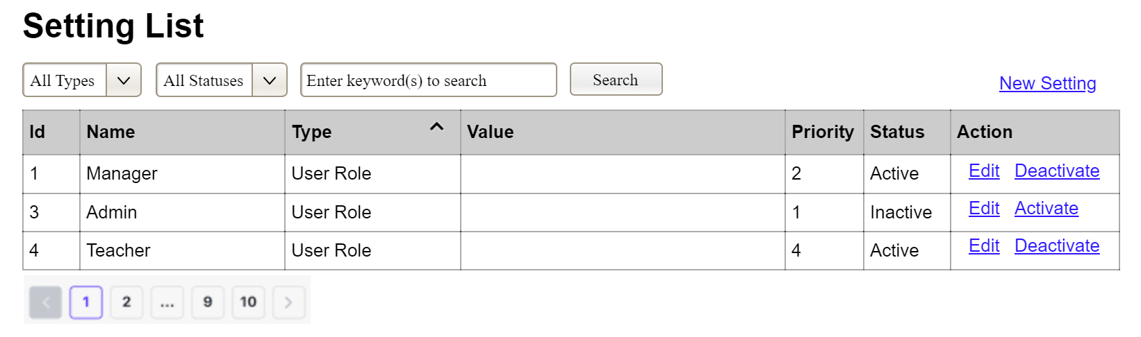
(1)
(2)
(3)
This screen allows the Administrator to:
- View Setting List: view list of current master data.
- Filter Setting List: filter master data by data types, statuses
- Search Settings: enter keyword(s) to search master data by their names or values
- Sort Setting List: sort master data list (ascending, descending) by clicking column headers
On the screen, s/he can also
- Activate/Deactivate Setting: change status of a specific inactive/active master data
- Choose to go to the Setting Details screens for adding new or updating an existing master data by clicking the New Setting or Edit link.
Field Description
Field Name | Description
(1) | Initial values: all the active setting names with null or blank type  Hover the mouse to show the field name: “Setting Type”
(2) | Initial values: All Statuses, Active, Inactive (default value “All Status”)  Hover the mouse to show the field name: “Setting Status”
(3) | The change-status action is Activate or Deactivate depending on the current status of the relevant setting (Inactive or Active, respectively).

3.3.1.2 Setting Details
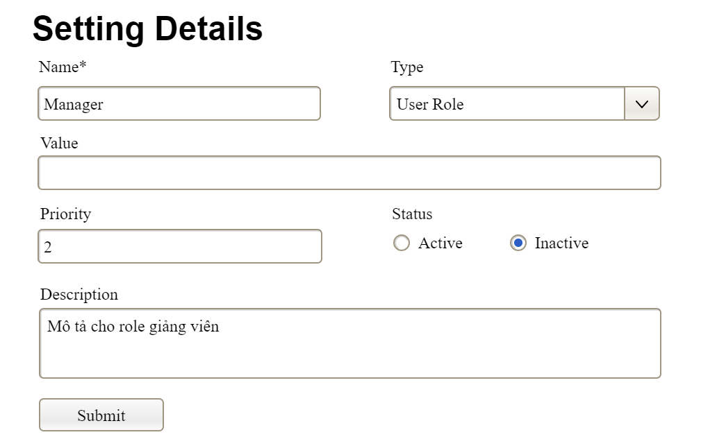

This screen allows the Administrator to:
- Add New Setting: add new master data.
- Update Setting Details: update details of a specific master data
Field Description
Field Name | Description
Name | Data type: non-digit string, max length of 20 characters
Type | Initial data values: all active setting names (with null or blank type)
Value | Data type: any string, max length of 100 characters
Priority | Data type: a positive integer
Description | Data type: any string, max length of 200 characters

3.3.2 User Management

3.3.2.1 User List
…

3.3.2.2 User Details
…

3.1 Public Access & Discovery

3.2 Authentication & Profile

3.3 Class Management

3.4 Question Bank Repository Management

3.5 Study Set Creation and Learning

3.6 Exam Session

3.7 Analytics & Reporting

3.8 Payment & Subscription

3.9 System Admin

4. Non-Functional Requirements

4.1 External Interfaces
This section outlines how the platform interacts with human users, hardware components, and external software services.
1. User Interfaces (UI): The system must provide a clean, modern web-based user interface accessible via desktop, tablet, and mobile browsers. The interface design must feature intuitive layout flows, meaning primary actions (such as launching Study flashcards or viewing Joined classes) are accessible within a maximum of three clicks from the user dashboard.
2. Hardware Interfaces: The platform has no dedicated hardware interface requirements. It runs entirely within standard web browsers on client devices (Personal Computers, Laptops, Smartphones). The system must run smoothly on low-to-mid-tier client devices without causing CPU spikes or thermal throttling.
3. Software Interfaces:
- Authentication Engine: The platform interfaces with Supabase Authentication via secure HTTPS API integrations to process user registration, identity handshakes (Log in with Google), and password updates.
- AI Services Layer: The backend communicates with the external Google Gemini API over secure REST endpoints to handle dynamic query pipelines, request AI answer explanations, and handle programmatic study question generation.
- Payment Gateway Interface: The system integrates with a third-party payment infrastructure ecosystem (e.g., VNPAY or Stripe) to offload secure cardholder data handling and track invoice payment approvals during plan updates (Upgrade to Premium).
- Data Tier: The application communicates with a relational data layer via standard JDBC/ODBC connection pooling protocols to execute transactional read/write events.

4.2 Quality Attributes

4.2.1 Usability
- Onboarding & Training Time: The platform must be designed for zero-training execution. A standard user (Learner or Teacher) should be capable of successfully operating primary features—like navigating classes or reviewing study dashboards—within 5 to 10 minutes of exposure without reading documentation.
- Task Performance Metrics: A teacher must be able to complete a custom exam compilation setup or complete a bulk question file import sheet within a measurable window of under 2 minutes.
- UI Standards Compliance: The user interface layouts must follow modern mobile-responsive layout practices. The text elements, status markers, and graphics must maintain standard accessibility color contrast thresholds (minimum 4.5:1 ratio conforming to WCAG 2.1 Level AA standards) so all learner populations can view learning materials under variable lighting environments.

4.2.2 Performance
- Transaction & Page Response Times:
  - Normal Conditions: Under standard user traffic weights (defined as 100 concurrent active users or less), 95% of all standard page transactions and dashboard loads must complete in 3.0 seconds or less.
  - Stress Conditions: Under peak stress loads (defined as more than 100 concurrent active users, scaling up to an upper baseline of 500 users), the platform must guarantee execution stability, with 90% of all page loads or processing pipelines completing within 10.0 seconds or less.
- Throughput & Capacity Limitations:
  - The application architecture must comfortably sustain a baseline capacity of up to 100 concurrent active browser sessions without suffering service crashes.
  - The system database must be optimized using indices to handle up to 50 transactional write commitments per second during high-intensity exam periods.
- Resource Utilization Metrics:
  - Client-Side Memory: The frontend web page instance running inside a client browser application must keep its memory allocation footprint under 300MB during active testing or flashcard operations.
  - Server-Side Bandwidth: Data transmission payloads for core analytical data views (View learning analytics) must utilize JSON data optimization to ensure file transfer sizes remain lightweight. Large batch operations, like document data serialization loops (Export report), must be handled asynchronously.

4.2.3 Security
- Role-Based Access Control (RBAC): The system must strictly enforce role privileges. Users authenticated with a "Learner" role must be completely blocked from accessing backend API endpoints or UI views reserved for "Teacher" or "Admin" roles, returning an HTTP 403 Forbidden status code.
- Data Encryption & Transport: All data transmitted between the client browser and the system backend, as well as communications with Supabase Authentication and the Google Gemini API, must be encrypted in transit using TLS 1.3 (HTTPS). Sensitive data at rest, including user profile properties (phone numbers, email hashes) and official exam grade logs, must be encrypted using AES-256 standards.
- Token Lifecycle Security: Session authentication must rely on stateless JSON Web Tokens (JWT) managed securely. Access tokens must have a brief validity window (e.g., 1 hour), requiring secure Refresh Tokens to request updates silently. Upon executing the Log out account, client-side token storage must be entirely cleared, and the server must invalidate the active refresh token.
- Input Sanitization: To safeguard the application against SQL Injection and Cross-Site Scripting (XSS) threats, all user-submitted text data—specifically questions authored by teachers or bulk roster spreadsheets uploaded via Excel—must be scrubbed and sanitized at the API layer before database commit actions occur.

4.2.4 Availability
- System Uptime Baseline: The platform must maintain an operational availability SLA of 99.5% or higher over any calendar month.
- Scheduled Maintenance Windows: Anticipated system upgrades, database migrations, or server reboots must be restricted to off-peak usage windows (specifically between 2:00 AM and 4:00 AM GMT+7) and must be announced to users at least 24 hours in advance.
- Exam Session Fault Tolerance: During active testing execution (Take exam), the system must execute an automated asynchronous background save of the learner's selected answers every 30 seconds. If the learner suffers an abrupt local network drop or a browser crash, they must be allowed to log back in and resume the exam seamlessly without losing any previously recorded progress.
- Graceful Degradation: If an external dependent dependency experiences an outage (e.g., the Google Gemini API rate limits or drops offline), the primary ecosystem must continue running normally. The system must display a temporary error notice for AI features (like requesting answer explanations) while ensuring core non-AI functionalities (taking quizzes, viewing classes, downloading reports) remain fully accessible.

4.2.5 Compatibility
- Cross-Browser Operations: The user interface layout and client script execution must behave consistently and flawlessly across the latest stable production releases of all primary modern browsers, including Google Chrome, Apple Safari, Mozilla Firefox, and Microsoft Edge.
- Responsive Layout Breakpoints: The application viewport rendering must adapt smoothly across variable form factors:
  - Mobile Optimization: Core learner features, such as studying flashcards or checking profiles, must scale perfectly down to mobile screens (360px to 480px width layouts).
  - Desktop Optimization: Data-dense management interfaces, such as the teacher's analytical reporting view, must be structurally optimized for desktop aspect ratios (1024px width and above).
- Data File Standards Compatibility: The bulk question template parser must remain backward-compatible, successfully handling both legacy binary spreadsheet structures and open XML spreadsheet schemas generated via Microsoft Excel, Google Sheets, or LibreOffice Calc.

4.2.6 Scalability
- Horizontal Server Scaling: The application backend architecture must be entirely decoupled and stateless, enabling horizontal auto-scaling (adding additional container instances behind a reverse proxy/load balancer) to distribute processing stress evenly as simultaneous traffic increases from 100 to 500 concurrent sessions.
- Data Volume Scalability: Database tables, specifically tables recording learner answers and public study sets, must be heavily indexed. Search query lookups must maintain an execution turnaround time of under 1.5 seconds, even as the global database grows to hold over 500,000 unique records.
- Storage Elasticity: The media asset repository hosting uploaded user avatars or attached lesson files must use elastic file allocation logic, ensuring that total storage bounds expand automatically without human intervention or localized server disk space depletion.

5. Requirement Appendix

5.1 Business Rules
ID | Feature | Business Rule
BR-01 | Public Access & Discovery | Only authenticated users are allowed to access role-specific features. Guests may only access public features such as homepage viewing, public search, public study set details, and public flashcards.
BR-02 |  | Public learning resources must be visible to Guests and authenticated users only when their visibility status is set to Public and they have not been hidden by an Admin.
BR-03 |  | Guests may study public flashcards but are not allowed to take private quizzes, join classes, view personal progress, review wrong answers, take real-time exams, or request AI explanations.
BR-04 | Authentication & Account Security | Each user account must be associated with one unique email address. The system must reject registration if the submitted email already belongs to an active account.
BR-05 |  | User passwords must satisfy the platform password complexity requirements and the confirmation password must match the new password before the account or password update is accepted.
BR-06 |  | After a configurable number of consecutive failed login attempts, the account must be temporarily locked to prevent unauthorized access.
BR-07 |  | Authentication sessions must expire after the configured inactive period. Users must log in again after the session expires.
BR-08 |  | Password reset links or tokens must be time-limited, single-use, and invalidated immediately after successful password reset.
BR-09 | Authorization & Role Management | Each authenticated user must be assigned to a valid system role: Learner, Teacher, or Admin. The assigned role determines the user’s accessible features and permissions.
BR-10 | User Profile Management | Users may update only allowed profile information such as full name, phone number, avatar, or profile description. They must not directly modify protected fields such as role, account status, or system permissions.
BR-11 | Class Management | Only Teachers are allowed to create classes, generate class codes or invitation links, approve join requests, remove learners, and manage class learning activities.
BR-12 |  | A class code or invitation link must be unique, valid, and active before a Learner can use it to request or join a class.
BR-13 |  | A Learner cannot join the same class more than once. Duplicate join requests or duplicate memberships must be rejected by the system.
BR-14 |  | If a class requires teacher approval, the Learner must not become an official class member until the Teacher approves the join request.
BR-15 |  | A Teacher may view and manage only the classes they created or are assigned to manage.
BR-16 | Question Bank Repository | Only authenticated Teachers can create and manage question banks. Each question bank is a reusable question repository with an owner and required classification information such as title, subject, topic, or visibility.
BR-17 |  | A Teacher may view or update only question banks they own, question banks shared with them, or public repository content allowed by system configuration. Learners and Guests must not access question banks directly.
BR-18 |  | A repository question cannot be saved unless it has valid question content, a supported question type, a correct answer, and required scoring information. Imported, generated, or manually entered questions must be previewed and approved before permanent save.
BR-19 |  | Imported Excel files for question banks or study sets must follow the required template. Invalid rows must not be saved and must be reported with row-level error messages.
BR-20 |  | A question bank or repository question that is already used in an active exam or required for historical reporting should not be permanently deleted. The system should archive, hide, or prevent deletion to preserve exam integrity and historical records.
BR-21 | AI Question Generation | Only Premium Learners and Premium Teachers are allowed to generate Study Set questions from learning material using Gemini API. Premium Teachers may also generate reusable Question Bank questions.
BR-22 | Study Set Management | Learners may access study sets that are Public, owned by themselves, or assigned to a class they have joined. Teachers may access study sets they own or are authorized to assign to managed classes.
BR-23 | Practice & Learning Progress | Quiz mode is available only to authenticated Learners. Guests may study public flashcards but are not allowed to take study set quizzes.
BR-24 |  | The system must record Learner learning progress, quiz results, wrong answers, difficult flashcards, and study history for analytics and review purposes, including progress on learner-created study sets.
BR-25 | AI Learning Support | Only Premium Learners are allowed to request AI-generated answer explanations. If the Gemini API is unavailable, the core study, quiz, or review process must still continue without AI support.
BR-26 | Exam Session Management | Only Teachers are allowed to create and configure official real-time exam sessions for classes they manage.
BR-27 | Real-time Exam Taking | A Learner can take an exam only if they belong to the assigned class, the exam is published, the current server time is within the exam time window, and the Learner has not exceeded the allowed number of attempts.
BR-28 |  | Each exam attempt must be locked after submission or auto-submission. A locked attempt cannot be edited by the Learner.
BR-29 |  | If the exam timer expires, the system must automatically submit the latest saved answers and grade the attempt according to the configured answer key.
BR-30 |  | If the Learner reloads the page, closes the browser, or reconnects after a network interruption, the system must restore the latest auto-saved attempt without resetting the exam timer.
BR-31 | Exam Result Review | Exam result visibility must follow the Teacher’s configuration. The system may show full results, score only, completion status only, or hide results until allowed.
BR-32 | Payment & Subscription | Premium access must be activated only after the Payment Gateway confirms a successful payment transaction.
BR-33 |  | If payment fails, is cancelled, or cannot be verified, the system must not upgrade the account to Premium and must allow the user to retry or choose another payment method.
BR-34 | Analytics & Reporting | Teachers may view analytics and export reports only for classes, exams, study sets, and learners under their authorized management scope.
BR-35 | Notification Management | Email notifications may be sent only to users who are valid recipients of the related event, such as class members, exam participants, or users involved in password reset.
BR-36 | Admin Management | Admins may manage user roles, hide inappropriate public learning resources, and monitor system status, but Admin actions must be recorded for accountability.
BR-37 | Study Set Management | Learners and Teachers can create study sets by manually entering questions, importing questions from Excel, or generating questions from learning material with Premium AI access. Teachers can additionally create study sets from authorized question banks.
BR-38 | Study Set Visibility | Newly created Study Sets must default to Public visibility. The owner may change visibility if the screen or system configuration supports it.
BR-39 | Study Set and Question Bank Integration | When a Teacher creates a Study Set from a private or restricted Question Bank, the system copies the selected question content into the Study Set and must not grant Learners direct access to the source Question Bank.

5.2 System Messages
ID | Message Type | Context | Content
MSG01 | Success | User registers an account successfully | Your account has been created successfully.
MSG02 | Error | User leaves required information empty, such as email, password, study set name, question bank name, or exam configuration | Please complete all required information.
MSG03 | Error | User enters invalid data, such as mismatched password confirmation, invalid class code, expired token, or invalid Excel file format | The information is invalid. Please check and try again.
MSG04 | Error | Registration email already exists in the system | This email is already associated with another account.
MSG05 | Error | User enters incorrect email or password during login | Incorrect email or password. Please try again.
MSG06 | Notification | Account is temporarily locked after multiple failed login attempts | Your account has been temporarily locked. Please try again later or reset your password.
MSG07 | Success | User logs in successfully | Login successful. Welcome back!
MSG08 | Success | User logs out successfully | You have been logged out successfully.
MSG09 | Notification | System sends password reset email successfully | A password reset link has been sent to your email.
MSG10 | Success | User updates personal profile successfully | Your profile has been updated successfully.
MSG11 | Error | User accesses a feature or resource without permission, such as Guest accessing quiz mode, Learner accessing a question bank, Learner accessing an unavailable exam, or Teacher editing an unauthorized question bank | You do not have permission to access or perform this action.
MSG12 | Success | Learner completes a flashcard study session | Flashcard study session completed. Your progress has been saved.
MSG13 | Error | System cannot load flashcards, quiz, study set, question bank, or learning data due to network or system error | Failed to load data. Please check your connection and try again.
MSG14 | Success | Learner completes a study set quiz | Quiz completed. Your score and progress have been saved.
MSG15 | Notification | Learner has no wrong answers to review | You do not have any wrong answers to review.
MSG16 | Error | Learner or Teacher does not have Premium access but requests a Study Set or Question Bank AI feature | AI features are available for Premium accounts only. Please upgrade to continue.
MSG17 | Processing | System is sending a request to Gemini API to generate an explanation or questions | The system is processing your AI request. Please wait…
MSG18 | Error | Gemini API fails, times out, or returns no usable content | AI processing is currently unavailable. Please try again later.
MSG19 | Success | Learner sends a class join request successfully | Your class join request has been sent successfully.
MSG20 | Notification | Learner attempts to join a class they already belong to | You are already a member of this class.
MSG21 | Success | Teacher creates a class successfully | Class created successfully. A class code has been generated.
MSG22 | Success | Teacher approves a Learner’s class join request | Class join request approved successfully.
MSG23 | Success | Teacher removes a Learner from a class | Learner removed from class successfully.
MSG24 | Success | Teacher creates a question bank successfully | Question bank created successfully.
MSG25 | Confirmation | Teacher clicks the delete question bank button | Are you sure you want to delete this question bank? This action cannot be undone.
MSG26 | Success | Teacher deletes or archives a question bank successfully | Question bank deleted successfully.
MSG27 | Error | Imported Excel file for a Study Set or Question Bank contains both valid and invalid rows | Some rows in the file are invalid. Please review row-level errors before saving.
MSG28 | Success | Valid imported questions are saved into a Study Set or Question Bank successfully | Questions imported successfully.
MSG29 | Success | AI returns generated Study Set or Question Bank questions and waits for user review | Questions generated successfully. Please review them before saving.
MSG30 | Success | Teacher creates an exam session successfully | Exam session created successfully. Learners will be notified.
MSG31 | Error | Learner accesses an exam before its start time or after the allowed time | This exam is not available at the current time.
MSG32 | Confirmation | Learner attempts to leave the exam page before submitting | Your exam is still in progress. Are you sure you want to leave?
MSG33 | Notification | System auto-saves a Learner’s exam answers | Your answers have been auto-saved.
MSG34 | Success | Learner submits an exam successfully | Exam submitted successfully.
MSG36 | Success | User completes Premium payment successfully | Payment successful. Your Premium access has been activated.
MSG37 | Error | Payment fails or is cancelled through the payment gateway | Payment failed or was cancelled. Please try again or choose another payment method.
MSG38 | Confirmation | Admin hides a public learning resource such as a public Study Set | Are you sure you want to hide this public learning resource?
MSG39 | Success | Admin hides an inappropriate or invalid public learning resource | Learning resource hidden successfully.
MSG40 | Success | Admin updates a user role successfully | User role updated successfully.
MSG41 | Error | Internal server error or system maintenance occurs | The system is unavailable. Please try again later.
MSG35 | Success | Learner or Teacher creates a Study Set successfully | Study set created successfully and published with Public visibility.
MSG42 | Error | Learner attempts to access or create from a Teacher Question Bank | Question banks are available to Teachers only.

5.3 Security Requirements
ID | Category | Requirement
SEC-01 | Authentication | All registered users must authenticate through Supabase Authentication before accessing role-specific features.
SEC-02 | Authorization | The system must enforce Role-Based Access Control. Access to features must be restricted based on the assigned role: Learner, Teacher, or Admin.
SEC-03 | Account Protection | User passwords and reset tokens must be securely managed. Plain text passwords must not be stored in the system database.
SEC-04 | Premium Access Control | The system must allow Premium features, such as AI answer explanations and AI question generation for Study Sets or Question Banks, only for users with valid Premium access.

5.4 Usability Requirements
ID | Category | Requirement
USE-01 | UI Consistency | UI elements such as buttons, forms, modals, icons, and messages must be consistent in style and behavior across all pages.
USE-02 | Navigation | Users must be able to access primary features, such as Study Sets, Classes, Question Banks, Exams, Profile, and Reports, from the main navigation area.
USE-03 | Error Guidance | The system must display understandable validation or error messages when users enter invalid data, access unavailable content, or perform unauthorized actions.

5.5 Data Integrity Requirements
ID | Category | Requirement
DI-01 | Input Validation | All user-submitted data must be validated on both frontend and backend, including email, password, class code, study set format, question format, answer options, and exam settings.
DI-02 | Unique Constraints | The system must prevent duplicate critical records, including duplicate active email accounts and duplicate learner membership in the same class.
DI-03 | Transactional Integrity | Critical multi-step operations, such as creating an exam session, submitting an exam attempt, importing questions, or activating Premium access, must be handled consistently so partial updates do not corrupt data.
DI-04 | Relationship Integrity | The system must maintain valid relationships between users, roles, classes, study sets, question banks, questions, exams, attempts, answers, payments, and reports while preventing Study Set access from exposing restricted Question Banks.

5.6 Maintainability Requirements
ID | Category | Requirement
MAI-01 | Coding Standards | Source code must adhere to established coding conventions and naming standards for the respective language/framework.
MAI-02 | API Documentation | All public API endpoints provided by the backend must be documented using Swagger/OpenAPI, detailing the request/response models, parameters, and status codes.
MAI-03 | Configurable Rules | Important rules such as session timeout, failed login limit, exam duration, attempt limit, result visibility, and Premium access must be configurable instead of hard-coded.
MAI-04 | Error Logging | The system must log important errors, including authentication failures, payment failures, AI generation failures, import failures, and exam submission failures, for troubleshooting and maintenance.

